

TOURISM MANAGEMENT

SYSTEM DATABASE DESIGN

Lanka Tours



### Table of Contents

Introduction to the scenario 3

Additional assumptions 4

Tour Package 4

Service Provider 4

Contract 4

Places to visit 4

Tour 4

Accommodation 4

Payment 5

Person 5

Employees 5

Meals 5

Drivers 5

Tour Guides 5

Consumer 5

Extended Entity Relationship (EER) Diagram 6

Relational Mapping 7

Data Normalisation 21

Data Dictionary 74

Data Base Structure 93

Create table statements 104

Data base Creation and data insertion SQL statements 142

Data Base Diagrom 278

Triggers 279

Functions 286

Create View 289

Procedure 291

# Introduction to the scenario

Lanka tour operator company has started since 2015.Our company provides you tour for memorable for life time.Sri lanka is country full of attractions that from ancient, cultural, beautiful nature, and alive sun kissed beaches, mist covered mountains, roaring waterfalls . We can organizing individual trips, couple trips, family trips ,association trips and trips for foreigners who love to spend in srilankan most beautiful places .We are engaged to provide a good service for your vacation including accomadation facilities ,supping meals ,good transportation system .

Our main focus to create a new database for our company to keep each records. From this database system we have keep tracks of all the humans who are connecting with us. Like if we get employees segment it will be devided in to many parts .as a example employees can be a tour guide or a driver or a manager.so we should have to keep all the trackings of each of them. And also persons can be a consumer. Our first priority should go to keep tacking of consumers mostly. As well as we should identify the consumers wether they are old customer or a current customer.

There are packages we have introduce to our customers . our packages will included meals or without meals , various kind of accomadation s, places you can visit ,special activities that you can engaged to.

After entering all the details of the consumers ,then we have to supply our services to them thoroughly . From our operating system we have given them some accomadations as accomadation rooms and accomadation hotels. Consumer can selected one of them as they needed. And also there are contract based accomadations and tour accomadations . consumers have feel free to choose what they mostly like to have. All of the details included in our system. Then we have supplied special activities and tours .as their requirements our company will provide them a good service from service providers.

Our company supplies goods for our consumers ,we got many tour guides that can be understand more than 3 languages. So it will be a big help for consumers who wished to have knowledge of unknown places. When the consumer will joing with us they can have to know the places that the choosed to visit entrance are free or not.

And also company will provide stress relaxing transportation system to the consumers who wished to joing with us.they can selected drivers as well as the vehicals they love to go for the tour.all the vehicas details and driver details are included in our system.

And also there are managers who support to keeping reports of everything .about all the mnager details and manager reports also included in track keeping process.

# Additional assumptions

## Tour Package

There is number of tour packages in our database Nathuree , Adventure , Pilgrimage, etc. Each Tour package has a basic price with basic requirements. When an user wants to add additional features to the tour package price will increase.

Eg : According to accommodation type (Luxury , Semi Luxury, Normal)

## Service Provider

Each Service Provider has at least one phone number , Email , and Fax number. But one service provider can have many of them.

## Contract

Each contact has a contact type. Some contacts can be only for meals , Some can be only for Accommodation, Some can be for both.

One contract has many tours

If there is contract for serve meals, We assume one contract serve more than one meal.

## Places to visit

In real world all the places that tourists visit are not free of charge so we divide Places to visit in to 2 parts.

* Free Entrance
* Paid Entrance

## Tour

We assume some tours can have more than one vehicle, more than one driver , and more than one tour guide.

## Accommodation

Accommodation is divided into 2 parts one

* Hotels
* Rooms

In real world Hotels have a unique id call Hotel code . Therefore we add that as a unique fields in hotels table.

## Payment

Consumers can make the payment is many ways by using credit cards , using cheque, Pay by cash, by a direct bank transaction etc..

## Person

We Assume there can be persons other than consumers , employees , drivers and tour

## guides.

Employees

Employees can have 0 or more dependent.

## Meals

Meals consists desert types and liquor.

## Drivers

There are 2 types of drivers we divide them into 2 parts using the VehicleClass types that they can drive

## Tour Guides

Tour Guides have special skills.

Eg-

* Some are specialized for bird watching.
* Some are specialized for adventures.
* Some are specialized for pilgrimages.

## Consumer

Each Consumer have a special contact person for in case of an emergency.

# Extended Entity Relationship (EER) Diagram

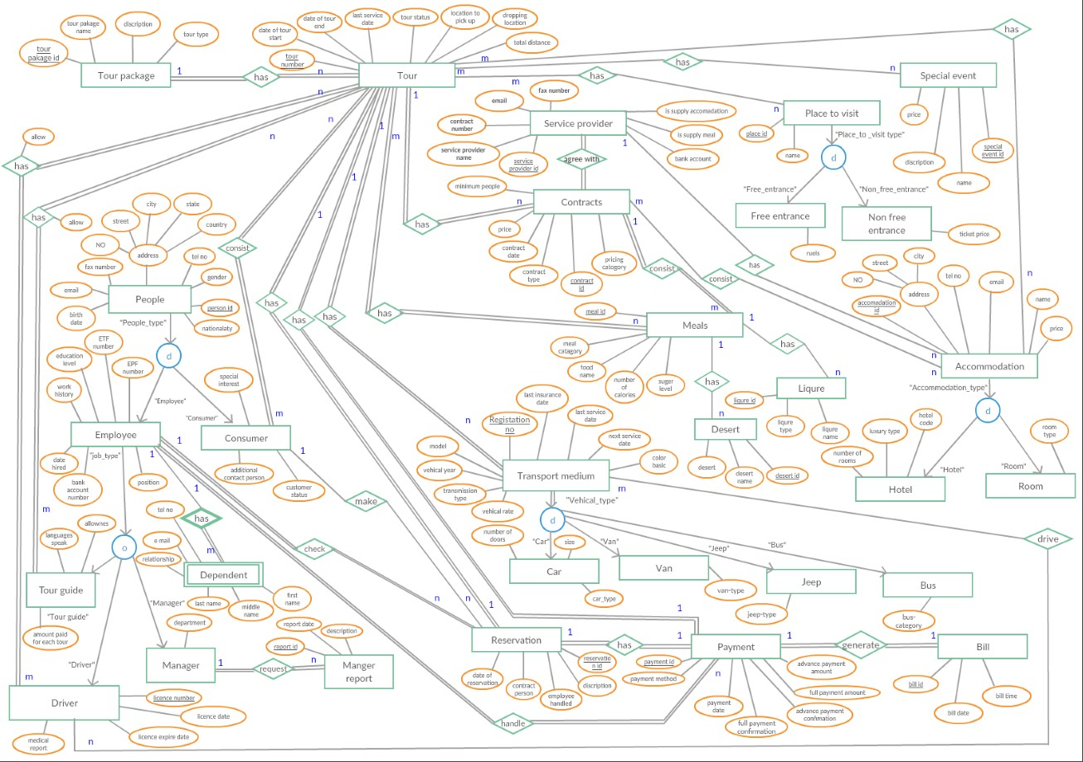

# Relational Mapping

 Tour Package

Tour package Entity have 4 attributes Tour_pakage_id, Tour_pakage_name ,

Tour_pakage_type, Tour_description

Tour_pakage_id is the primary key of this Entity. Tour package type can be adventure, Pilgrimage , bird watching etc..

#### **Tour_pakage_id** **Tour_pakage_name** **Tour_pakage_type** **Tour_description**

 Service Provider

Service provider is a entity that consists 8 attributes Service_provider_id is the primary key field. As we assume Service Provider can have more than one telephone number and email address we make 2 different tables for that with the primary key of Service_provider_id.

Therefore this entity is divided into 3 tables

 Service Provider

|  |  |  |  |  |
| --- | --- | --- | --- | --- |
| Service_provider_i d | Service_provide r name | Is_supply_Accomodatio n | Is_suppl y meal | Bank_account_numbe r |

 Service_Provider_Telephone_number

To Identify a record uniquely we make the both fields as primary keys .

|  |  |
| --- | --- |
| Service_provider_id | Telephone_number |

 Service_Provider_Fax

To Identify a record uniquely we make the both fields as primary keys .

|  |  |
| --- | --- |
| Service_provider_id | Fax_number |

 Service_Provider_Email

To Identify a record uniquely we make the both fields as primary keys.

|  |  |
| --- | --- |
| Service_provider_id | Email |

 Tour

Tour Entity type have 8 attributes on the ER diagram, but it has a 1 to many relationship with tour_package .Each tour belongs to one tour package. Since the many side is tour entity we add the tour_package id as a foreign key column in tour table. There is a 1 to 1 relationship in tour entity with reservation. Therefore we add the reservation_id to the tour table as a foreign key.

|  |  |  |  |  |  |  |
| --- | --- | --- | --- | --- | --- | --- |
| Tour_id | Date_St arted | Date_end | Tour_  status | Location_to_pic k_ip | Location_to_dr op | Total_dsitance |

|  |  |  |  |  |
| --- | --- | --- | --- | --- |
| No_of_vechiles | No_of_tour_guides | No_of_drivers | Reservation_id | Tour_pakage_Id |

 Accommodation

Accommodation is generalized into 2 types Hotel and room. Accommodation has a primary key which is Accommodation_id, and it has 7 fields of total.

Accommodation

|  |  |  |  |  |  |  |
| --- | --- | --- | --- | --- | --- | --- |
| Accommodation_id | Accommodation_name | No | Street | City | Price | No_Of_people |

 Accommodation_hotel

Accommodation_id is the primary key field of this table as well as it is the foreign key column of this table.

|  |  |  |  |
| --- | --- | --- | --- |
| Accommodation_id | Hotel_Code | Luxuary_type | No_of_rooms |

 Accommodation_Room

Accommodation_id is the primary key field of this table as well as it is the foreign key column of this table.

|  |  |
| --- | --- |
| Accommodation_id | Room_type |

 Accomodation_tour

Since Accommodation table has a many to many relationship with tour table we create a different relation. To identify a record uniquely we set both fields as primary key coloums.

Foreign keys

Tour_iD – Relation with Tour and Accomodation_tour

Accommodation_id - Relation with Accomodation and Accomodation_tour

|  |  |
| --- | --- |
| Accommodation_id | Tour_iD |

 Contract

Contract table have 8 fields

Primary key - Contact_ID.

Since we assume one contract covers many tours, since it’s an 1 to many relationship and the many side is Contract table we add the tour id as a foreign key in contract table.

One service provider can signed many contracts, and the many side is contract table we add service provider id as a foreign key in contract table.

Foreign key

* Service_provider_id- Relationship with Service_provider table
* Tour_id - Relationship with Tour table

|  |  |  |  |  |  |  |  |
| --- | --- | --- | --- | --- | --- | --- | --- |
| Contact_ID | Contact_ type | Pricing category | Maximum  people | Minimum  people | Contact_ sign_date | Service  _provider  _id | Tour _id |

 Contract_accomodation

We thought one contract consists many Accommodation. Since it’s an many to many relationship we create a different relation with primary keys of both tables.

Primary keys – Tour_id, Accommodation_id

Foreign key

* tour_id – Relationship with tour table
* Accommodation_id – Relationship with Accommodation table

|  |  |
| --- | --- |
| Tour_id | Accommodation_id |

 Places to visit

Places to visit table is generalized into 2 tables free entrance and non-free entrance. Primary key – Place_id

* Places_to_visit

Primary key – Place_id

|  |  |
| --- | --- |
| Place_id | Place_name |

 Free_entrance

Primary key – Place_id

Foreign key

* Place_id – Relationship with places to visit table

|  |  |
| --- | --- |
| Place_id | Special_rules |

 Non_free_Entrance

Primary key – Place_id

Foreign key

* Place_id – Relationship with places to visit table

|  |  |
| --- | --- |
| Place_id | Ticket_price |

 Tour_Places_To_Visit

Since one tour covers more than one place and many tours visit the same place , Relationship between tour and places to visit is a many to many one, There for it creates a new relation including the primary keys of both tables

Primary keys – Tour_id, place_id

Foreign keys

* Tour_id – Relationship with Tour table
* Place_id – Relationship with Places_to_visit table

|  |  |
| --- | --- |
| Tour_ID | Place_id |

 Special_activity

This table has 4 fields with including a primary key

Primary key – Special_activity_id

|  |  |  |  |
| --- | --- | --- | --- |
| Special_activity_id | Special_activity_name | Description | Price |

 Tour_Special_activity

Since there is a relationship between special activity and tour and its many to many relationship, it creates a different relationship with including the primary keys of both tables.

Primary keys – Tour_id, Special_activity_id

Foreign key

* Tour_id – Relationship with tour table
* Special_activity_id – Relationship with special activity id

|  |  |
| --- | --- |
| Tour_id | Special_activity_id |

 Reservation

Reservation table has 4 fields. One of them , is a primary key. Two of them, are foreign keys.

Primary key – Reservation_id

Foreign key

* Contacted_person_id – Relationship with Consumer table
* Employee_who_handled - Relationship with Employee table

|  |  |  |  |  |
| --- | --- | --- | --- | --- |
| Reservation_i d | Date_of_reservatio  n | Descriptio  n | Contacted_person_I d | Employee_who_handle  d |

 Person

Person table Super class of all the other subclasses like employee, consumer, tour guide , Driver and etc.. This table contains all general information of people. This table is generalized into 4 tables.

Primary key – Person_id

|  |  |  |  |  |  |  |  |
| --- | --- | --- | --- | --- | --- | --- | --- |
| Person_id | First_name | Middle_name | Last_name | Nationality | birthdate | Gender | NIC/Pass |

We assume one person has one or many addresses, contact numbers, emails zero or more fax numbers. Since those are multivalued attributes it creates a different relation with including the primary key of person table.

 Person_address

Since this field is a composite attribute , and one person can have more than one address , This attribute is a complex attribute. (Composite and multivalued)

Primary key – Person_id, NO , Street, city , state/province, country.

Foreign key

* Person_id – Relationship with person table

|  |  |  |  |  |  |
| --- | --- | --- | --- | --- | --- |
| Person_id | No | Street | City | State/province | Country |

 Person_contact_number

Primary key – Person_id , Contact_number

Foreign key

* Person_id – Relationship with person table

|  |  |
| --- | --- |
| Person_id | Contact_number |

 Person_fax_number

Primary key – Person_id , Fax_number

Foreign key

* Person_id – Relationship with person table

|  |  |
| --- | --- |
| Person_id | Fax_number |

 Person_Email

Primary key – Person_id , Email

Foreign key

* Person_id – Relationship with person table

|  |  |
| --- | --- |
| Person_id | Email |

 Consumer

Consumer is a sub table of person table.

Primary key – Consumer_id

Foreign key

* Consumer_id – Relationship between Consumer table and person table

|  |  |  |  |  |
| --- | --- | --- | --- | --- |
| Consumer_id | Special_interests | Additional_contact_ person_name | Additional_contact_ person_number | Consumer_status |

 Employee

Employee is a sub table of person table. Employee table contains unique 2 fields which is EPF_number and ETF_number and it contains 8 fields

Primary key – Employee_id

Foreign key

* Empolyee_id – Relationship between person table and Employee table

|  |  |  |  |  |
| --- | --- | --- | --- | --- |
| Employee_id | EPF_number | ETF_number | Educational_level | Working_history |

|  |  |  |
| --- | --- | --- |
| Job_discription | Date_hired | Bank_account_number |

Driver

Driver is a sub table of person table.

Primary key – Driver_id

Foreign key

* Driver_id – Relationship between driver table and person table

|  |  |  |  |  |
| --- | --- | --- | --- | --- |
| Driver_id | Licence_number | Licence_issued_date | Licence_expire_date | Medical_reports |

|  |  |
| --- | --- |
| Records_about_disobeying_traffic_rules | Vechile_type_that_drive |

 Tour_guide

Tour_guide is a sub table of person table.

Primary key – Tour_guide_id

Foreign key

* Tour_guide_id - Relationship between Tour_guide table and person table

|  |  |
| --- | --- |
| Tour_guide_id | Special_skill |

 Manager

Manager is a sub table of person table.

Primary key –Maneger_id

Foreign key

* Maneger_id - Relationship between Manager table and person table

|  |  |
| --- | --- |
| Maneger_id | Department |

Manegement_reports

Primary key – Report_id

Foreign key

* Manager_id – Relationship between manager and Manegement_reports table

|  |  |  |  |
| --- | --- | --- | --- |
| Manager_id | Report_date | Description | Manager_id |

 Tour_guide_languages_speak

Primary key - Tour_guide_id, Language

Foreign key - Tour_guide_id

|  |  |
| --- | --- |
| Tour_guide_id | Language |

 Tour_guide_Tour

There is a many to many relationship between tour and tour_guide, Therefore it Creates a different relation

Primary key – Tour_guide, Tour_id

Foreign key

* Tour_guide_id - Relationship between Tour_guide_tour table and Tour_guide table ▪ Tour_id - Relationship between Tour_guide_tour table and Tour

|  |  |  |
| --- | --- | --- |
| Tour_guide_id | Tour_id | Allowance |

 Tour_Driver

There is a many to many relationship between tour and driver table, Therefore it Creates a different relation

Primary key – Driver_id, Tour_id

Foreign key

* Driver_id - Relationship between Tour_driver table and Driver table ▪ Tour_id - Relationship between Tour_ driver table and Tour table

|  |  |  |
| --- | --- | --- |
| Driver_id | Tour_id | Allowance |

Meal

This table contains 4 fields which one is a foreign key column , and one is a primary key column.

|  |  |  |  |
| --- | --- | --- | --- |
| Meal_id | Meal_category | No_of_calories | Suger_level |

 Meal_item

Primary key – Meal_id, Meal_item_name

Foreign key – Meal_id – Relationship between meal table and Meal_item table

|  |  |
| --- | --- |
| Meal_id | Meal_item_name |

 Desert

Primary key – desert_id

Foreign key – meal_id – Relationship between meal table and Desert table.

|  |  |  |
| --- | --- | --- |
| Desert_id | Desert_name | Meal_id |

 Liquor

Primary key – Liqure_ids

Foreign key – meal_id – Relationship between meal table and Liquor table.

|  |  |  |  |
| --- | --- | --- | --- |
| Liqure_id | Liqure_type | Liqure_name | Meal_id |

 Tour_Meal

One tour has more than one meal. Also one meal type can be have in many tours, For an example biriyani can be served in many tours . hence the relationship between meal and tour is a many to many one

Primary key – Tour_id , Meal_id

Foreign key

* Tour_id – Relationship with tour table
* Meal_id – Relationship with Meal table

|  |  |
| --- | --- |
| Tour_id | Meal_id |

Meal_contract

Since the relationship between meal and contact is a many to many one it creates different relation that contains the primary keys of both relation tables.

Primary key – Meal_id , Contract_id

Foreign key

* Meal_id – Relationship with meal table
* Contract_id – Relationship with Contract table.

|  |  |
| --- | --- |
| Meal_id | Contract_id |

 Transportation medium

This is the super class of car, jeep , bus ,van and bus. This table contains a primary key field which is registration number. This table has 9 fields.

|  |  |  |  |  |
| --- | --- | --- | --- | --- |
| Registration_number | Last_insurance_date | Last_service_date | Next_service_date | Color_basic |

|  |  |  |  |
| --- | --- | --- | --- |
| Model | Vechile_year | Transmission_type | Vechile_rate |

 Car

Primary key - Registration_number

Foreign key

* Registration_number – Relationship with vechile table.

|  |  |  |  |
| --- | --- | --- | --- |
| Registration_id | No_of_doors | Car_type | Size |

 Jeep

Primary key - Registration_number

Foreign key

* Registration_number – Relationship with vechile table.

|  |  |
| --- | --- |
| Registration_id | Car_type |

Van

Primary key - Registration_number

Foreign key

* Registration_number – Relationship with vechile table.

|  |  |
| --- | --- |
| Registration_id | van_type |

 Bus

Primary key - Registration_number

Foreign key

* Registration_number – Relationship with vechile table.

|  |  |
| --- | --- |
| Registration_id | Bus_category |

 Tour_transportation_medium

We assume one tour should have at least one vehicle , or more than one vehicle. Therefore the relationship between tour and transportation_medium is many to many one.

Primary key – Tour_id, Transportation_medium_id

Foreign key

* Tour_id – Relationship with tour table
* Transportation_medium_id – Relationship with Transportation_medium table

|  |  |
| --- | --- |
| Tour_id | Transportation_medium_id |

Driver_transpotation_medium

One driver drives more than one vehicle and one vehicle is also drive by many drivers. Therefore relationship between driver and vehicle is many to many one.

So it creates a different relation with containing primary keys of driver table and transportation medium table.

Primary key – Driver_id , Transportation_id

Foreign key

* Driver_id – Relationship with the driver table
* Transportation_medium_id = Relationship with Transportation_ medium_table

|  |  |
| --- | --- |
| Driver_id | Transportation_medium_id |

 Payment

Payment table contains transactions details that happened in the company. It has 9 fields which includes one primary key , 2 foreign keys.

Primary key – Payment_id

Foreign key – Consumer_id , Employee_id

One consumer can do many payments, and one payment is done by only one employee so its an 1 to many relationship many side is payment table therefore we add the consumer id to that field.

One employee can handle many payments . But one payment is handled only by one employee.

|  |  |  |  |  |
| --- | --- | --- | --- | --- |
| Paymaent_id | Payment_method | Payment_date | Advance_payment_ ammount | Advance_Payment_ ammount_confirmation |

|  |  |  |  |
| --- | --- | --- | --- |
| Full_payment_ammount | Full_payment_confirmation | Consumer_id | Employee_id |

Bill

Bill table contains the details that wanted to print in the bill. It has 4 fields. Which contains one primary key field and one foreign key field

Primary key – Bill_id Foreign key

• Payment_id – There is 1 to 1 relationship in between payment table and bill table. Hence we add the payment_id as a foreign key to the bill table.

|  |  |  |  |
| --- | --- | --- | --- |
| Bill_id | Bill_date | Bill_time | Payment_id |

## Data Normalisation

Second Normalization

Definition. A relation schema R is in 2NF if every nonprime attribute A in R is fully functionally dependent on the primary key of R

Third Normalization

Definition. According to Codd’s original definition, a relation schema R is in 3NF if it satisfies 2NF and no nonprime attribute of R is transitively dependent on the primary key

Boyce-Codd Normalization

Definition. A relation schema R is in BCNF if whenever a nontrivial functional dependency X → A holds in R, then X is a superkey of R.

Tour Package

#### 1st Normalization

##### Tour_pakage_id Tour_pakage_name Tour_pakage_type Tour_description

All the relations are in first Normalization . There is no composite or multivalued attributes and there is no nested relations.

#### 2nd Normalization

##### Tour_pakage_id Tour_pakage_name Tour_pakage_type Tour_description

All the relations are in Second Normalization . All the values are atomic and There is no Partial dependencies.

#### 3rd Normalization

##### Tour_pakage_id Tour_pakage_name Tour_pakage_type Tour_description

All the relations are in Third Normalization . All the values are atomic and There is no Partial dependencies.

Also There is no transitive dependencies.

BCNF

##### Tour_pakage_id Tour_pakage_name Tour_pakage_type Tour_description

All the relations are in BCNF. All the relations are atomic and there is no partial dependencies or transitive dependencies.

Also any non-key or key attribute does not determine the candidate key.

Service_Provider

#### 1st Normalization

|  |  |  |  |  |
| --- | --- | --- | --- | --- |
| Service_provider_i d | Service_provide r name | Is_supply_Accomodatio n | Is_suppl y meal | Bank_account_numbe r |

All the relations are in first Normalization . There is no composite or multivalued attributes and there is no nested relations.

#### 2nd Normalization

|  |  |  |  |  |
| --- | --- | --- | --- | --- |
| Service_provider_i d | Service_provide r name | Is_supply_Accomodatio n | Is_suppl y meal | Bank_account_numbe r |

All the relations are in Second Normalization . All the values are atomic and There is no Partial dependencies.

#### 3rd Normalization

|  |  |  |  |  |
| --- | --- | --- | --- | --- |
| Service_provider_i d | Service_provide r name | Is_supply_Accomodatio n | Is_suppl y meal | Bank_account_numbe r |

All the relations are in Third Normalization . All the values are atomic and There is no Partial dependencies.

Also There is no transitive dependencies.

BCNF

|  |  |  |  |  |
| --- | --- | --- | --- | --- |
| Service_provider_i d | Service_provide r name | Is_supply_Accomodatio n | Is_suppl y meal | Bank_account_numbe r |

All the relations are in BCNF. All the relations are atomic and there is no partial dependencies or transitive dependencies.

Also any non-key or key attribute does not determine the candidate key.

Service_Provider_Telephone_number

#### 1st Normalization

|  |  |
| --- | --- |
| Service_provider_id | Telephone_number |

All the relations are in first Normalization . There is no composite or multivalued attributes and there is no nested relations.

#### 2nd Normalization

|  |  |
| --- | --- |
| Service_provider_id | Telephone_number |

All the relations are in Second Normalization . All the values are atomic and There is no Partial dependencies.

#### 3rd Normalization

|  |  |
| --- | --- |
| Service_provider_id | Telephone_number |

All the relations are in Third Normalization . All the values are atomic and There is no Partial dependencies.

Also There is no transitive dependencies.

 Service_Provider_Fax

#### 1st Normalization

|  |  |
| --- | --- |
| Service_provider_id | Fax_number |

All the relations are in first Normalization . There is no composite or multivalued attributes and there is no nested relations.

#### 2nd Normalization

|  |  |
| --- | --- |
| Service_provider_id | Fax_number |

All the relations are in Second Normalization . All the values are atomic and There is no Partial dependencies.

3rd

|  |  |
| --- | --- |
| Service_provider_id | Fax_number |

All the relations are in Third Normalization . All the values are atomic and There is no Partial dependencies.

Also There is no transitive dependencies.

BCNF

|  |  |
| --- | --- |
| Service_provider_id | Fax_number |

All the relations are in BCNF. All the relations are atomic and there is no partial dependencies or transitive dependencies.

Also any non-key or key attribute does not determine the candidate key.

 Service_Provider_Email

#### 1st Normalization

|  |  |
| --- | --- |
| Service_provider_id | Email |

All the relations are in first Normalization . There is no composite or multivalued attributes and there is no nested relations.

#### 2nd Normalization

|  |  |
| --- | --- |
| Service_provider_id | Email |

All the relations are in Second Normalization . All the values are atomic and There is no Partial dependencies.

3rd

|  |  |
| --- | --- |
| Service_provider_id | Email |

All the relations are in Third Normalization . All the values are atomic and There is no Partial dependencies.

Also There is no transitive dependencies.

BCNF

|  |  |
| --- | --- |
| Service_provider_id | Email |

All the relations are in BCNF. All the relations are atomic and there is no partial dependencies or transitive dependencies.

Also any non-key or key attribute does not determine the candidate key.

 Service_Provider_Fax

#### 1st Normalization

|  |  |
| --- | --- |
| Service_provider_id | Fax_number |

All the relations are in first Normalization . There is no composite or multivalued attributes and there is no nested relations.

#### 2nd Normalization

|  |  |
| --- | --- |
| Service_provider_id | Fax_number |

All the relations are in Second Normalization . All the values are atomic and There is no Partial dependencies.

3rd

|  |  |
| --- | --- |
| Service_provider_id | Fax_number |

All the relations are in Third Normalization . All the values are atomic and There is no Partial dependencies.

Also There is no transitive dependencies.

BCNF

|  |  |
| --- | --- |
| Service_provider_id | Fax_number |

All the relations are in BCNF. All the relations are atomic and there is no partial dependencies or transitive dependencies.

Also any non-key or key attribute does not determine the candidate key.

 Service_provider_ Telephone_number

#### 1st Normalization

|  |  |
| --- | --- |
| Service_provider_id | Telephone_number |

All the relations are in first Normalization . There is no composite or multivalued attributes and there is no nested relations.

#### 2nd Normalization

|  |  |
| --- | --- |
| Service_provider_id | Telephone_number |

All the relations are in Second Normalization . All the values are atomic and There is no Partial dependencies.

3rd

|  |  |
| --- | --- |
| Service_provider_id | Telephone_number |

All the relations are in Third Normalization . All the values are atomic and There is no Partial dependencies.

Also There is no transitive dependencies.

BCNF

|  |  |
| --- | --- |
| Service_provider_id | Telephone_number |

All the relations are in BCNF. All the relations are atomic and there is no partial dependencies or transitive dependencies.

Also any non-key or key attribute does not determine the candidate key.

 Tour

#### 1st Normalization

|  |  |  |  |  |  |  |
| --- | --- | --- | --- | --- | --- | --- |
| Tour_id | Date_St arted | Date_end | Tour_  status | Location_to_pic k_ip | Location_to_dr op | Total_dsitance |

|  |  |  |  |  |
| --- | --- | --- | --- | --- |
| No_of_vechiles | No_of_tour_guides | No_of_drivers | Reservation_id | Tour_pakage_Id |

All the relations are in first Normalization . There is no composite or multivalued attributes and there is no nested relations.

#### 2nd Normalization

|  |  |  |  |  |  |  |
| --- | --- | --- | --- | --- | --- | --- |
| Tour_id | Date_St arted | Date_end | Tour_  status | Location_to_pic k_ip | Location_to_dr op | Total_dsitance |

|  |  |  |  |  |
| --- | --- | --- | --- | --- |
| No_of_vechiles | No_of_tour_guides | No_of_drivers | Reservation_id | Tour_pakage_Id |

All the relations are in Second Normalization . All the values are atomic and There is no Partial dependencies.

3rd

|  |  |  |  |  |  |  |
| --- | --- | --- | --- | --- | --- | --- |
| Tour_id | Date_St arted | Date_end | Tour_  status | Location_to_pic k_ip | Location_to_dr op | Total_dsitance |

|  |  |  |  |  |
| --- | --- | --- | --- | --- |
| No_of_vechiles | No_of_tour_guides | No_of_drivers | Reservation_id | Tour_pakage_Id |

All the relations are in Third Normalization . All the values are atomic and There is no Partial dependencies.

Also There is no transitive dependencies.

BCNF

|  |  |  |  |  |  |  |
| --- | --- | --- | --- | --- | --- | --- |
| Tour_id | Date_St arted | Date_end | Tour_  status | Location_to_pic k_ip | Location_to_dr op | Total_dsitance |

|  |  |  |  |  |
| --- | --- | --- | --- | --- |
| No_of_vechiles | No_of_tour_guides | No_of_drivers | Reservation_id | Tour_pakage_Id |

All the relations are in BCNF. All the relations are atomic and there is no partial dependencies or transitive dependencies.

Also any non-key or key attribute does not determine the candidate key.

 Accommodation

#### 1st Normalization

|  |  |  |  |  |  |  |
| --- | --- | --- | --- | --- | --- | --- |
| Accommodation_id | Accommodation_name | No | Street | City | Price | No_Of_people |

All the relations are in first Normalization . There is no composite or multivalued attributes and there is no nested relations.

2nd

|  |  |  |  |  |  |  |
| --- | --- | --- | --- | --- | --- | --- |
| Accommodation_id | Accommodation_name | No | Street | City | Price | No_Of_people |

All the relations are in Second Normalization . All the values are atomic and There is no Partial dependencies.

#### 3rd Normalization

|  |  |  |  |  |  |  |
| --- | --- | --- | --- | --- | --- | --- |
| Accommodation_id | Accommodation_name | No | Street | City | Price | No_Of_people |

All the relations are in Third Normalization . All the values are atomic and There is no Partial dependencies.

Also There is no transitive dependencies.

BCNF

|  |  |  |  |  |  |  |
| --- | --- | --- | --- | --- | --- | --- |
| Accommodation_id | Accommodation_name | No | Street | City | Price | No_Of_people |

All the relations are in BCNF. All the relations are atomic and there is no partial dependencies or transitive dependencies.

Also any non-key or key attribute does not determine the candidate key.

 Accommodation_hotel

#### 1st Normalization

|  |  |  |  |
| --- | --- | --- | --- |
| Accommodation_id | Hotel_Code | Luxuary_type | No_of_rooms |

All the relations are in first Normalization . There is no composite or multivalued attributes and there is no nested relations.

2nd

|  |  |  |  |
| --- | --- | --- | --- |
| Accommodation_id | Hotel_Code | Luxuary_type | No_of_rooms |

All the relations are in Second Normalization . All the values are atomic and There is no Partial dependencies.

#### 3rd Normalization

|  |  |  |  |
| --- | --- | --- | --- |
| Accommodation_id | Hotel_Code | Luxuary_type | No_of_rooms |

All the relations are in Third Normalization . All the values are atomic and There is no Partial dependencies.

Also There is no transitive dependencies.

BCNF

|  |  |  |  |
| --- | --- | --- | --- |
| Accommodation_id | Hotel_Code | Luxuary_type | No_of_rooms |

All the relations are in BCNF. All the relations are atomic and there is no partial dependencies or transitive dependencies.

Also any non-key or key attribute does not determine the candidate key.

 Accommodation_Room

#### 1st Normalization

|  |  |
| --- | --- |
| Accommodation_id | Room_type |

All the relations are in first Normalization . There is no composite or multivalued attributes and there is no nested relations.

#### 2nd Normalization

|  |  |
| --- | --- |
| Accommodation_id | Room_type |

All the relations are in Second Normalization . All the values are atomic and There is no Partial dependencies.

|  |  |
| --- | --- |
| Accommodation_id | Room_type |

All the relations are in Third Normalization . All the values are atomic and There is no Partial dependencies.

Also There is no transitive dependencies.

BCNF

|  |  |
| --- | --- |
| Accommodation_id | Room_type |

All the relations are in BCNF. All the relations are atomic and there is no partial dependencies or transitive dependencies.

Also any non-key or key attribute does not determine the candidate key.

 Accomodation_tour

#### 1st Normalization

|  |  |
| --- | --- |
| Accommodation_id | Tour_iD |

All the relations are in first Normalization . There is no composite or multivalued attributes and there is no nested relations.

#### 2nd Normalization

|  |  |
| --- | --- |
| Accommodation_id | Tour_iD |

All the relations are in Second Normalization . All the values are atomic and There is no Partial dependencies.

3rd

|  |  |
| --- | --- |
| Accommodation_id | Tour_iD |

All the relations are in Third Normalization . All the values are atomic and There is no Partial dependencies.

Also There is no transitive dependencies.

BCNF

|  |  |
| --- | --- |
| Accommodation_id | Tour_iD |

All the relations are in BCNF. All the relations are atomic and there is no partial dependencies or transitive dependencies.

Also any non-key or key attribute does not determine the candidate key.

 Contract

#### 1st Normalization

|  |  |  |  |  |  |  |  |
| --- | --- | --- | --- | --- | --- | --- | --- |
| Contact_ID | Contact_ type | Pricing category | Maximum  people | Minimum  people | Contact_ sign_date | Service  _provider  _id | Tour _id |

All the relations are in first Normalization . There is no composite or multivalued attributes and there is no nested relations.

#### 2nd Normalization

|  |  |  |  |  |  |  |  |
| --- | --- | --- | --- | --- | --- | --- | --- |
| Contact_ID | Contact_ type | Pricing category | Maximum  people | Minimum  people | Contact_ sign_date | Service  _provider  _id | Tour _id |

All the relations are in Second Normalization . All the values are atomic and There is no Partial dependencies.

|  |  |  |  |  |  |  |  |
| --- | --- | --- | --- | --- | --- | --- | --- |
| Contact_ID | Contact_ type | Pricing category | Maximum  people | Minimum  people | Contact_ sign_date | Service  _provider  _id | Tour _id |

All the relations are in Third Normalization . All the values are atomic and There is no Partial dependencies.

Also There is no transitive dependencies.

BCNF

|  |  |  |  |  |  |  |  |
| --- | --- | --- | --- | --- | --- | --- | --- |
| Contact_ID | Contact_ type | Pricing category | Maximum  people | Minimum  people | Contact_ sign_date | Service  _provider  _id | Tour _id |

All the relations are in BCNF. All the relations are atomic and there is no partial dependencies or transitive dependencies.

Also any non-key or key attribute does not determine the candidate key.

 Contract_accomodation

|  |  |
| --- | --- |
| Tour_id | Accommodation_id |
| Places to visit  1st  Normalization |  |
| Place_id | Place_name |

All the relations are in first Normalization . There is no composite or multivalued attributes and there is no nested relations.

#### 2nd Normalization

|  |  |
| --- | --- |
| Place_id | Place_name |

All the relations are in Second Normalization . All the values are atomic and There is no Partial dependencies.

.

#### 3rd Normalization

|  |  |
| --- | --- |
| Place_id | Place_name |

All the relations are in Third Normalization . All the values are atomic and There is no Partial dependencies.

Also There is no transitive dependencies.

BCNF

|  |  |
| --- | --- |
| Place_id | Place_name |

All the relations are in BCNF. All the relations are atomic and there is no partial dependencies or transitive dependencies.

Also any non-key or key attribute does not determine the candidate key.

 Free_entrance

#### 1st Normalization

|  |  |
| --- | --- |
| Place_id | Special_rules |

All the relations are in first Normalization . There is no composite or multivalued attributes and there is no nested relations.

#### 2nd Normalization

|  |  |
| --- | --- |
| Place_id | Special_rules |

All the relations are in Second Normalization . All the values are atomic and There is no Partial dependencies.

.

|  |  |
| --- | --- |
| Place_id | Special_rules |

All the relations are in Third Normalization . All the values are atomic and There is no Partial dependencies.

Also There is no transitive dependencies.

BCNF

|  |  |
| --- | --- |
| Place_id | Special_rules |

All the relations are in BCNF. All the relations are atomic and there is no partial dependencies or transitive dependencies.

Also any non-key or key attribute does not determine the candidate key.

 Non_free_Entrance

#### 1st Normalization

|  |  |
| --- | --- |
| Place_id | Ticket_price |

All the relations are in first Normalization . There is no composite or multivalued attributes and there is no nested relations.

#### 2nd Normalization

|  |  |
| --- | --- |
| Place_id | Ticket_price |

All the relations are in Second Normalization . All the values are atomic and There is no Partial dependencies.

|  |  |
| --- | --- |
| Place_id | Ticket_price |

All the relations are in Third Normalization . All the values are atomic and There is no Partial dependencies.

Also There is no transitive dependencies.

BCNF

|  |  |
| --- | --- |
| Place_id | Ticket_price |

All the relations are in BCNF. All the relations are atomic and there is no partial dependencies or transitive dependencies.

Also any non-key or key attribute does not determine the candidate key.

 Tour_Places_To_Visit

#### 1st Normalization

|  |  |
| --- | --- |
| Tour_ID | Place_id |

All the relations are in first Normalization . There is no composite or multivalued attributes and there is no nested relations.

#### 2nd Normalization

|  |  |
| --- | --- |
| Tour_ID | Place_id |

. All the values are atomic and There is no

|  |  |
| --- | --- |
| Tour_ID | Place_id |

All the relations are in Third Normalization . All the values are atomic and There is no Partial dependencies.

Also There is no transitive dependencies.

BCNF

|  |  |
| --- | --- |
| Tour_ID | Place_id |

All the relations are in BCNF. All the relations are atomic and there is no partial dependencies or transitive dependencies.

Also any non-key or key attribute does not determine the candidate key.

 Special_activity

#### 1st Normalization

|  |  |  |  |
| --- | --- | --- | --- |
| Special_activity_id | Special_activity_name | Description | Price |

All the relations are in first Normalization . There is no composite or multivalued attributes and there is no nested relations.

#### 2nd Normalization

|  |  |  |  |
| --- | --- | --- | --- |
| Special_activity_id | Special_activity_name | Description | Price |

. All the values are atomic and There is no

All the relations are in Third Normalization . All the values are atomic and There is no Partial dependencies.

Also There is no transitive dependencies.

BCNF

|  |  |  |  |
| --- | --- | --- | --- |
| Special_activity_id | Special_activity_name | Description | Price |

All the relations are in BCNF. All the relations are atomic and there is no partial dependencies or transitive dependencies.

Also any non-key or key attribute does not determine the candidate key.

|  |  |  |  |
| --- | --- | --- | --- |
| Special_activity_id | Special_activity_name | Description | Price |

 Tour_Special_activity

#### 1st Normalization

|  |  |
| --- | --- |
| Tour_id | Special_activity_id |

All the relations are in first Normalization . There is no composite or multivalued attributes and there is no nested relations.

#### 2nd Normalization

|  |  |
| --- | --- |
| Tour_id | Special_activity_id |

. All the values are atomic and There is no

All the relations are in Third Normalization . All the values are atomic and There is no Partial dependencies.

Also There is no transitive dependencies.

BCNF

|  |  |
| --- | --- |
| Tour_id | Special_activity_id |

All the relations are in BCNF. All the relations are atomic and there is no partial dependencies or transitive dependencies.

Also any non-key or key attribute does not determine the candidate key.

#### Reservation

|  |  |
| --- | --- |
| Tour_id | Special_activity_id |

#### 1st Normalization

|  |  |  |  |  |
| --- | --- | --- | --- | --- |
| Reservation_i d | Date_of_reservatio  n | Descriptio  n | Contacted_person_I d | Employee_who_handle  d |

All the relations are in first Normalization . There is no composite or multivalued attributes and there is no nested relations.

#### 2nd Normalization

|  |  |  |  |  |
| --- | --- | --- | --- | --- |
| Reservation_i d | Date_of_reservatio  n | Descriptio  n | Contacted_person_I d | Employee_who_handle  d |

All the relations are in Second Normalization . All the values are atomic and There is no Partial dependencies.

|  |  |  |  |  |
| --- | --- | --- | --- | --- |
| Reservation_i d | Date_of_reservatio  n | Descriptio  n | Contacted_person_I d | Employee_who_handle  d |

All the relations are in Third Normalization . All the values are atomic and There is no Partial dependencies.

Also There is no transitive dependencies.

BCNF

|  |  |  |  |  |
| --- | --- | --- | --- | --- |
| Reservation_i d | Date_of_reservatio  n | Descriptio  n | Contacted_person_I d | Employee_who_handle  d |

All the relations are in BCNF. All the relations are atomic and there is no partial dependencies or transitive dependencies.

Also any non-key or key attribute does not determine the candidate key.

 Person

#### 1st Normalization

|  |  |  |  |  |  |  |  |
| --- | --- | --- | --- | --- | --- | --- | --- |
| Person_id | First_name | Middle_name | Last_name | Nationality | birthdate | Gender | NIC/Pass |

All the relations are in first Normalization . There is no composite or multivalued attributes and there is no nested relations.

#### 2nd Normalization

|  |  |  |  |  |  |  |  |
| --- | --- | --- | --- | --- | --- | --- | --- |
| Person_id | First_name | Middle_name | Last_name | Nationality | birthdate | Gender | NIC/Pass |

All the relations are in Second Normalization . All the values are atomic and There is no Partial dependencies.

|  |  |  |  |  |  |  |  |
| --- | --- | --- | --- | --- | --- | --- | --- |
| Person_id | First_name | Middle_name | Last_name | Nationality | birthdate | Gender | NIC/Pass |
| All the relations are in Third Normalization . All the values are atomic and There is no Partial dependencies.  Also There is no transitive dependencies.    BCNF | | | | | | |  |
| Person_id | First_name | Middle_name | Last_name | Nationality | birthdate | Gender | NIC/Pass |

All the relations are in BCNF. All the relations are atomic and there is no partial dependencies or transitive dependencies.

Also any non-key or key attribute does not determine the candidate key.

 Person_address

#### 1st Normalization

|  |  |  |  |  |  |
| --- | --- | --- | --- | --- | --- |
| Person_id | No | Street | City | State/province | Country |

All the relations are in first Normalization . There is no composite or multivalued attributes and there is no nested relations.

#### 2nd Normalization

|  |  |  |  |  |  |
| --- | --- | --- | --- | --- | --- |
| Person_id | No | Street | City | State/province | Country |

All the relations are in Second Normalization . All the values are atomic and There is no Partial dependencies.

|  |  |  |  |  |  |
| --- | --- | --- | --- | --- | --- |
| Person_id | No | Street | City | State/province | Country |

All the relations are in Third Normalization . All the values are atomic and There is no Partial dependencies.

Also There is no transitive dependencies.

BCNF

|  |  |  |  |  |  |
| --- | --- | --- | --- | --- | --- |
| Person_id | No | Street | City | State/province | Country |

All the relations are in BCNF. All the relations are atomic and there is no partial dependencies or transitive dependencies.

Also any non-key or key attribute does not determine the candidate key.

 Person_contact_number

#### 1st Normalization

|  |  |
| --- | --- |
| Person_id | Contact_number |

All the relations are in first Normalization . There is no composite or multivalued attributes and there is no nested relations.

#### 2nd Normalization

|  |  |
| --- | --- |
| Person_id | Contact_number |

All the relations are in Second Normalization . All the values are atomic and There is no Partial dependencies.

#### 3rd Normalization

|  |  |
| --- | --- |
| Person_id | Contact_number |

All the relations are in Third Normalization . All the values are atomic and There is no Partial dependencies.

Also There is no transitive dependencies.

BCNF

|  |  |
| --- | --- |
| Person_id | Contact_number |

All the relations are in BCNF. All the relations are atomic and there is no partial dependencies or transitive dependencies.

Also any non-key or key attribute does not determine the candidate key.

Person_fax_number

#### 1st Normalization

|  |  |
| --- | --- |
| Person_id | Fax_number |

All the relations are in first Normalization . There is no composite or multivalued attributes and there is no nested relations.

#### 2nd Normalization

|  |  |
| --- | --- |
| Person_id | Fax_number |

All the relations are in Second Normalization . All the values are atomic and There is no Partial dependencies.

#### 3rd Normalization

|  |  |
| --- | --- |
| Person_id | Fax_number |

All the relations are in Third Normalization . All the values are atomic and There is no Partial dependencies.

Also There is no transitive dependencies.

BCNF

|  |  |
| --- | --- |
| Person_id | Fax_number |

All the relations are in BCNF. All the relations are atomic and there is no partial dependencies or transitive dependencies.

Also any non-key or key attribute does not determine the candidate key.

 Person_Email

#### 1st Normalization

|  |  |
| --- | --- |
| Person_id | Email |

All the relations are in first Normalization . There is no composite or multivalued attributes and there is no nested relations.

#### 2nd Normalization

|  |  |
| --- | --- |
| Person_id | Email |

All the relations are in Second Normalization . All the values are atomic and There is no Partial dependencies.

#### 3rd Normalization

|  |  |
| --- | --- |
| Person_id | Email |

All the relations are in Third Normalization . All the values are atomic and There is no Partial dependencies.

Also There is no transitive dependencies.

BCNF

|  |  |
| --- | --- |
| Person_id | Email |

All the relations are in BCNF. All the relations are atomic and there is no partial dependencies or transitive dependencies.

Also any non-key or key attribute does not determine the candidate key.

 Consumer

#### 1st Normalization

|  |  |  |  |  |
| --- | --- | --- | --- | --- |
| Consumer_id | Special_interests | Additional_contact_ person_name | Additional_contact_ person_number | Consumer_status |

All the relations are in first Normalization . There is no composite or multivalued attributes and there is no nested relations.

#### 2nd Normalization

|  |  |  |  |  |
| --- | --- | --- | --- | --- |
| Consumer_id | Special_interests | Additional_contact_ person_name | Additional_contact_ person_number | Consumer_status |

All the relations are in Second Normalization . All the values are atomic and There is no Partial dependencies.

#### 3rd Normalization

|  |  |  |  |  |
| --- | --- | --- | --- | --- |
| Consumer_id | Special_interests | Additional_contact_ person_name | Additional_contact_ person_number | Consumer_status |

All the relations are in Third Normalization . All the values are atomic and There is no Partial dependencies.

Also There is no transitive dependencies.

BCNF

|  |  |  |  |  |
| --- | --- | --- | --- | --- |
| Consumer_id | Special_interests | Additional_contact_ person_name | Additional_contact_ person_number | Consumer_status |

All the relations are in BCNF. All the relations are atomic and there is no partial dependencies or transitive dependencies.

Also any non-key or key attribute does not determine the candidate key.

 Employee

|  |  |  |  |  |
| --- | --- | --- | --- | --- |
| Employee_id | EPF_number | ETF_number | Educational_level | Working_history |

|  |  |  |
| --- | --- | --- |
| Job_discription | Date_hired | Bank_account_number |

#### 1st Normalization

|  |  |  |  |  |
| --- | --- | --- | --- | --- |
| Employee_id | EPF_number | ETF_number | Educational_level | Working_history |

|  |  |  |
| --- | --- | --- |
| Job_discription | Date_hired | Bank_account_number |

All the relations are in first Normalization . There is no composite or multivalued attributes and there is no nested relations.

#### 2nd Normalization

|  |  |  |  |  |
| --- | --- | --- | --- | --- |
| Employee_id | EPF_number | ETF_number | Educational_level | Working_history |

|  |  |  |
| --- | --- | --- |
| Job_discription | Date_hired | Bank_account_number |

All the relations are in Second Normalization . All the values are atomic and There is no Partial dependencies.

#### 3rd Normalization

|  |  |  |  |  |
| --- | --- | --- | --- | --- |
| Employee_id | EPF_number | ETF_number | Educational_level | Working_history |

|  |  |  |
| --- | --- | --- |
| Job_discription | Date_hired | Bank_account_number |

All the relations are in Third Normalization . All the values are atomic and There is no Partial dependencies.

Also There is no transitive dependencies.

BCNF

|  |  |  |  |  |
| --- | --- | --- | --- | --- |
| Employee_id | EPF_number | ETF_number | Educational_level | Working_history |

|  |  |  |
| --- | --- | --- |
| Job_discription | Date_hired | Bank_account_number |

All the relations are in BCNF. All the relations are atomic and there is no partial dependencies or transitive dependencies.

Also any non-key or key attribute does not determine the candidate key.

 Driver

#### 1st Normalization

|  |  |  |  |  |
| --- | --- | --- | --- | --- |
| Driver_id | Licence_number | Licence_issued_date | Licence_expire_date | Medical_reports |

|  |  |
| --- | --- |
| Records_about_disobeying_traffic_rules | Vechile_type_that_drive |

All the relations are in first Normalization . There is no composite or multivalued attributes and there is no nested relations.

#### 2nd Normalization

|  |  |  |  |  |
| --- | --- | --- | --- | --- |
| Driver_id | Licence_number | Licence_issued_date | Licence_expire_date | Medical_reports |

|  |  |
| --- | --- |
| Records_about_disobeying_traffic_rules | Vechile_type_that_drive |

All the relations are in Second Normalization . All the values are atomic and There is no Partial dependencies.

#### 3rd Normalization

|  |  |  |  |  |
| --- | --- | --- | --- | --- |
| Driver_id | Licence_number | Licence_issued_date | Licence_expire_date | Medical_reports |

|  |  |
| --- | --- |
| Records_about_disobeying_traffic_rules | Vechile_type_that_drive |

All the relations are in Third Normalization . All the values are atomic and There is no Partial dependencies.

Also There is no transitive dependencies.

BCNF

|  |  |  |  |  |
| --- | --- | --- | --- | --- |
| Driver_id | Licence_number | Licence_issued_date | Licence_expire_date | Medical_reports |

|  |  |
| --- | --- |
| Records_about_disobeying_traffic_rules | Vechile_type_that_drive |

All the relations are in BCNF. All the relations are atomic and there is no partial dependencies or transitive dependencies.

Also any non-key or key attribute does not determine the candidate key.

Tour_guide

#### Normalization

|  |  |
| --- | --- |
| Tour_guide_id | Special_skill |

All the relations are in first Normalization . There is no composite or multivalued attributes and there is no nested relations.

#### 2nd Normalization

|  |  |
| --- | --- |
| Tour_guide_id | Special_skill |

All the relations are in Second Normalization . All the values are atomic and There is no Partial dependencies.

#### 3rd Normalization

|  |  |
| --- | --- |
| Tour_guide_id | Special_skill |

All the relations are in Third Normalization . All the values are atomic and There is no Partial dependencies.

Also There is no transitive dependencies.

BCNF

|  |  |
| --- | --- |
| Tour_guide_id | Special_skill |

All the relations are in BCNF. All the relations are atomic and there is no partial dependencies or transitive dependencies.

Also any non-key or key attribute does not determine the candidate key.

Manager

#### Normalization

|  |  |
| --- | --- |
| Manager_id | Department |

All the relations are in first Normalization . There is no composite or multivalued attributes and there is no nested relations.

#### 2nd Normalization

|  |  |
| --- | --- |
| Manager_id | Department |

All the relations are in Second Normalization . All the values are atomic and There is no Partial dependencies.

#### 3rd Normalization

|  |  |
| --- | --- |
| Manager_id | Department |

All the relations are in Third Normalization . All the values are atomic and There is no Partial dependencies.

Also There is no transitive dependencies.

BCNF

|  |  |
| --- | --- |
| Manager_id | Department |

All the relations are in BCNF. All the relations are atomic and there is no partial dependencies or transitive dependencies.

Also any non-key or key attribute does not determine the candidate key.

Manegement_reports

#### Normalization

|  |  |  |  |
| --- | --- | --- | --- |
| Manager_id | Report_date | Description | Manager_id |

All the relations are in first Normalization . There is no composite or multivalued attributes and there is no nested relations.

#### 2nd Normalization

|  |  |  |  |
| --- | --- | --- | --- |
| Manager_id | Report_date | Description | Manager_id |

All the relations are in Second Normalization . All the values are atomic and There is no Partial dependencies.

#### 3rd Normalization

|  |  |  |  |
| --- | --- | --- | --- |
| Manager_id | Report_date | Description | Manager_id |

All the relations are in Third Normalization . All the values are atomic and There is no Partial dependencies.

Also There is no transitive dependencies.

BCNF

|  |  |  |  |
| --- | --- | --- | --- |
| Manager_id | Report_date | Description | Manager_id |

All the relations are in BCNF. All the relations are atomic and there is no partial dependencies or transitive dependencies.

Also any non-key or key attribute does not determine the candidate key.

Tour_guide_languages_speak

#### Normalization

|  |  |
| --- | --- |
| Tour_guide_id | Language |

All the relations are in first Normalization . There is no composite or multivalued attributes and there is no nested relations.

#### 2nd Normalization

|  |  |
| --- | --- |
| Tour_guide_id | Language |
| All the relations are in Second Normalization Partial dependencies.    3rd  Normalization | . All the values are atomic and There is no |
| Tour_guide_id | Language |

All the relations are in Third Normalization . All the values are atomic and There is no Partial dependencies.

Also There is no transitive dependencies.

BCNF

|  |  |
| --- | --- |
| Tour_guide_id | Language |

All the relations are in BCNF. All the relations are atomic and there is no partial dependencies or transitive dependencies.

Also any non-key or key attribute does not determine the candidate key.

Tour_guide_Tour

#### 1st Normalization

|  |  |  |
| --- | --- | --- |
| Tour_guide_id | Tour_id | Allowance |

All the relations are in first Normalization . There is no composite or multivalued attributes and there is no nested relations.

#### 2nd Normalization

|  |  |  |
| --- | --- | --- |
| Tour_guide_id | Tour_id | Allowance |

All the relations are in Second Normalization . All the values are atomic and There is no Partial dependencies.

#### 3rd Normalization

|  |  |  |
| --- | --- | --- |
| Tour_guide_id | Tour_id | Allowance |

All the relations are in Third Normalization . All the values are atomic and There is no Partial dependencies.

Also There is no transitive dependencies.

BCNF

|  |  |  |
| --- | --- | --- |
| Tour_guide_id | Tour_id | Allowance |

All the relations are in BCNF. All the relations are atomic and there is no partial dependencies or transitive dependencies.

Also any non-key or key attribute does not determine the candidate key.

Tour_Driver

#### 1st Normalization

|  |  |  |
| --- | --- | --- |
| Driver_id | Tour_id | Allowance |

All the relations are in first Normalization . There is no composite or multivalued attributes and there is no nested relations.

#### 2nd Normalization

|  |  |  |
| --- | --- | --- |
| Driver_id | Tour_id | Allowance |

All the relations are in Second Normalization . All the values are atomic and There is no Partial dependencies.

#### 3rd Normalization

|  |  |  |
| --- | --- | --- |
| Driver_id | Tour_id | Allowance |

All the relations are in Third Normalization . All the values are atomic and There is no Partial dependencies.

Also There is no transitive dependencies.

BCNF

|  |  |  |
| --- | --- | --- |
| Driver_id | Tour_id | Allowance |

All the relations are in BCNF. All the relations are atomic and there is no partial dependencies or transitive dependencies.

Also any non-key or key attribute does not determine the candidate key.

Meal

#### Normalization

|  |  |  |  |
| --- | --- | --- | --- |
| Meal_id | Meal_category | No_of_calories | Suger_level |

All the relations are in first Normalization . There is no composite or multivalued attributes and there is no nested relations.

#### 2nd Normalization

|  |  |  |  |
| --- | --- | --- | --- |
| Meal_id | Meal_category | No_of_calories | Suger_level |

All the relations are in Second Normalization . All the values are atomic and There is no Partial dependencies.

#### 3rd Normalization

|  |  |  |  |
| --- | --- | --- | --- |
| Meal_id | Meal_category | No_of_calories | Suger_level |

All the relations are in Third Normalization . All the values are atomic and There is no Partial dependencies.

Also There is no transitive dependencies.

BCNF

|  |  |  |  |
| --- | --- | --- | --- |
| Meal_id | Meal_category | No_of_calories | Suger_level |

All the relations are in BCNF. All the relations are atomic and there is no partial dependencies or transitive dependencies.

Also any non-key or key attribute does not determine the candidate key.

Meal_item

#### Normalization

|  |  |
| --- | --- |
| Meal_id | Meal_item_name |

All the relations are in first Normalization . There is no composite or multivalued attributes and there is no nested relations.

#### 2nd Normalization

|  |  |
| --- | --- |
| Meal_id | Meal_item_name |
| All the relations are in Second Normalization Partial dependencies.    3rd  Normalization | . All the values are atomic and There is no |
| Meal_id | Meal_item_name |

All the relations are in Third Normalization . All the values are atomic and There is no Partial dependencies.

Also There is no transitive dependencies.

BCNF

|  |  |
| --- | --- |
| Meal_id | Meal_item_name |

All the relations are in BCNF. All the relations are atomic and there is no partial dependencies or transitive dependencies.

Also any non-key or key attribute does not determine the candidate key.

Desert

#### Normalization

|  |  |  |
| --- | --- | --- |
| Desert_id | Desert_name | Meal_id |
| All the relations are in first Normalization and there is no nested relations.  2nd  Normalization | | . There is no composite or multivalued attributes |
| Desert_id | Desert_name | Meal_id |

All the relations are in Second Normalization . All the values are atomic and There is no Partial dependencies.

#### 3rd Normalization

|  |  |  |
| --- | --- | --- |
| Desert_id | Desert_name | Meal_id |

All the relations are in Third Normalization . All the values are atomic and There is no Partial dependencies.

Also There is no transitive dependencies.

BCNF

|  |  |  |
| --- | --- | --- |
| Desert_id | Desert_name | Meal_id |

All the relations are in BCNF. All the relations are atomic and there is no partial dependencies or transitive dependencies.

Also any non-key or key attribute does not determine the candidate key.

Liquor

#### 1st Normalization

|  |  |  |  |
| --- | --- | --- | --- |
| Liqure_id | Liqure_type | Liqure_name | Meal_id |
| All the relations are in first Normalization and there is no nested relations.  2nd  Normalization | | . There is no composite or multivalued attributes |  |
| Liqure_id | Liqure_type | Liqure_name | Meal_id |

All the relations are in Second Normalization . All the values are atomic and There is no Partial dependencies.

#### 3rd Normalization

|  |  |  |  |
| --- | --- | --- | --- |
| Liqure_id | Liqure_type | Liqure_name | Meal_id |

All the relations are in Third Normalization . All the values are atomic and There is no Partial dependencies.

Also There is no transitive dependencies.

BCNF

|  |  |  |  |
| --- | --- | --- | --- |
| Liqure_id | Liqure_type | Liqure_name | Meal_id |

All the relations are in BCNF. All the relations are atomic and there is no partial dependencies or transitive dependencies.

Also any non-key or key attribute does not determine the candidate key.

 Tour_Meal

#### 1st Normalization

|  |  |
| --- | --- |
| Tour_id | Meal_id |

All the relations are in first Normalization . There is no composite or multivalued attributes and there is no nested relations.

#### 2nd Normalization

|  |  |
| --- | --- |
| Tour_id | Meal_id |

All the relations are in Second Normalization . All the values are atomic and There is no Partial dependencies.

#### 3rd Normalization

|  |  |
| --- | --- |
| Tour_id | Meal_id |

All the relations are in Third Normalization . All the values are atomic and There is no Partial dependencies.

Also There is no transitive dependencies.

BCNF

|  |  |
| --- | --- |
| Tour_id | Meal_id |

All the relations are in BCNF. All the relations are atomic and there is no partial dependencies or transitive dependencies.

Also any non-key or key attribute does not determine the candidate key.

 Meal_contract

#### 1st Normalization

|  |  |
| --- | --- |
| Meal_id | Contract_id |

All the relations are in first Normalization . There is no composite or multivalued attributes and there is no nested relations.

#### 2nd Normalization

|  |  |
| --- | --- |
| Meal_id | Contract_id |

All the relations are in Second Normalization . All the values are atomic and There is no Partial dependencies.

#### 3rd Normalization

|  |  |
| --- | --- |
| Meal_id | Contract_id |

All the relations are in Third Normalization . All the values are atomic and There is no Partial dependencies.

Also There is no transitive dependencies.

BCNF

|  |  |
| --- | --- |
| Meal_id | Contract_id |

All the relations are in BCNF. All the relations are atomic and there is no partial dependencies or transitive dependencies.

Also any non-key or key attribute does not determine the candidate key.

 Transportation medium

#### 1st Normalization

|  |  |  |  |  |
| --- | --- | --- | --- | --- |
| Registration_number | Last_insurance_date | Last_service_date | Next_service_date | Color_basic |

|  |  |  |  |
| --- | --- | --- | --- |
| Model | Vechile_year | Transmission_type | Vechile_rate |

All the relations are in first Normalization . There is no composite or multivalued attributes and there is no nested relations.

#### 2nd Normalization

|  |  |  |  |  |
| --- | --- | --- | --- | --- |
| Registration_number | Last_insurance_date | Last_service_date | Next_service_date | Color_basic |

|  |  |  |  |
| --- | --- | --- | --- |
| Model | Vechile_year | Transmission_type | Vechile_rate |

All the relations are in Second Normalization . All the values are atomic and There is no Partial dependencies.

#### 3rd Normalization

|  |  |  |  |  |
| --- | --- | --- | --- | --- |
| Registration_number | Last_insurance_date | Last_service_date | Next_service_date | Color_basic |

|  |  |  |  |
| --- | --- | --- | --- |
| Model | Vechile_year | Transmission_type | Vechile_rate |

All the relations are in Third Normalization . All the values are atomic and There is no Partial dependencies.

Also There is no transitive dependencies.

|  |  |  |  |
| --- | --- | --- | --- |
| Model | Vechile_year | Transmission_type | Vechile_rate |

All the relations are in BCNF. All the relations are atomic and there is no partial dependencies or transitive dependencies.

Also any non-key or key attribute does not determine the candidate key.

 Car

#### 1st Normalization

|  |  |  |  |
| --- | --- | --- | --- |
| Registration_id | No_of_doors | Car_type | Size |

|  |  |  |  |  |
| --- | --- | --- | --- | --- |
| Registration_number | Last_insurance_date | Last_service_date | Next_service_date | Color_basic |

All the relations are in first Normalization . There is no composite or multivalued attributes and there is no nested relations.

#### 2nd Normalization

|  |  |  |  |
| --- | --- | --- | --- |
| Registration_id | No_of_doors | Car_type | Size |

All the relations are in Second Normalization . All the values are atomic and There is no Partial dependencies.

#### 3rd Normalization

|  |  |  |  |
| --- | --- | --- | --- |
| Registration_id | No_of_doors | Car_type | Size |

All the relations are in Third Normalization . All the values are atomic and There is no Partial dependencies.

Also There is no transitive dependencies.

|  |  |  |  |
| --- | --- | --- | --- |
| Registration_id | No_of_doors | Car_type | Size |

All the relations are in BCNF. All the relations are atomic and there is no partial dependencies or transitive dependencies.

Also any non-key or key attribute does not determine the candidate key.

 Jeep

#### 1st Normalization

|  |  |
| --- | --- |
| Registration_id | Car_type |

All the relations are in first Normalization . There is no composite or multivalued attributes and there is no nested relations.

#### 2nd Normalization

|  |  |
| --- | --- |
| Registration_id | Car_type |

All the relations are in Second Normalization . All the values are atomic and There is no Partial dependencies.

#### 3rd Normalization

|  |  |
| --- | --- |
| Registration_id | Car_type |

All the relations are in Third Normalization . All the values are atomic and There is no Partial dependencies.

Also There is no transitive dependencies.

|  |  |
| --- | --- |
| Registration_id | Car_type |

dependencies or transitive dependencies.

Also any non-key or key attribute does not determine the candidate key.

#### Van 1st Normalization

|  |  |
| --- | --- |
| Registration_id | van_type |

All the relations are in first Normalization . There is no composite or multivalued attributes and there is no nested relations.

#### 2nd Normalization

|  |  |
| --- | --- |
| Registration_id | van_type |

All the relations are in Second Normalization . All the values are atomic and There is no Partial dependencies.

#### 3rd Normalization

|  |  |
| --- | --- |
| Registration_id | van_type |

All the relations are in Third Normalization . All the values are atomic and There is no Partial dependencies.

Also There is no transitive dependencies.

dependencies or transitive dependencies.

Also any non-key or key attribute does not determine the candidate key.

#### Bus 1st Normalization

|  |  |
| --- | --- |
| Registration_id | Bus_category |

All the relations are in first Normalization . There is no composite or multivalued attributes and there is no nested relations.

#### 2nd Normalization

|  |  |
| --- | --- |
| Registration_id | van_type |

|  |  |
| --- | --- |
| Registration_id | Bus_category |

All the relations are in Second Normalization . All the values are atomic and There is no Partial dependencies.

#### 3rd Normalization

|  |  |
| --- | --- |
| Registration_id | Bus_category |

All the relations are in Third Normalization . All the values are atomic and There is no Partial dependencies.

Also There is no transitive dependencies.

dependencies or transitive dependencies.

Also any non-key or key attribute does not determine the candidate key.

 Tour_transportation_medium

#### 1st Normalization

|  |  |
| --- | --- |
| Registration_id | Bus_category |

|  |  |
| --- | --- |
| Tour_id | Transportation_medium_id |
| All the relations are in first Normalization and there is no nested relations.  2nd  Normalization | . There is no composite or multivalued attributes |
| Tour_id | Transportation_medium_id |

All the relations are in Second Normalization . All the values are atomic and There is no Partial dependencies.

#### 3rd Normalization

|  |  |
| --- | --- |
| Tour_id | Transportation_medium_id |

All the relations are in Third Normalization . All the values are atomic and There is no Partial dependencies.

Also There is no transitive dependencies.

All the relations are in BCNF. All the relations are atomic and there is no partial dependencies or transitive dependencies.

Also any non-key or key attribute does not determine the candidate key.

 Driver_transpotation_medium

#### 1st Normalization

|  |  |
| --- | --- |
| Tour_id | Transportation_medium_id |

|  |  |
| --- | --- |
| Driver_id | Transportation_medium_id |
| All the relations are in first Normalization and there is no nested relations.  2nd  Normalization | . There is no composite or multivalued attributes |
| Driver_id | Transportation_medium_id |

All the relations are in Second Normalization . All the values are atomic and There is no Partial dependencies.

#### 3rd Normalization

|  |  |
| --- | --- |
| Driver_id | Transportation_medium_id |

All the relations are in Third Normalization . All the values are atomic and There is no Partial dependencies.

Also There is no transitive dependencies.

|  |  |
| --- | --- |
| Driver_id | Transportation_medium_id |

All the relations are in BCNF. All the relations are atomic and there is no partial dependencies or transitive dependencies.

Also any non-key or key attribute does not determine the candidate key.

 Payment

#### 1st Normalization

|  |  |  |  |  |
| --- | --- | --- | --- | --- |
| Paymaent_id | Payment_method | Payment_date | Advance_payment_ ammount | Advance_Payment_ ammount_confirmation |

|  |  |  |  |
| --- | --- | --- | --- |
| Full_payment_ammount | Full_payment_confirmation | Consumer_id | Employee_id |

All the relations are in first Normalization . There is no composite or multivalued attributes and there is no nested relations.

#### 2nd Normalization

|  |  |  |  |  |
| --- | --- | --- | --- | --- |
| Paymaent_id | Payment_method | Payment_date | Advance_payment_ ammount | Advance_Payment_ ammount_confirmation |

|  |  |  |  |
| --- | --- | --- | --- |
| Full_payment_ammount | Full_payment_confirmation | Consumer_id | Employee_id |

All the relations are in Second Normalization . All the values are atomic and There is no Partial dependencies.

#### 3rd Normalization

|  |  |  |  |  |
| --- | --- | --- | --- | --- |
| Paymaent_id | Payment_method | Payment_date | Advance_payment_ ammount | Advance_Payment_ ammount_confirmation |

|  |  |  |  |
| --- | --- | --- | --- |
| Full_payment_ammount | Full_payment_confirmation | Consumer_id | Employee_id |

All the relations are in Third Normalization . All the values are atomic and There is no Partial dependencies.

Also There is no transitive dependencies.

BCNF

|  |  |  |  |  |
| --- | --- | --- | --- | --- |
| Paymaent_id | Payment_method | Payment_date | Advance_payment_ ammount | Advance_Payment_ ammount_confirmation |

|  |  |  |  |
| --- | --- | --- | --- |
| Full_payment_ammount | Full_payment_confirmation | Consumer_id | Employee_id |

All the relations are in BCNF. All the relations are atomic and there is no partial dependencies or transitive dependencies.

Also any non-key or key attribute does not determine the candidate key.

 Bill

#### 1st Normalization

|  |  |  |  |
| --- | --- | --- | --- |
| Bill_id | Bill_date | Bill_time | Payment_id |
| All the relations are in first Normalization and there is no nested relations.  2nd  Normalization | | . There is no composite or multivalued attributes |  |
| Bill_id | Bill_date | Bill_time | Payment_id |

All the relations are in Second Normalization . All the values are atomic and There is no Partial dependencies.

#### 3rd Normalization

|  |  |  |  |
| --- | --- | --- | --- |
| Bill_id | Bill_date | Bill_time | Payment_id |

All the relations are in Third Normalization . All the values are atomic and There is no Partial dependencies.

Also There is no transitive dependencies.

BCNF

|  |  |  |  |
| --- | --- | --- | --- |
| Bill_id | Bill_date | Bill_time | Payment_id |

All the relations are in BCNF. All the relations are atomic and there is no partial dependencies or transitive dependencies.

Also any non-key or key attribute does not determine the candidate key.

# Data Dictionary

Tour Package

|  |  |  |
| --- | --- | --- |
| Field Name | Data type | Description |
| Tour_package_ID | Text | An id to identify a record uniquely |
| Tourpackage_Name | Text | Name of the tour |
| Tourpackage_Type | Text | Which kind of a package is it |
| Tour_Description | Text | Description of the tour package they selected |

Service Provider

|  |  |  |
| --- | --- | --- |
| Field Name | Data type | Description |
| Service_provider_id | Text | An id to identify a record uniquely |
| Servide_provider_name | Text | Name of the service provider |
| Is_supply_accommodation | Text | Accommodation details |
| Is_supply_meal | Text | About meal |
| Bank_account_num | Text | Service provider account number |

Servide Provider Telephone number

|  |  |  |
| --- | --- | --- |
| Field Name | Data type | Description |
| Serviceprovider_id | Text | Primary key of Service provider |
| Telephone_number | Text | Telephone number of service provider |

Service Provider Mail

|  |  |  |
| --- | --- | --- |
| Field Name | Data type | Description |
| Serviceprovider_id | Text | Primary key of Service provider |
| Email | Text | Email number of service provider |

Servide_Provider_Fax

|  |  |  |
| --- | --- | --- |
| Field Name | Data type | Description |
| Serviceprovider_id | Text | Primary key of Service provider |
| Fax_number | Text | Email number of service provider |

Accommodation

|  |  |  |
| --- | --- | --- |
| Field Name | Data type | Description |
| Accommodation_id | Text | An id to identify a record uniquely |
| Accommodation_name | Text | Name of the Accommodation place |
| [NO] | Number | Address number |
| Street | Text | About the place street |
| City | Text | About the place city |
| Price | Money | Price of the accommodation |
| No_of_people_can_stay | number | No of people allow to stay |

Accommodation Hotel

|  |  |  |
| --- | --- | --- |
| Field Name | Data type | Description |
| Accommodation_id | Text | An id to identify a record uniquely |
| Hotel_code | Text | Unique hotel registration code. |
| No_of_rooms | number | No of rooms on the hotel |
| Luxury_type | Text | Star rate of the hotel |

Accommodation Room

|  |  |  |
| --- | --- | --- |
| Field Name | Data type | Description |
| Accommodation_id | Text | Primary key of the accommodation table |
| Room_Type | Text | AC/Non-AC |

Places_To_Visit

|  |  |  |
| --- | --- | --- |
| Field Name | Data type | Description |
| Place_id | Text | An id to identify a record uniquely |
| Place_name | Text | Name of places can visit |

Non_Free_Entrance

|  |  |  |
| --- | --- | --- |
| Field Name | Data type | Description |
| Place id | Text | Number automatically assigned |
| Ticket price | money | Ticket price of the place |

Free_entrance

|  |  |  |
| --- | --- | --- |
| Field Name | Data type | Description |
| Place_id | text | Primary key of place Places_To_Visit table |
| Special_rules | Text | Rules have to followed |

Special_Activities

|  |  |  |
| --- | --- | --- |
| Field Name | Data type | Description |
| Special_activity_id | Text | An id to identify a record uniquely |
| Special_activity_name | Text | Name of the activity |
| Description | Text | Description of the activity |
| Price | money | Cost for each activity |

Liquor

|  |  |  |
| --- | --- | --- |
| Field Name | Data type | Description |
| Liquor_id | Text | An id to identify a record uniquely |
| Liquor_type | Text | Liquor type (whisky, beer, Brandi ) |
| Liquor_name | Text | Name of the liquor |

Dessert

|  |  |  |
| --- | --- | --- |
| Field Name | Data type | Description |
| Dessert_id | Text | An id to identify a record uniquely |
| Dessert_type | Text | What kind of desert it is |
| Dessert_name | Text | Name of the desert |

Transportation_medium

|  |  |  |
| --- | --- | --- |
| Car Registration_number | number | Vehicle registered number |
| Model | Text | Vehicle model |
| Vehicle_Year | text | Manufacture_Year |
| Vehicle_rate | Money | Price_per_Km |
| Transmission_type | Text | Auto/Manual |
| Last_insurance_date | Date | Date of insurance |
| Last_service_date | Date | Last service date |
| Next_service_date | Date | Next service date |
| Color_basic | Text | Basic color of the vechile |

Car

|  |  |  |
| --- | --- | --- |
| Field Name | Data type | Description |
| Registation_number | Text | An id to identify a record uniquely |
| No of doors | Text | Number of the doors(2 door / 4 door) |
| Car type | Text | Saloon/hatchback etc… |
| Size | Text | Small / Medium/ Large |

Van

|  |  |  |
| --- | --- | --- |
| Field Name | Data type | Description |
| Registation number | Auto Number | An id to identify a record uniquely |
| Van type | Text | High roof / low roof |

jeep

|  |  |  |
| --- | --- | --- |
| Field Name | Data type | Description |
| Registation_number | Auto Number | Primary key of the  Transportation_medium |
| jeep type | Text | Off road / tour |

Bus

|  |  |  |
| --- | --- | --- |
| Field Name | Data type | Description |
| Registation_number | Text | Primary key of the Transportation_medium |
| Bus type | Text | Layland/Tour etc. |

Meal

|  |  |  |
| --- | --- | --- |
| Field Name | Data type | Description |
| Meal_id | Text | An id to identify a record uniquely |
| Meal_category | Text | Breakfast,Breakfast_light etc. |
| No_of_calories | Number | Number of calories |
| Sugar_level | Text | Level of sugar |
| Dessert_id | Text | Primary key of the desert table |
| Liquor_id | Text | Liquor types that included to the meal |

Person

|  |  |  |
| --- | --- | --- |
| Field name | Data type | Description |
| Person_id | Auto Number | An id to identify a record uniquely |
| First_name | Text | First name of the person |
| Middle_name | text | Middle name of the person |
| Last_name | Text | Last name of the person |
| Nationality | Text | Nationality of the person Eg – Sinhalese |
| Birth_date | Date | Date of birth |
| Gender | Text | Male / Female |

Person_address

|  |  |  |
| --- | --- | --- |
| Field name | Data type | Description |
| Person_id | Text | An id to identify a record uniquely |
| Number | Text | Number of the address |
| street | text | Street name of the address |
| City | Text | City name of the address |
| state | Text | State Name of the address |
| country | Text | Country name of the address |

Person Telephone Number

|  |  |  |
| --- | --- | --- |
| Field Name | Data type | Description |
| Person_id | Auto Number | Primary key of Person table |
| Telephone_number | Text | Telephone number |

Person Fax Number

|  |  |  |
| --- | --- | --- |
| Field Name | Data type | Description |
| Person_id | Text | Primary key of Person table |
| Fax_number | Text | Fax number |

Person email

|  |  |  |
| --- | --- | --- |
| Field Name | Data type | Description |
| Person_id | Text | An id to identify a record uniquely |
| Email | Text | Email |

Consumer

|  |  |  |
| --- | --- | --- |
| Field Name | Data type | Description |
| Consumer_id | Text | An id to identify a record uniquely |
| Additional_contact person_name | Text | Contact person for an emergency |
| Additional_contact person_number | Text | Contact person for an emergency |
| Consumer_status | Text | Current customer / old customer / new customer |
| Special_intersrts | Text | Bird watching, Adventure |

Employee

|  |  |  |
| --- | --- | --- |
| Field Name | Data type | description |
| Employee_id | text | An id to identify a record uniquely |
| EPF_number | taxt | Unique Employee provident fund number. |
| ETF_number | text | Unique Employee trust fund number. |
| Job_role | text | Job description |
| Date_hired | Date | Date Hired |
| Bank_account_number | text | Bank account number |
| Educational_level | text | Educational level |
| Working_history | text | Working history |

Driver

|  |  |  |
| --- | --- | --- |
| Field name | Data type | Description |
| Driver_id | Auto Number | An id to identify a record uniquely |
| Licence_number | Text | License Number of the driver |
| Licence_issue_date | Date | License issue date |
| Licence_expire_date | Date | License expire date |
| Medical_reports | Text | Medical reports of the driver |
| Traffic_rules_disobeying records | text | Traffic rules disobeying records |
| Vechile_catagory | Text | Vehicle category that a driver drives |

Dependent

|  |  |  |
| --- | --- | --- |
| Field name | Data type | Description |
| Employee_id | Auto Number | An id to identify a record uniquely |
| First_name | Text | First name of the dependent |
| Middle_name | text | Middle name of the dependent |
| Last_name | Text | Last name of the dependent |
| Relationship | Text | Relationship with the employee (eg – son ) |
| Telephone_number | number | Telephone number of the dependent |
| email | Text | Email of the dependent |

Driver Transportation medium

|  |  |  |
| --- | --- | --- |
| Field Name | Data type | Description |
| Driver_id | Text | Primary key of the driver table |
| Transportation_medium_id | Text | Vehicles that a specific driver drives |

Tour_Guide

|  |  |  |
| --- | --- | --- |
| Field Name | Data type | Description |
| Tour_guide_id | Text | Primary key of tour guide table |
| Special_skills | Text | Special skills of the tour guide (Eg – bird watching) |

Tour_guide_languages_speak

|  |  |  |
| --- | --- | --- |
| Field Name | Data type | Description |
| Tour_guide_id | Text | Primary key of the tour guide table |
| Language | Text | Languages speak |

Management_reports

|  |  |  |
| --- | --- | --- |
| Field Name | Data type | Description |
| Report_id | Text | An id to identify a record uniquely |
| Manager_id | Text | Manage id who check the reports |
| Report_date | date | Date of the report |
| Description | Text | Description about the report |

Reservation

|  |  |  |
| --- | --- | --- |
| Field Name | Data type | Description |
| Reservation_id | Auto Number | An id to identify a record uniquely |
| Date_of_reservation | Date | Reservation date |
| Discription | Text | Reservation description |
| Contacted_person_id | Text | Number automatically assign |
| Employee_handled | Text | Employee id who handled the reservation |

Tour

|  |  |  |
| --- | --- | --- |
| Field name | Data type | Description |
| Tour id | Text | An id to identify a record uniquely |
| Start date | Date | Tour start Date |
| End date | Date | Tour End date |
| Tour status | Text | Tour current states |
| Location to pick up | Text | Pick up location |
| Location to drop | Text | Location to drop |
| Total distance | Text | Tour distance |
| No of drivers | number | Number of drivers |
| No_of_tour_guids | number | Number of tour guides |
| No_of_vechiles | number | Number of vehicles |
| Reservation_id | Text | Number automatically assign |
| Tour_pakage_id | Text | Number automatically assign |

Tour Accommodation

|  |  |  |
| --- | --- | --- |
| Field Name | Data type | Description |
| Tour_id | text | Primary key of tour table |
| Accommodation_id | text | Accommodation for a specific tour |

Tour Places To Visit

|  |  |  |
| --- | --- | --- |
| Field Name | Data type | Description |
| Tour_id | Text | Primary key of tour table |
| Place_id | Text | Visiting places for a specific tour |

Tour_Special_Activities

|  |  |  |
| --- | --- | --- |
| Field Name | Data type | Description |
| Tour_id | Auto Number | Primary key of tour table |
| Special_activity_id | Auto  Number | Special Activities for a specific tour |

Tour Consumer

|  |  |  |
| --- | --- | --- |
| Field Name | Data type | Description |
| Tour_id | Text | Primary key of tour table |
| Consumer_id | Text | Consumers for a specific tour |

Driver_tour

|  |  |  |
| --- | --- | --- |
| Field Name | Data type | Description |
| Tour_id | Text | Primary key of the tour table |
| Driver_id | Text | Number automatically assigned |
| Allowance | Money | Allowance that a Driver receives from a tour |

Tour Tour Guide

|  |  |  |
| --- | --- | --- |
| Field Name | Data type | Description |
| Tour_id | Text | Primary key of the tour table |
| Tour_guide_id | Text | Primary key of the tour guide (tour guides for a specific tour ) |
| Allowance | money | Allowance that a tour guide receives from a tour |

Tour Meals

|  |  |  |
| --- | --- | --- |
| Field Name | Data type | Description |
| Tour id | Text | Primary key of the tour table |
| Meal id | Text | Primary key of the meal (meals that included on a specific tour) |

Tour_Transpotation_medium

|  |  |  |
| --- | --- | --- |
| Field Name | Data type | Description |
| Tour id | Text | Primary key of the tour table |
| Transportation_medium_id | Text | Primary key of the Transportation medium table(Vehicles that included on a specific tour) |

Contract

|  |  |  |
| --- | --- | --- |
| Field name | Data type | Description |
| Contract id | Text | Number automatically assigned |
| Contract type | Text | Contact for meal / Accommodation etc |
| Pricing Category | Money | Single person , couple , group |
| Maximum people | number | Maximum number of people that included in the contract |
| Minimum people | number | Minimum number of people that included in the contract |
| Contract sign date | Date | Contract sign date |
| Tour id | Auto Number | Number automatically assigned |
| Service provider id | Auto Number | Number automatically assigned |

Contract Accommodation

|  |  |  |
| --- | --- | --- |
| Field Name | Data type | Description |
| Contract id | Auto Number | Primary key of the Contact table |
| Accommodation  id | Auto  Number | Primary key of the Accommodation table |

Contract_meal

|  |  |  |
| --- | --- | --- |
| Field Name | Data type | Description |
| Contract id | Auto Number | Primary key of the Contact table |
| Meal id | Auto  Number | Primary key of the meal table |

Payment

|  |  |  |
| --- | --- | --- |
| Field Name | Data type | Description |
| Payment id | Text | An id to identify a record uniquely |
| Payment method | Text | Credit_card/Cheque |
| Payment date | Date | Date of payment |
| Tour_id | Text | Primary key of the tour table |
| Reservation id | Text | Primary key of the Reservation table |
| Consumer_contacted_id | Text | Primary key of the Consumer table |
| Employee_handled_id | Text | Primary key of the Consumer table |
| Advance_payment_amount | money | Advance payment |
| Advance payment  confirmation | Boolean | Advance payment confirmation  (confirmation that they have received money ) |
| Full payment amount | money | Full payment |
| Full payment confirmation | Boolean | Full payment confirmation  (confirmation that they have received |

Bill

|  |  |  |
| --- | --- | --- |
| Field Name | Data type | Description |
| Bill id | Auto Number | An id to identify a record uniquely |
| Bill date | Auto Number | Date of the bill issued |
| Bill time | time | Time of the bill issued |
| Payment id | Auto  Number | Primary key of payment table |

# Data Base Structure

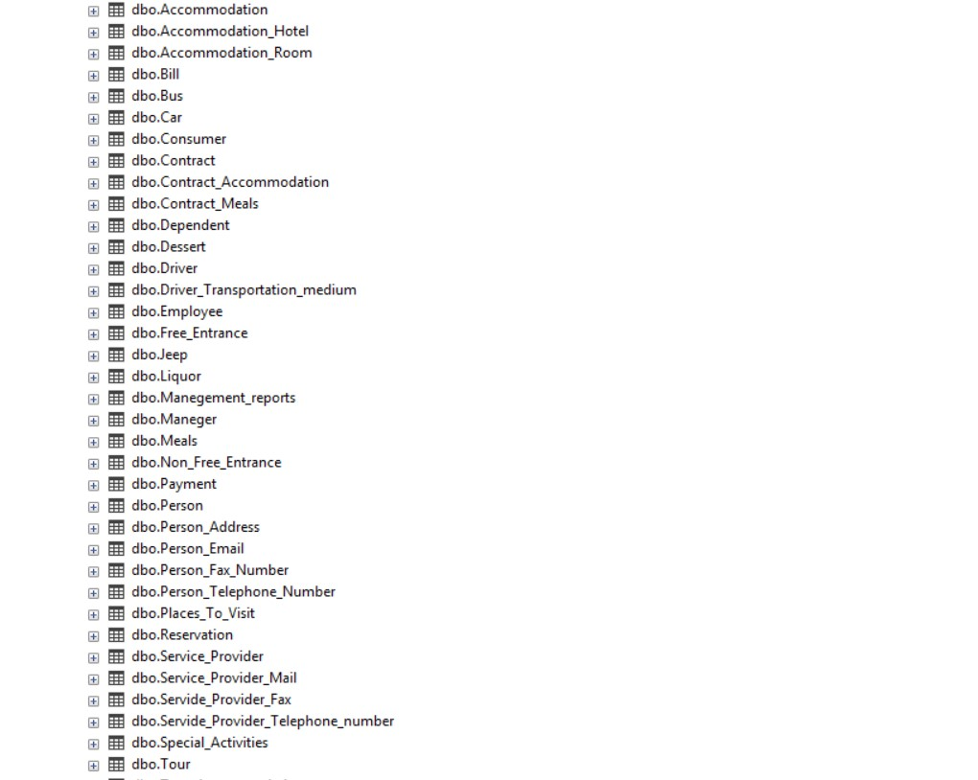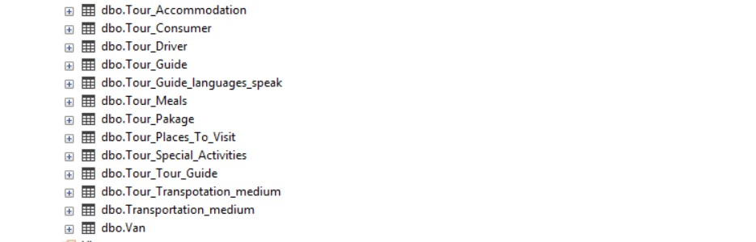

Figure 1.01

Accommodation

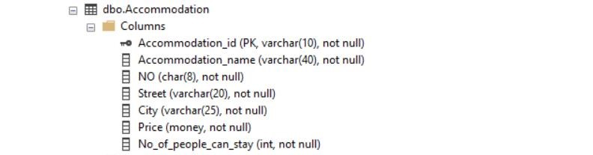

Figure 1.02

Accommodation_Hotel

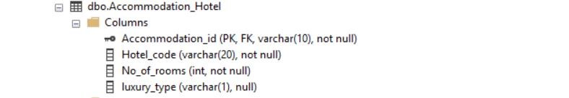

Figure 1.03

Accommodation_Room



Figure 1.04

Bill

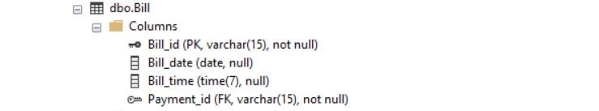

Figure 1.05

Bus

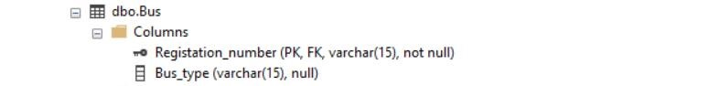

Figure 1.06

Car

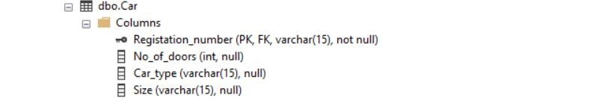

Figure 1.07

Consumer

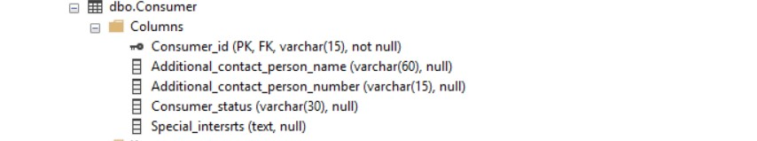

Figure 1.08

Contract

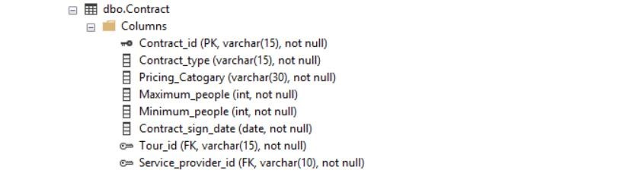

Figure 1.09

Contract_Accomodation

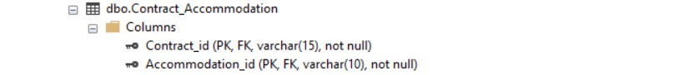

Figure 1.10

Contract_Meals

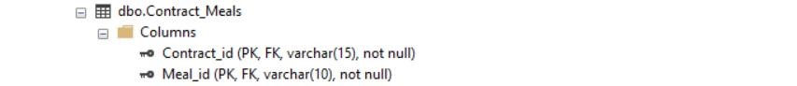

Figure 1.11

Dependent

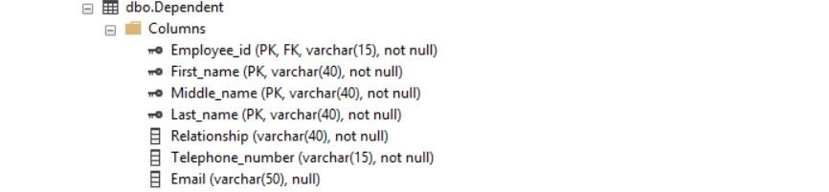

Figure 1.12

Dessert

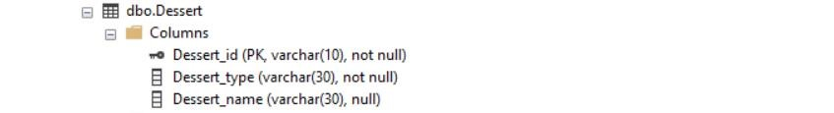

Figure 1.13

Driver

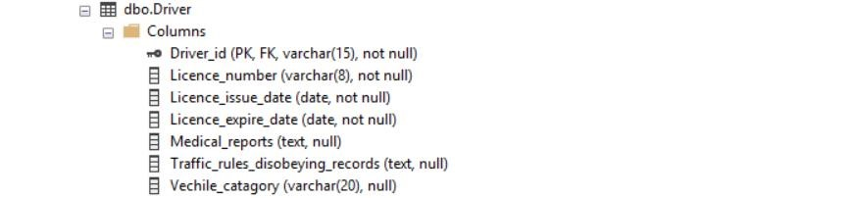

Figure 1.14

Driver_Transportation_Medium



Figure 1.15

Employee

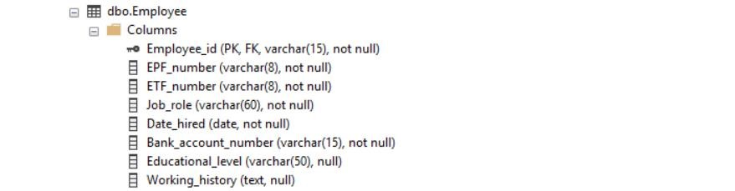

Figure 1.16

Free_Entrance

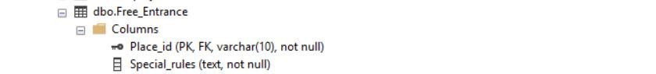

Figure 1.17

Jeep



Figure 1.18

Liquor

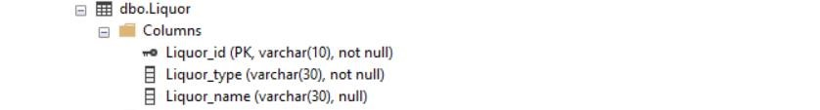

Figure 1.19

Management_Report

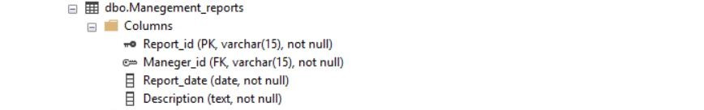

Figure 1.20

Manager



Figure 1.21

Meals

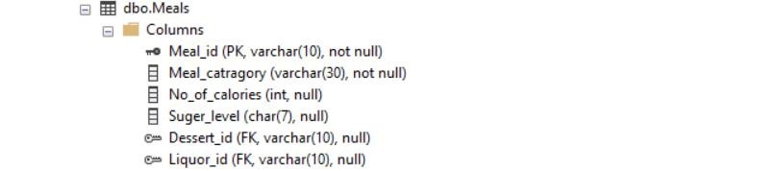

Figure 1.22

Non_Free_Entrance

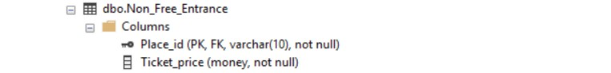

Figure 1.23

Payment

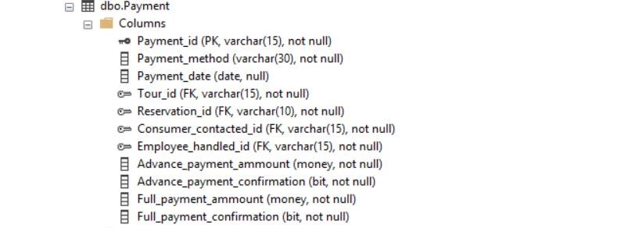

Figure 1.24

Person

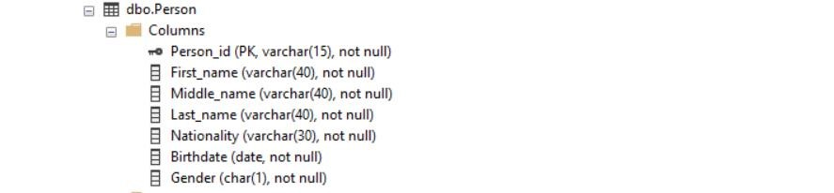

Figure 1.25

Person_Adress

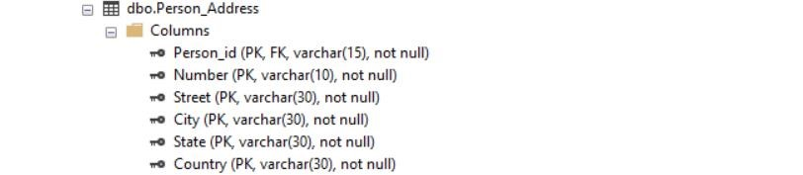

Figure 1.26

Person_Email

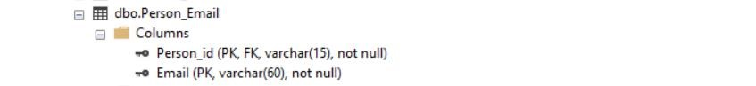

Figure 1.27

Person_Fax_Number



Figure 1.28

Person_Telephone_Number

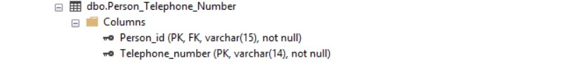

Figure 1.29

Place_To_Visit



Figure 1.30

Reservation

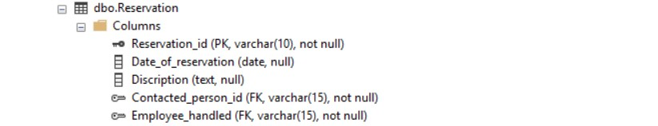

Figure 1.31

Service_Provider

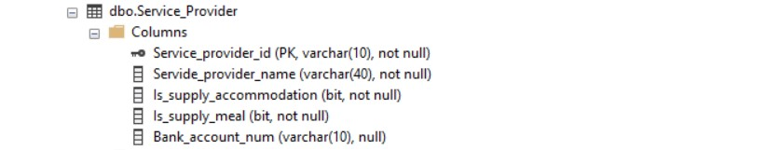

Figure 1.32

Service_Provider_Mail



Figure 1.33

Service_Provider_Fax



Figure 1.34

Service_Provider_Telephone_number



Figure 1.35

Special_Activities

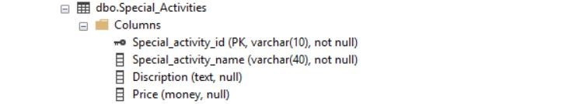

Figure 1.36

Tour

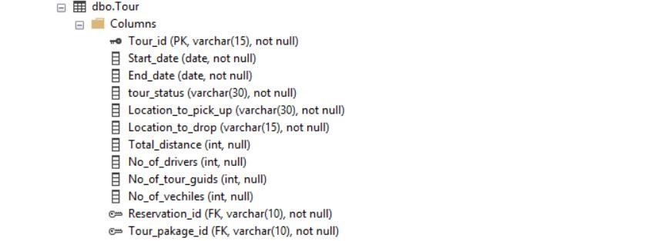

Figure 1.37

Tour_Accomodation

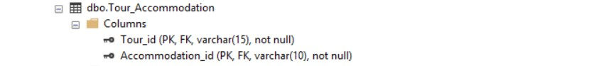

Figure 1.38

Tour_Consumer

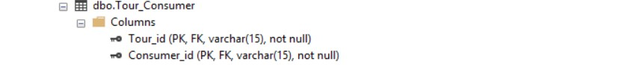

Figure 1.39

Tour_Driver

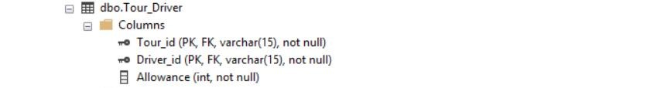

Figure 1.40

Tour_Guide



Figure 1.41

Tour_Guide_Languages_Speak



Figure 1.42

Tour_Meals

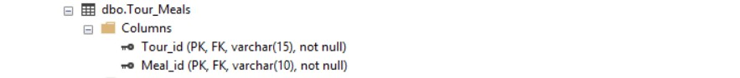

Figure 1.43

Tour_Pakage

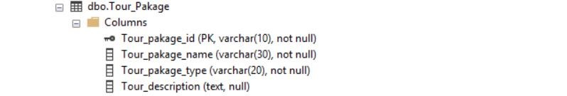

Figure 1.43

Tour_Places_To_Visit

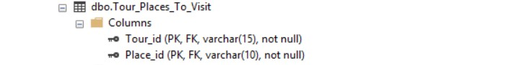

Figure 1.44

Tour_Special_Activites



Figure 1.45

Tour_Tour_Guide

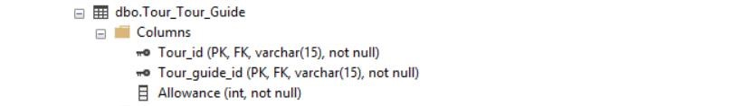

Figure 1.46

Tour_Transpotation_Medium

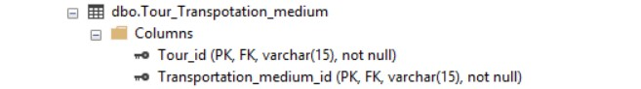

Figure 1.47

Transportation_Medium

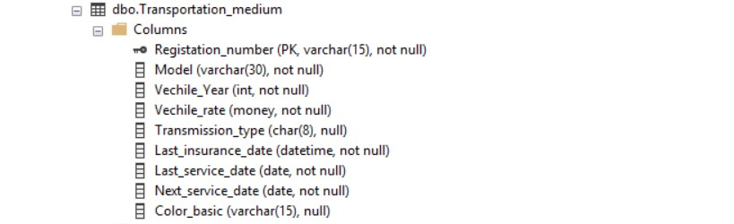

Figure 1.48

Van



Figure 1.49

# Create table statements

Accommodation

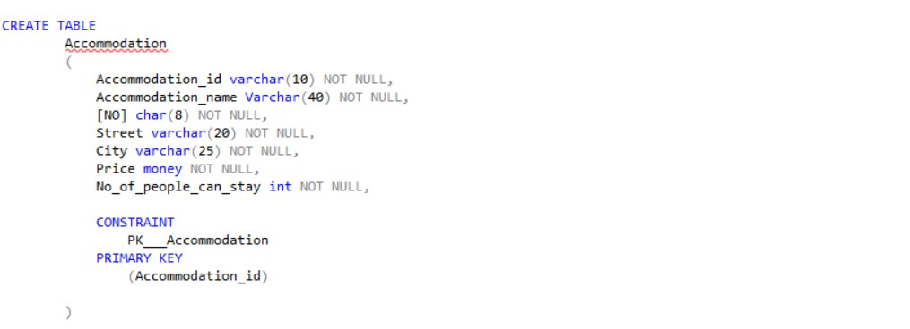

Figure 2.01

Accommodation_Hotel

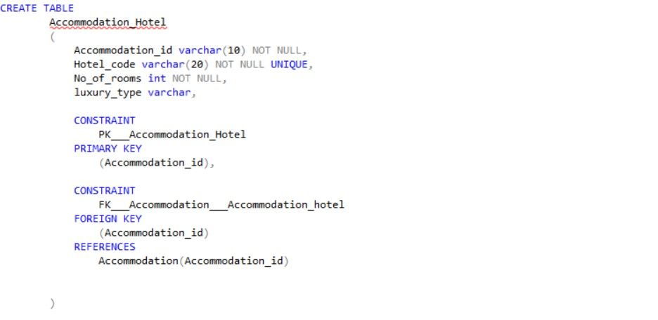

Figure 2.02

Accommodation_Room

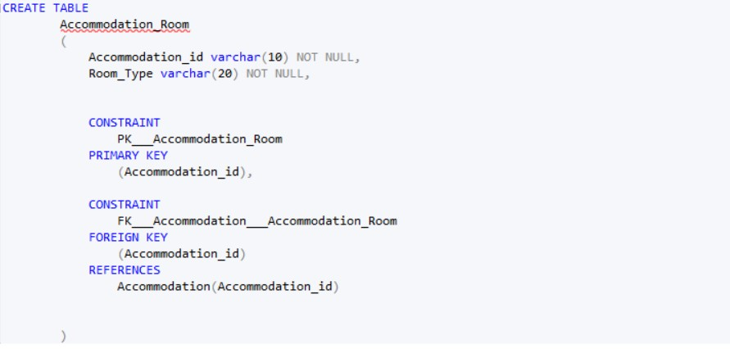

Figure 2.03

Bill

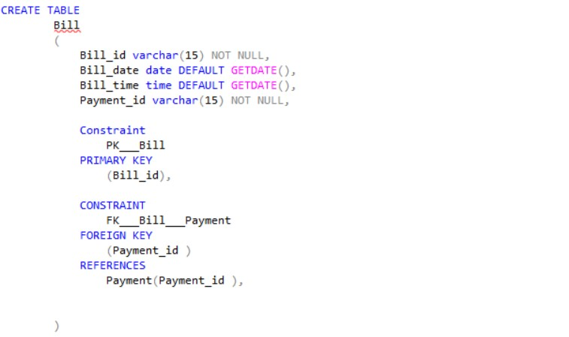

Figure 2.04

Bus

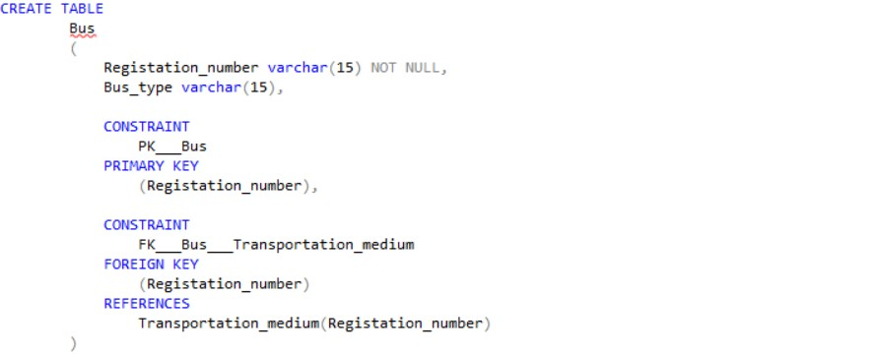

Figure 2.05

Car

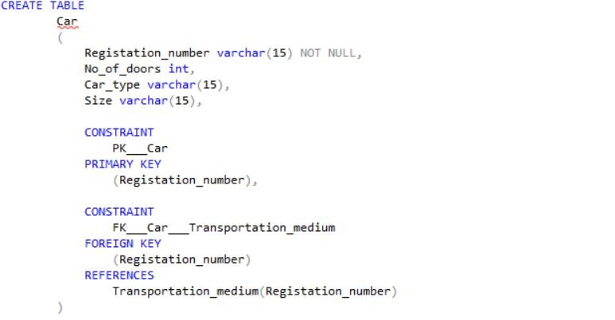

Figure 2.06

Consumer

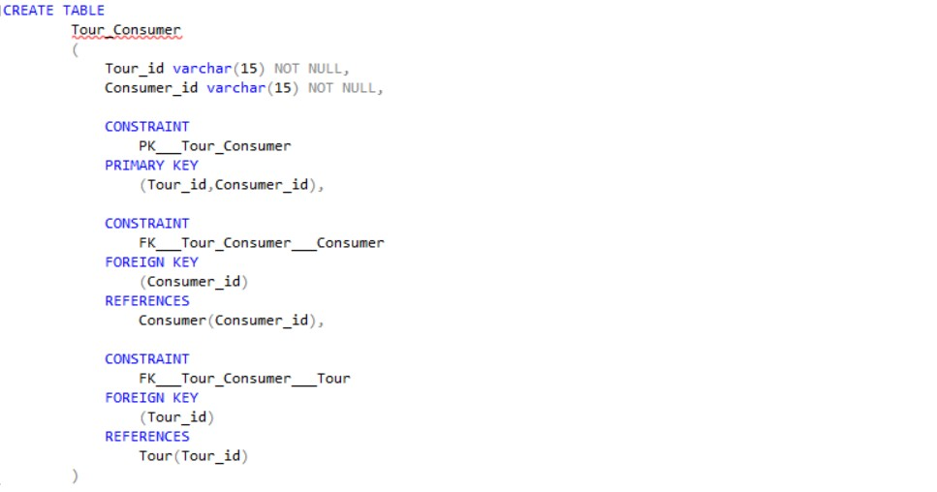

Figure 2.07

Contract

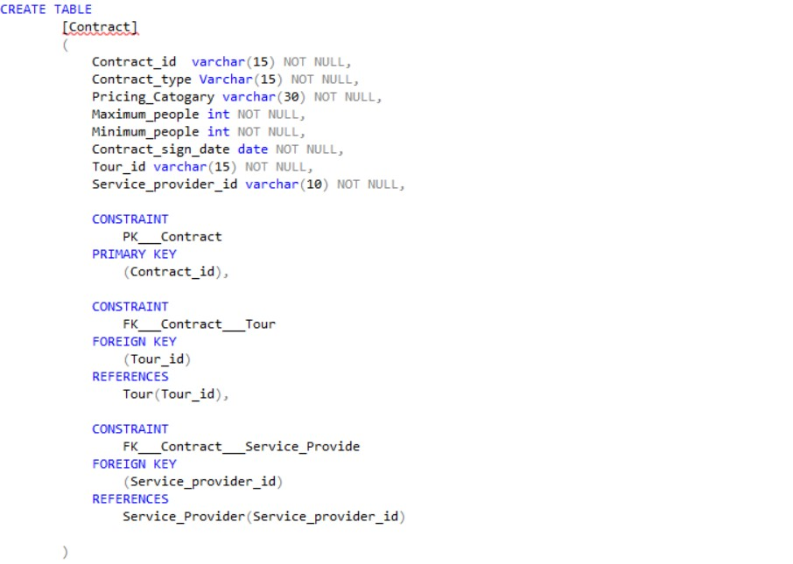

Figure 2.08

Contract_Accommodation

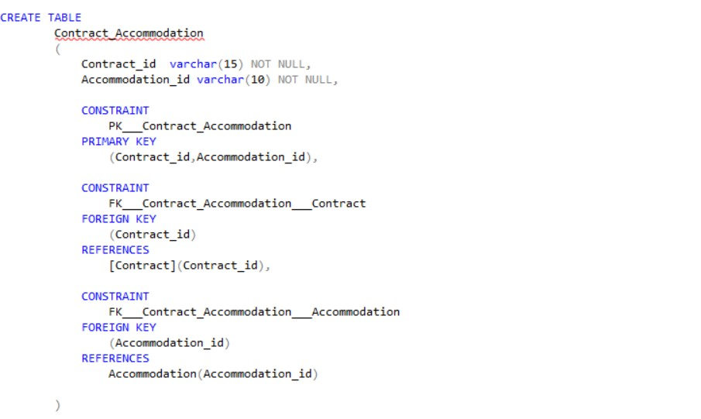

Figure 2.09

Contract_Meals

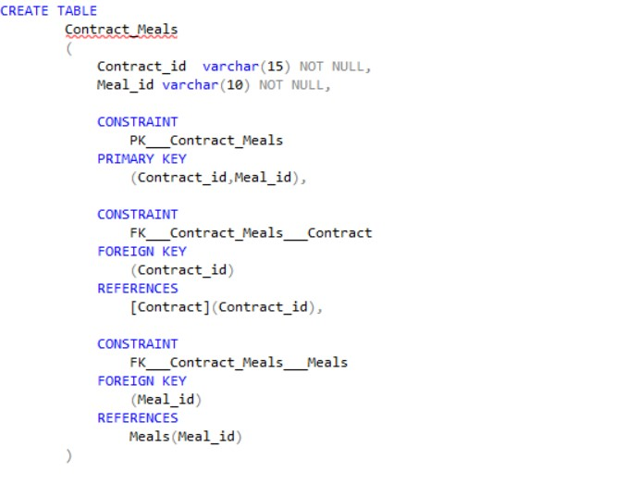

Figure 2.10

Dependent

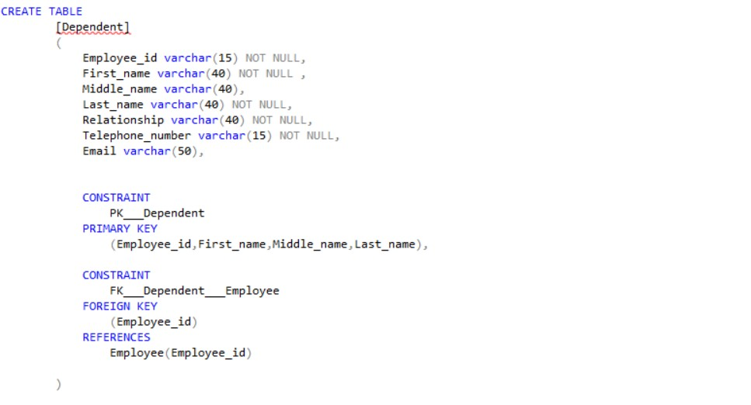

Figure 2.11

Dessert

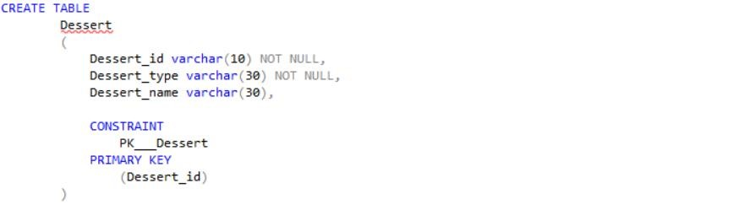

Figure 2.12

Driver

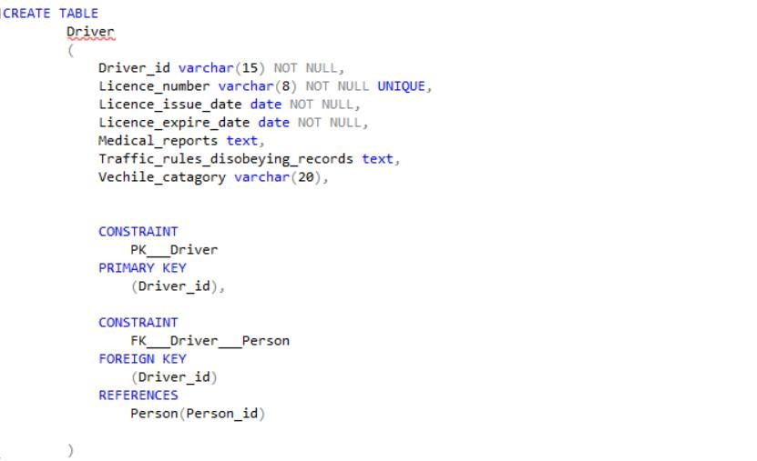

Figure 2.13

Driver_Transportation_Medium

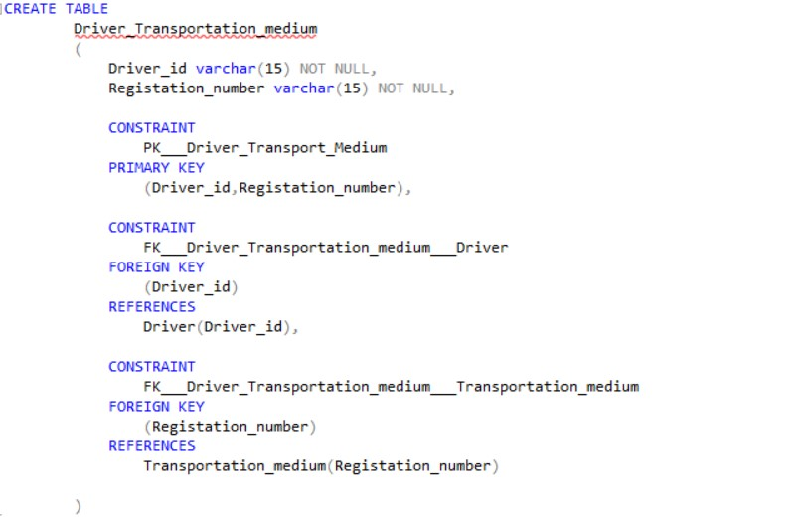

Figure 2.14

Employee

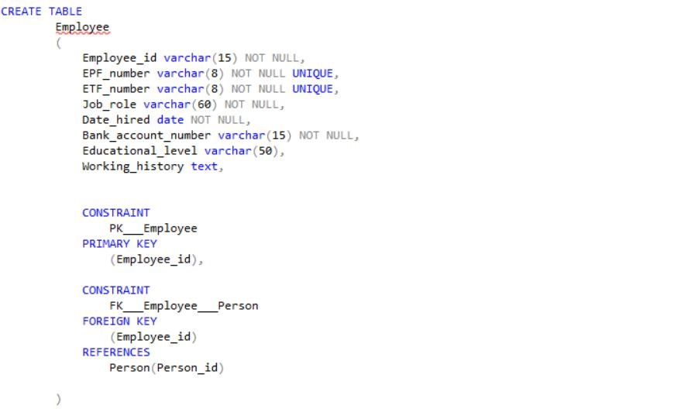

Figure 2.15

Free_Entrance

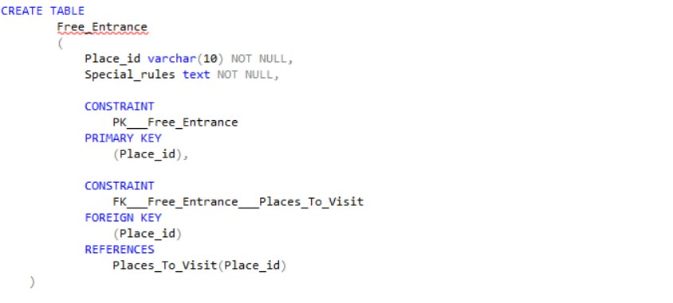

Figure 2.16

Jeep

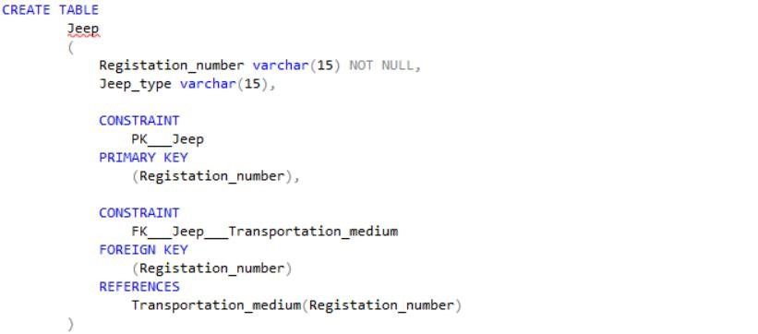

Figure 2.17

Liquor

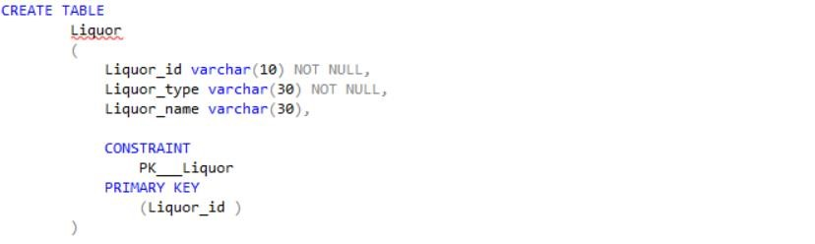

Figure 2.18

Management_Report

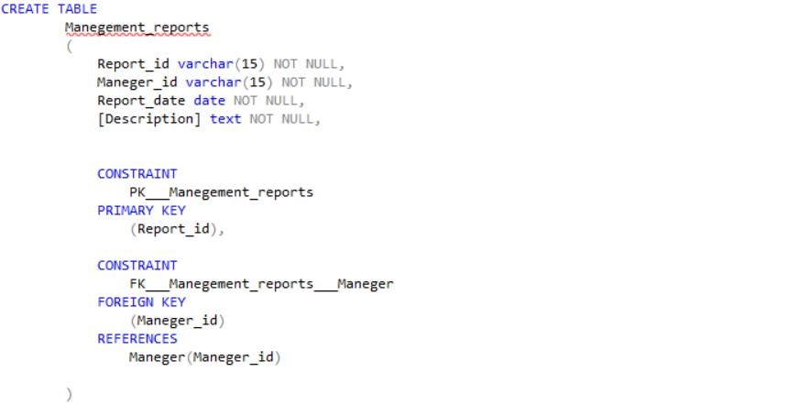

Figure 2.19

Manager

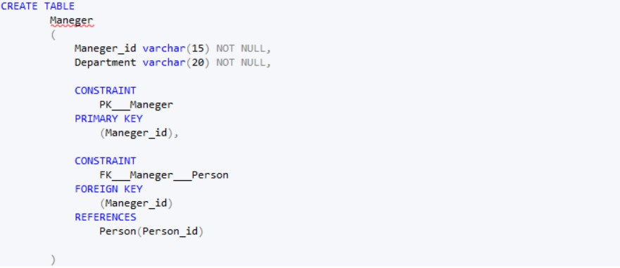

Figure 2.20

Meals

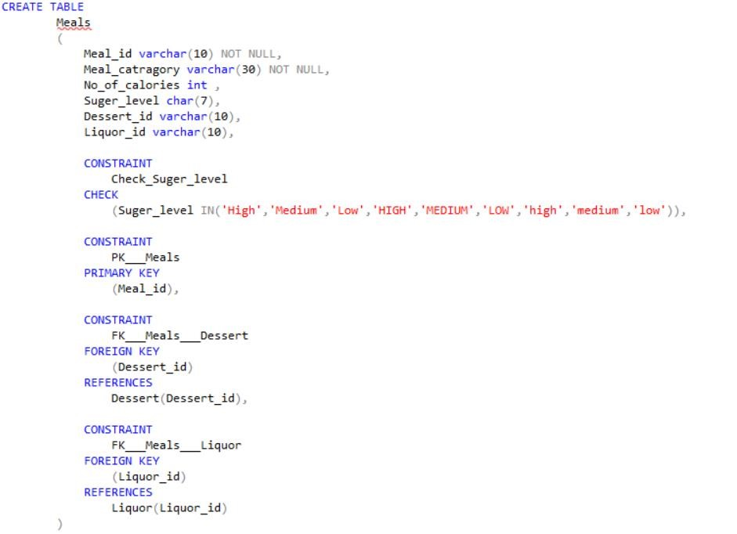

Figure 2.21

Non_Free_Entrance

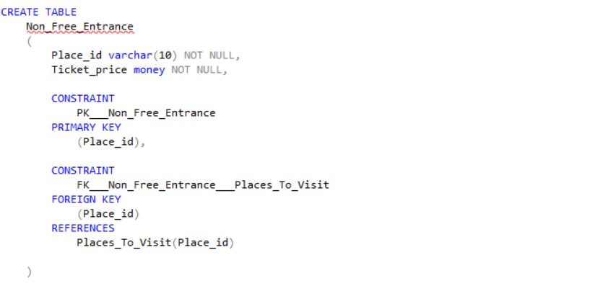

Figure 2.22

Payment

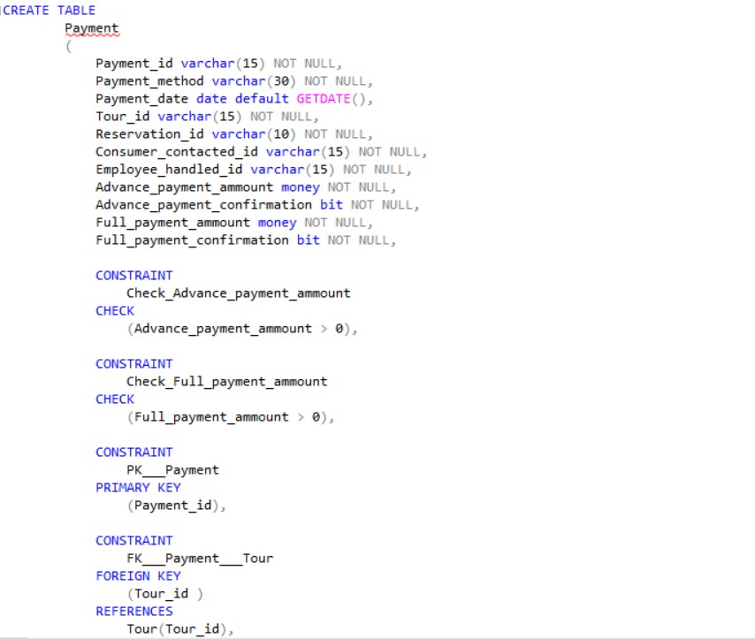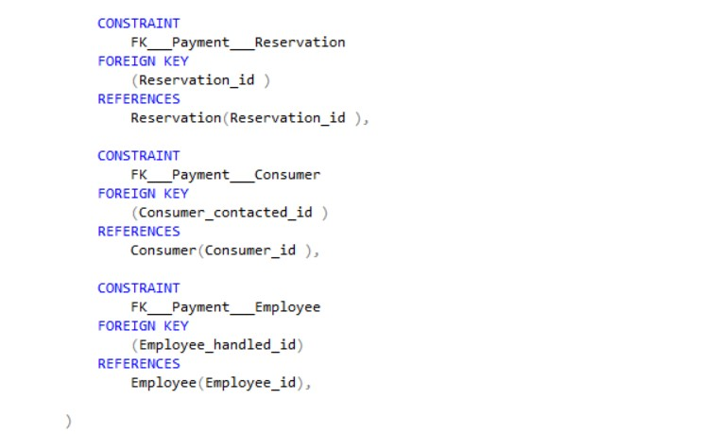

Figure 2.23

Person

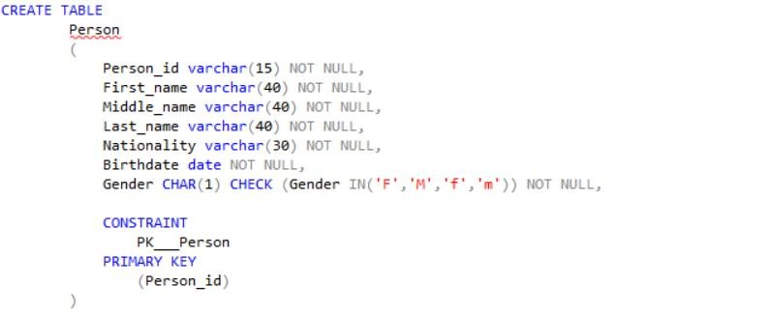

Figure 2.24

Person_Adrress

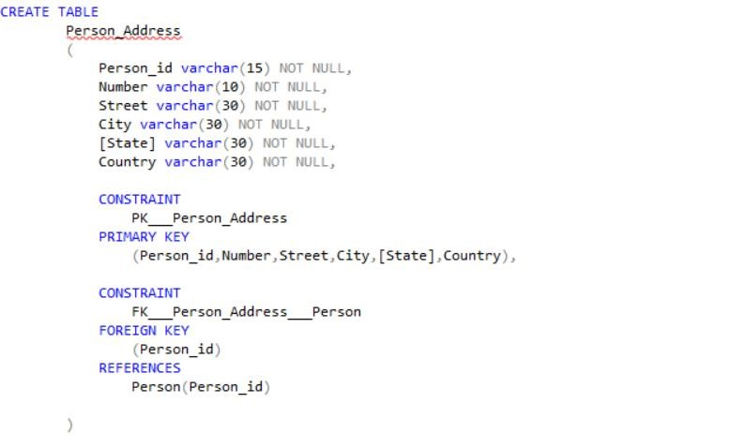

Figure 2.25

Person_Email

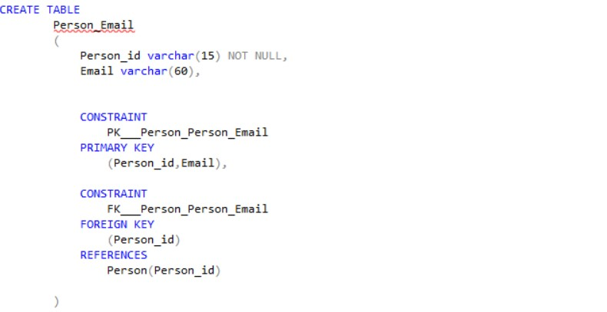

Figure 2.26

Person_Fax_Number

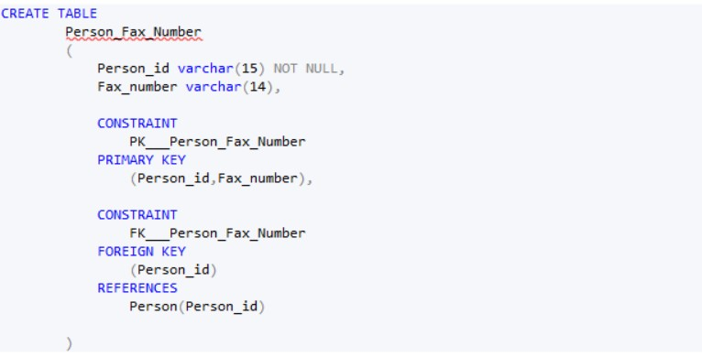

Figure 2.27

Person_Telephone_Number

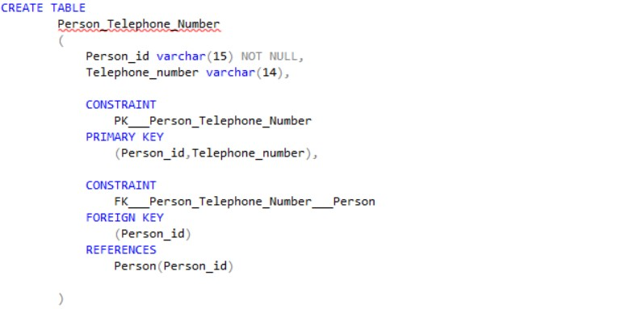

Figure 2.28

Place_To_Visit

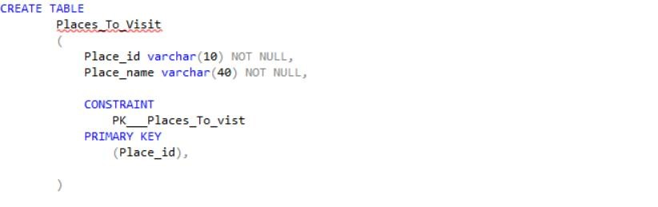

Figure 2.29

Reservation

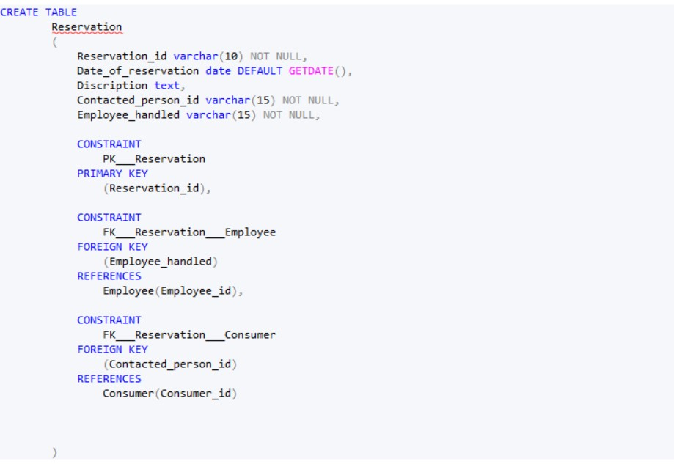

Figure 2.30

Service_Provider

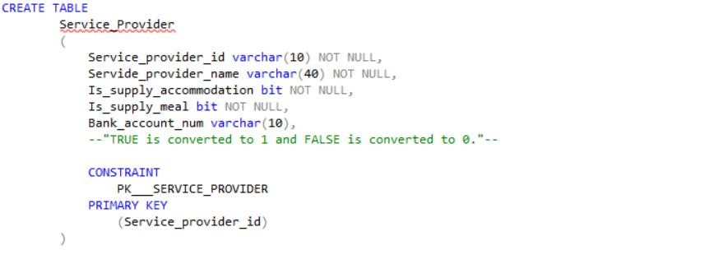

Figure 2.31

Service_Provider_Mail

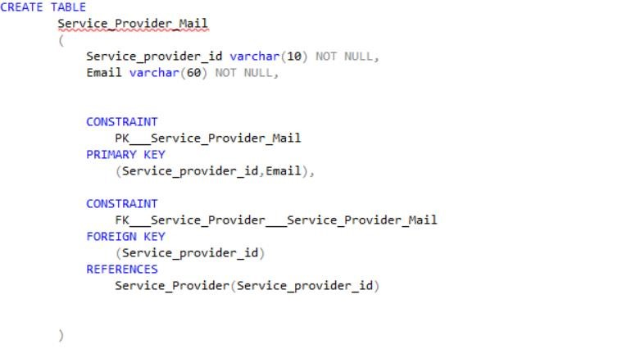

Figure 2.32

Service_Provider_Fax

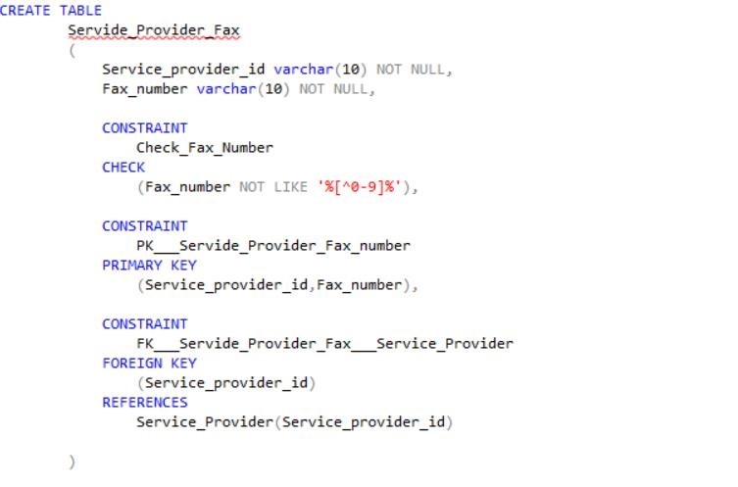

Figure 2.33

Service_Provider_Telephone_Number

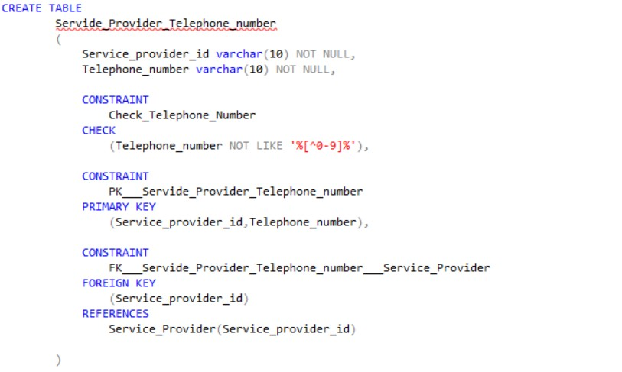

Figure 2.34

Special_Activities

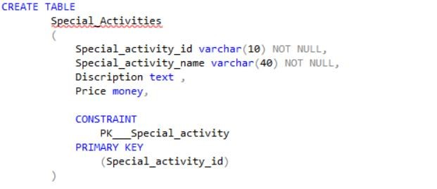

Figure 2.35

Tour

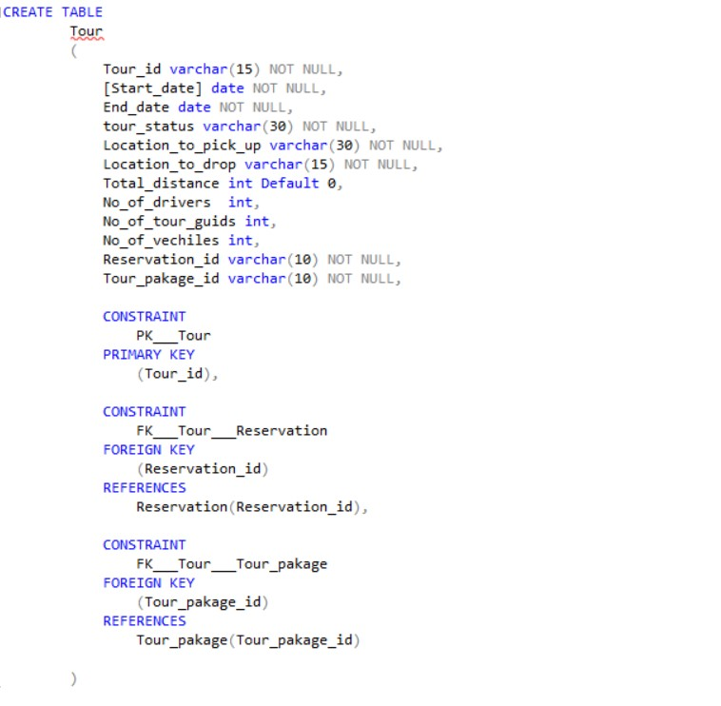

Figure 2.36

Tour_Accommodation

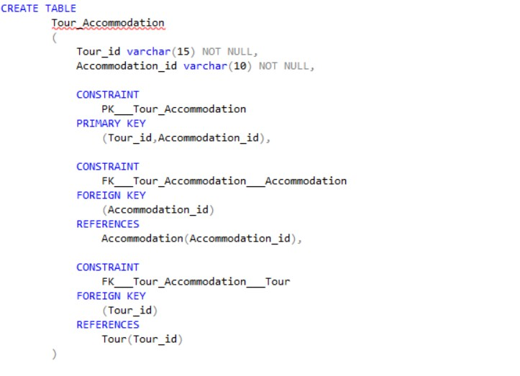

Figure 2.37

Tour_Consumer

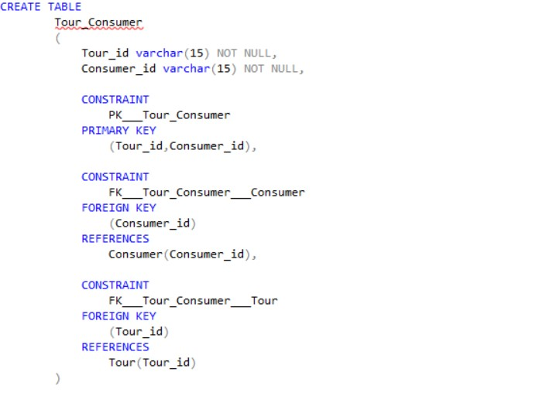

Figure 2.38

Tour_Driver

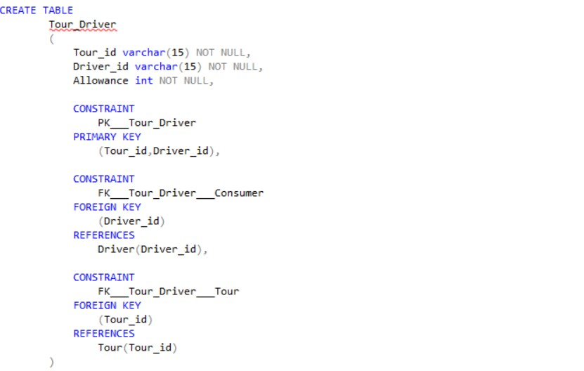

Figure 2.39

Tour_Guide

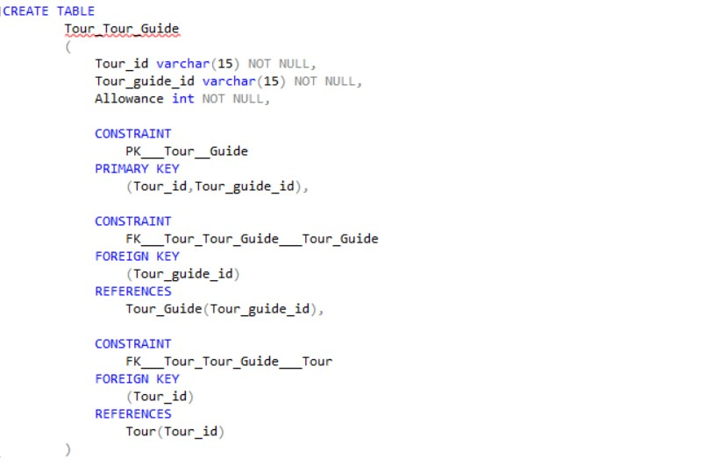

Figure 2.40

Tour_Guide_Languages_Speak

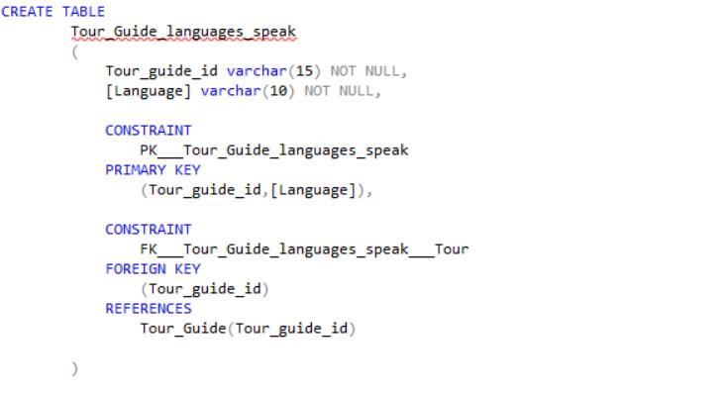

Figure 2.41

Tour_Meals

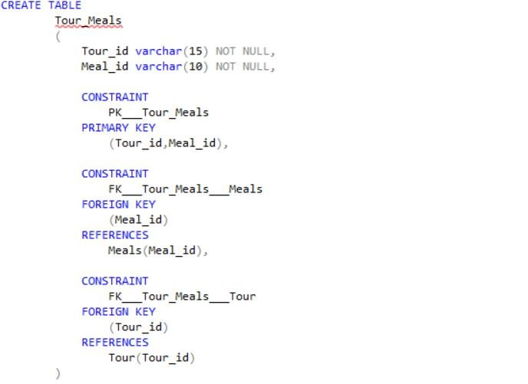

Figure 2.42

Tour_Pakage

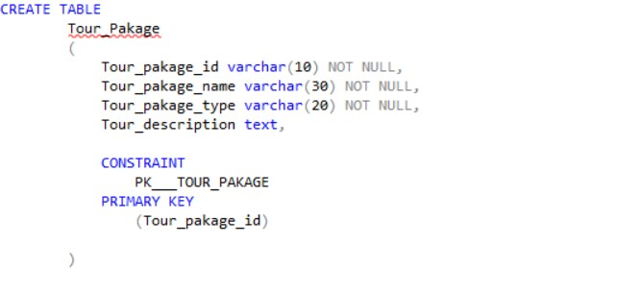

Figure 2.43

Tour_Place_To_Visit

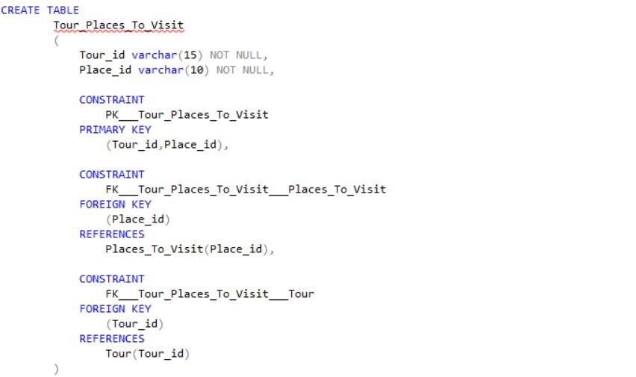

Figure 2.44

Tour_Special_Activities

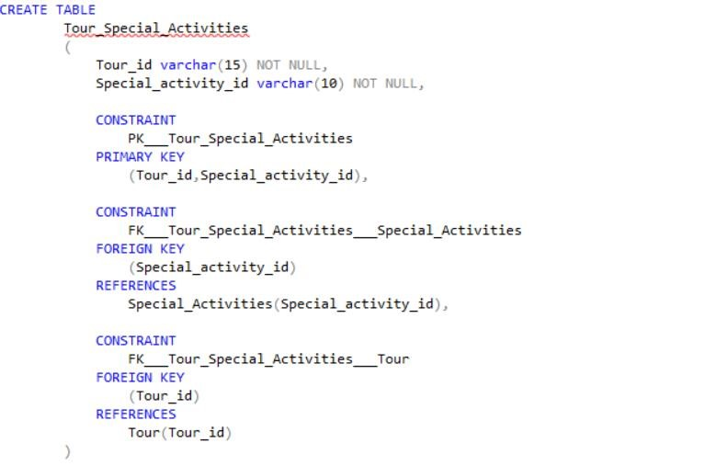

Figure 2.45

Tour_Tour_Guide

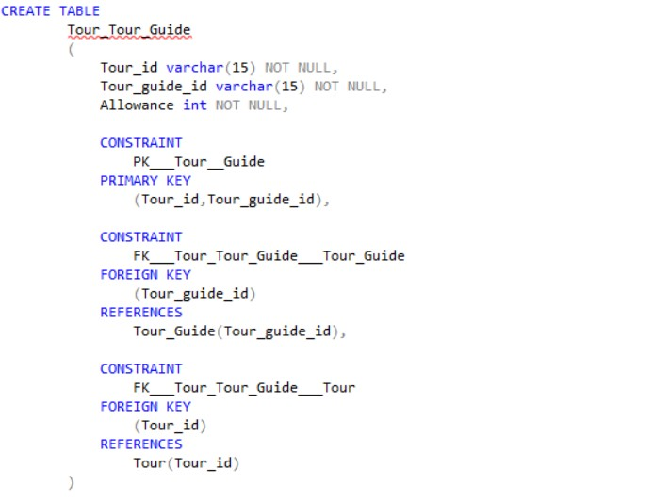

Figure 2.46

Tour_Transportation_Medium

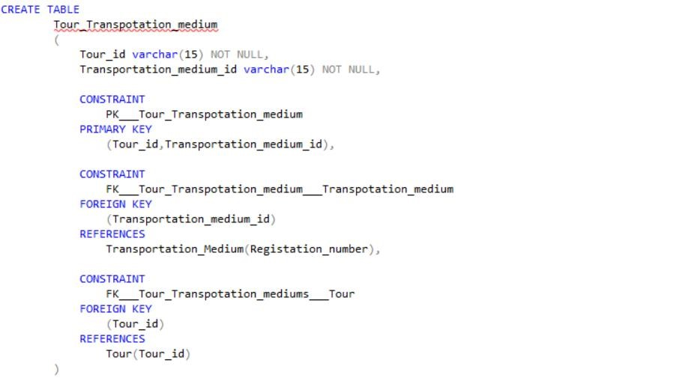

Figure 2.47

Transportation_Medium

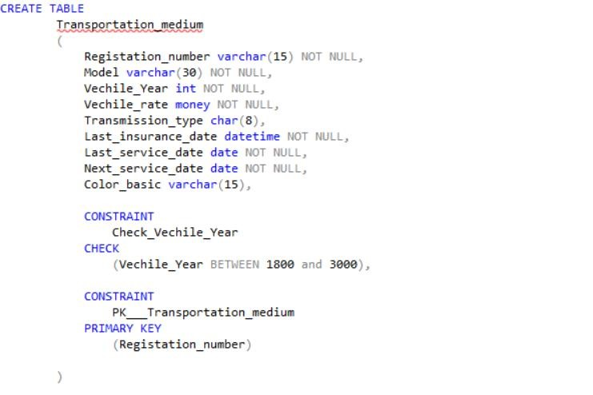

Figure 2.48

Van

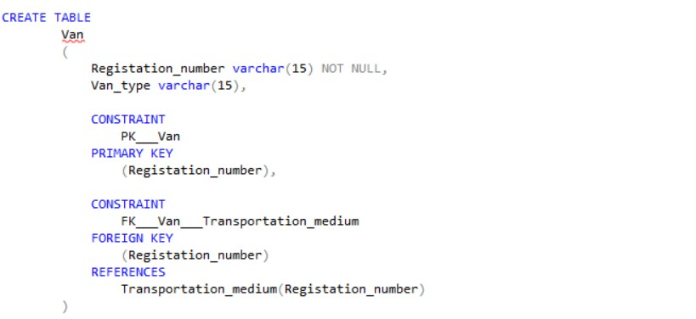

Figure 2.49

#### Data insert statements

Accommodation

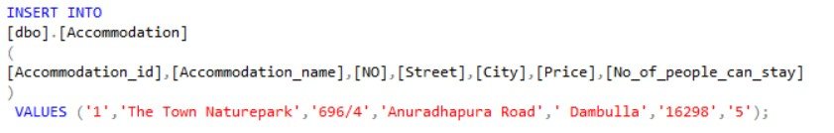

Figure 3.01

Accommodation_Hotel

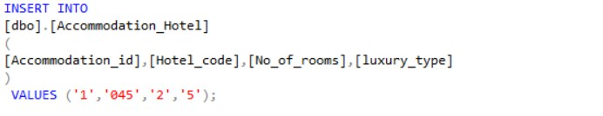

Figure 3.02

Accommodation_Room

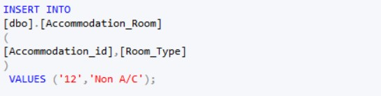

Figure 3.03

Bill

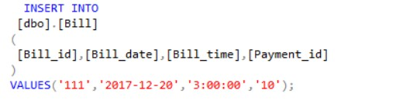

Figure 3.04

Bus

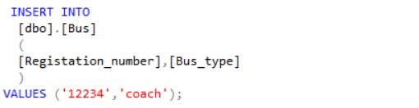

Figure 3.05

Car

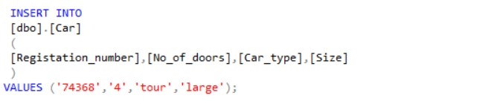

Figure 3.06

Consumer

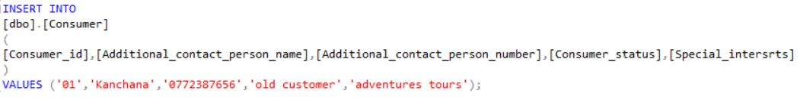

Figure 3.07

Contract

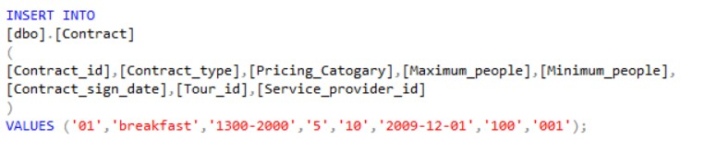

Figure 3.08

Contract_Accommodation

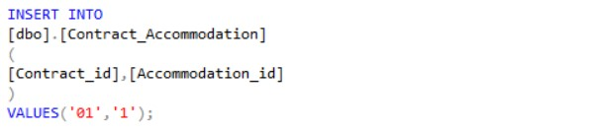

Figure 3.09

Contract_Meals

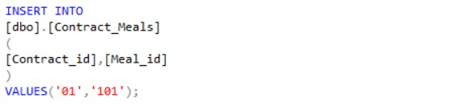

Figure 3.10

Dependent

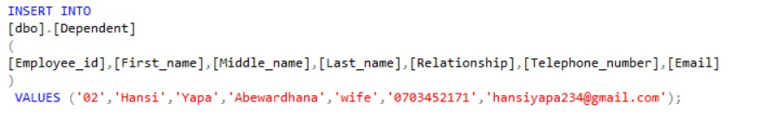

Figure 3.11

Dessert

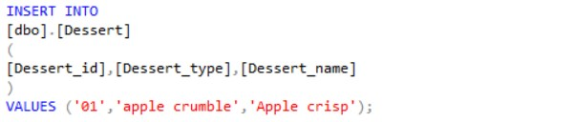

Figure 3.12

Driver

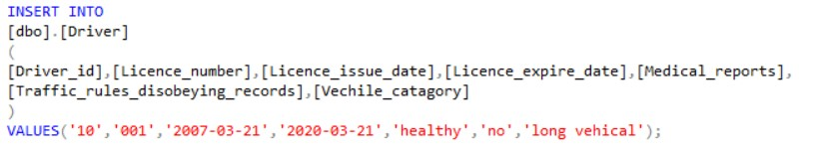

Figure 3.13

Driver_Transportation_Medium

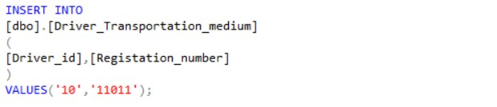

Figure 3.14

Employee

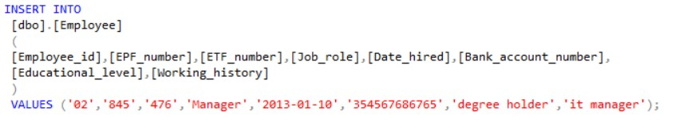

Figure 3.15

Free_Entrance

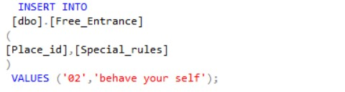

Figure 3.16

Jeep

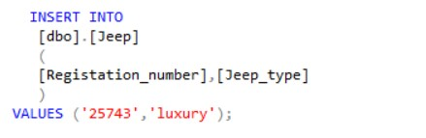

Figure 3.17

Liquor

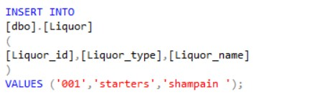

Figure 3.18

Management_Report

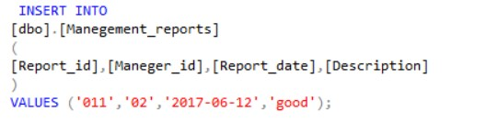

Figure 3.19

Manager

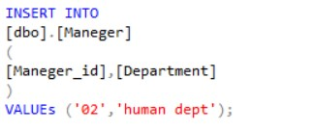

Figure 3.20

Meals

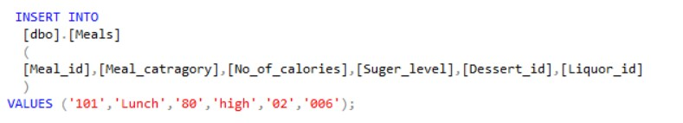

Figure 3.21

Non_Free_Entrance

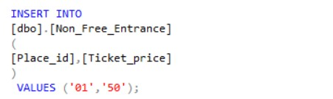

Figure 3.22

Payment

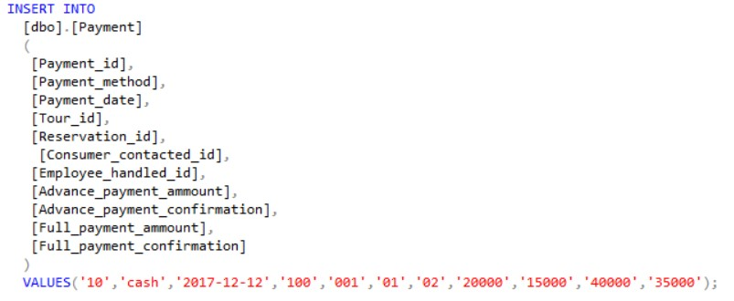

Figure 3.23

Person

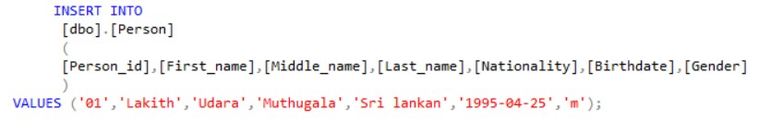

Figure 3.24

Person_Adrress

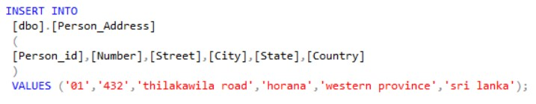

Figure 3.25

Person_Email

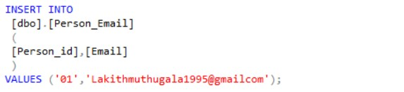

Figure 3.26

Person_Fax_Number

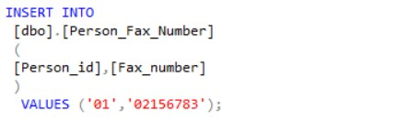

Figure 3.27

Person_Telephone_Number

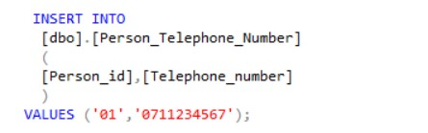

Figure 3.28

Place_To_Visit

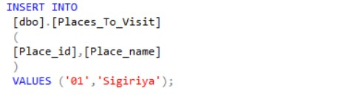

Figure 3.29

Reservation

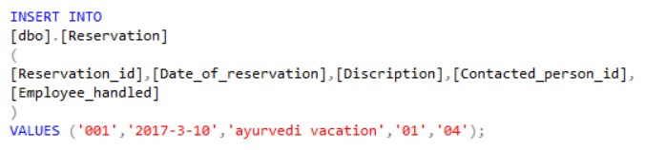

Figure 3.30

Service_Provider

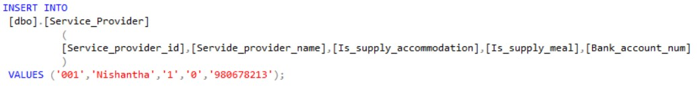

Figure 3.31

Service_Provider_Mail

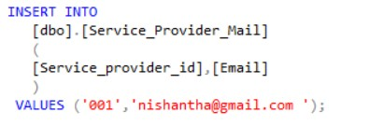

Figure 3.32

Service_Provider_Fax

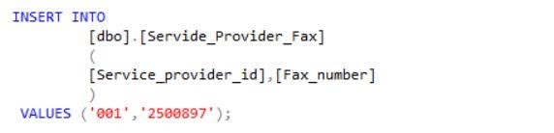

Figure 3.33

Service_Provider_Telephone_Number

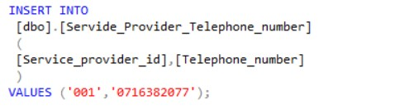

Figure 3.34

Special_Activities

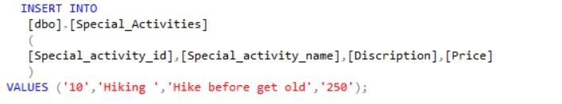

Figure 3.35

Tour

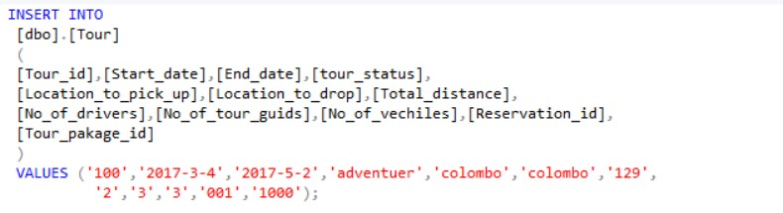

Figure 3.36

Tour_Accommodation

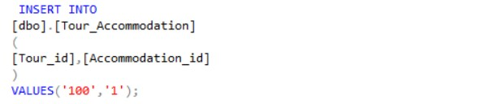

Figure 3.37

Tour_Consumer

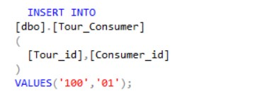

Figure 3.38

Tour_Driver

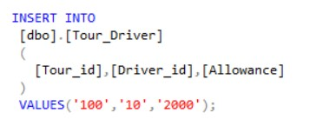

Figure 3.9

Tour_Guide

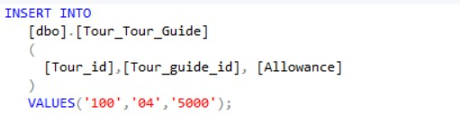

Figure 3.40

Tour_Guide_Languages_Speak

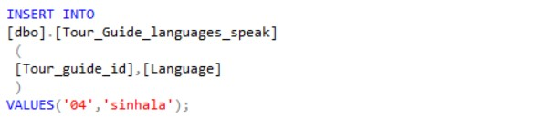

Figure 3.41

Tour_Meals

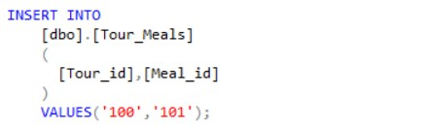

Figure 3.42

Tour_Pakage

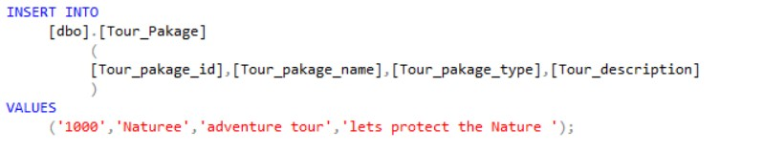

Figure 3.43

Tour_Place_To_Visit

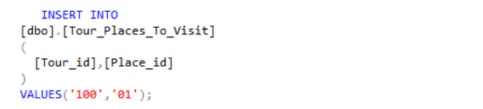

Figure 3.44

Tour_Special_Activities

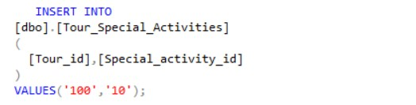

Figure 3.45

Tour_Tour_Guide

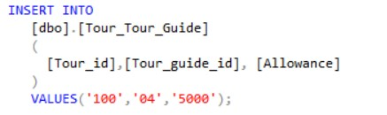

Figure 3.46

Tour_Transportation_Medium

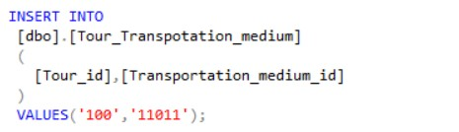

Figure 3.47

Transportation_Medium

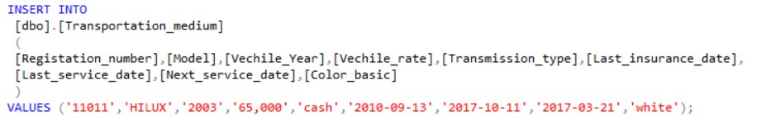

Figure 3.48

Van

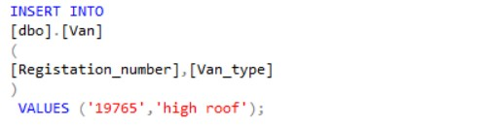

Figure 3.49

## Data base Creation and data insertion SQL statements

CREATE DATABASE

LANKA_TOURS7

GO

--------------------------------------------------------------------------------------

----------------------------

USE

LANKA_TOURS7

Go

--------------------------------------------------------------------------------------

----------------------------

CREATE TABLE

|  |  |
| --- | --- |
| Tour_Pakage | |
| ( |  |
|  | Tour_pakage_id varchar(10) NOT NULL, |
|  | Tour_pakage_name varchar(30) NOT NULL, |
|  | Tour_pakage_type varchar(20) NOT NULL, |
|  | Tour_description text, |
|  |  |
|  | CONSTRAINT |
|  | PK___TOUR_PAKAGE |
|  | PRIMARY KEY |
| ) | (Tour_pakage_id) |

--------------------------------------------------------------------------------------

-----------------------------

CREATE TABLE

Service_Provider

(

Service_provider_id varchar(10) NOT NULL,

Servide_provider_name varchar(40) NOT NULL,

Is_supply_accommodation bit NOT NULL,

Is_supply_meal bit NOT NULL,

Bank_account_num varchar(10),

--"TRUE is converted to 1 and FALSE is converted to 0."--

CONSTRAINT

PK___SERVICE_PROVIDER

PRIMARY KEY

(Service_provider_id)

)

--------------------------------------------------------------------------------------

-----------------------------

CREATE TABLE

Servide_Provider_Telephone_number

(

Service_provider_id varchar(10) NOT NULL,

Telephone_number varchar(10) NOT NULL,

CONSTRAINT

Check_Telephone_Number

CHECK

(Telephone_number NOT LIKE '%[^0-9]%'),

CONSTRAINT

PK___Servide_Provider_Telephone_number

PRIMARY KEY

(Service_provider_id,Telephone_number),

CONSTRAINT

FK___Servide_Provider_Telephone_number___Service_Provider

FOREIGN KEY

(Service_provider_id)

REFERENCES

Service_Provider(Service_provider_id)

)

--------------------------------------------------------------------------------------

----------------------------

CREATE TABLE

Service_Provider_Mail

(

Service_provider_id varchar(10) NOT NULL,

Email varchar(60) NOT NULL,

CONSTRAINT

PK___Service_Provider_Mail

PRIMARY KEY

(Service_provider_id,Email),

CONSTRAINT

FK___Service_Provider___Service_Provider_Mail

FOREIGN KEY

(Service_provider_id)

REFERENCES

Service_Provider(Service_provider_id)

)

--------------------------------------------------------------------------------------

-----------------------------

CREATE TABLE

Servide_Provider_Fax

(

Service_provider_id varchar(10) NOT NULL,

Fax_number varchar(10) NOT NULL,

CONSTRAINT

Check_Fax_Number

CHECK

(Fax_number NOT LIKE '%[^0-9]%'),

CONSTRAINT

PK___Servide_Provider_Fax_number

PRIMARY KEY

(Service_provider_id,Fax_number),

CONSTRAINT

FK___Servide_Provider_Fax___Service_Provider

FOREIGN KEY

(Service_provider_id)

REFERENCES

Service_Provider(Service_provider_id)

)

--------------------------------------------------------------------------------------

------------------------------

CREATE TABLE

|  |  |
| --- | --- |
| Accommodation | |
| ( |  |
|  | Accommodation_id varchar(10) NOT NULL, |
|  | Accommodation_name Varchar(40) NOT NULL, |
|  | [NO] char(8) NOT NULL, |
|  | Street varchar(20) NOT NULL, |
|  | City varchar(25) NOT NULL, |
|  | Price money NOT NULL, |
|  | No_of_people_can_stay int NOT NULL, |
|  | CONSTRAINT |
|  | PK___Accommodation |
|  | PRIMARY KEY |
|  | (Accommodation_id) |
| ) |  |

--------------------------------------------------------------------------------------

------------------------------

--Accommodation ->

Accommodation_hotel--

CREATE TABLE

Accommodation_Hotel

(

Accommodation_id varchar(10) NOT NULL,

Hotel_code varchar(20) NOT NULL UNIQUE, No_of_rooms int NOT NULL,

luxury_type varchar,

CONSTRAINT

PK___Accommodation_Hotel

PRIMARY KEY

(Accommodation_id),

CONSTRAINT

FK___Accommodation___Accommodation_hotel

FOREIGN KEY

(Accommodation_id)

REFERENCES

Accommodation(Accommodation_id)

)

--------------------------------------------------------------------------------------

-----------------------------

--Accommodation -

>Accommodation_room--

CREATE TABLE

Accommodation_Room

(

Accommodation_id varchar(10) NOT NULL,

Room_Type varchar(20) NOT NULL,

CONSTRAINT

PK___Accommodation_Room

PRIMARY KEY

(Accommodation_id),

CONSTRAINT

FK___Accommodation___Accommodation_Room

FOREIGN KEY

(Accommodation_id)

REFERENCES

Accommodation(Accommodation_id)

)

--------------------------------------------------------------------------------------

------------------------------

CREATE TABLE

Places_To_Visit

(

Place_id varchar(10) NOT NULL,

Place_name varchar(40) NOT NULL,

CONSTRAINT

PK___Places_To_vist

PRIMARY KEY

(Place_id),

)

--------------------------------------------------------------------------------------

-----------------------------

--Places_To_Visit -> Non_free_entance-

-

CREATE TABLE

Non_Free_Entrance

(

Place_id varchar(10) NOT NULL,

Ticket_price money NOT NULL,

CONSTRAINT

PK___Non_Free_Entrance

PRIMARY KEY

(Place_id),

CONSTRAINT

FK___Non_Free_Entrance___Places_To_Visit

FOREIGN KEY

(Place_id)

REFERENCES

Places_To_Visit(Place_id)

)

--------------------------------------------------------------------------------------

-----------------------------

--Places_To_Visit -> Non_free_entance-

-

CREATE TABLE

Free_Entrance

(

Place_id varchar(10) NOT NULL,

Special_rules text NOT NULL,

CONSTRAINT

PK___Free_Entrance

PRIMARY KEY

(Place_id),

CONSTRAINT

FK___Free_Entrance___Places_To_Visit

FOREIGN KEY

(Place_id)

REFERENCES

Places_To_Visit(Place_id)

)

--------------------------------------------------------------------------------------

-----------------------------

CREATE TABLE

Special_Activities

(

Special_activity_id varchar(10) NOT NULL,

Special_activity_name varchar(40) NOT NULL,

Discription text ,

Price money,

CONSTRAINT

PK___Special_activity

PRIMARY KEY

(Special_activity_id)

)

--------------------------------------------------------------------------------------

-----------------------------

CREATE TABLE

Dessert

(

Dessert_id varchar(10) NOT NULL,

Dessert_type varchar(30) NOT NULL,

Dessert_name varchar(30),

CONSTRAINT

PK___Dessert

PRIMARY KEY

(Dessert_id)

) --------------------------------------------------------------------------------------

-----------------------------

CREATE TABLE

Liquor

(

Liquor_id varchar(10) NOT NULL,

Liquor_type varchar(30) NOT NULL,

Liquor_name varchar(30),

CONSTRAINT

PK___Liquor

PRIMARY KEY

(Liquor_id )

)

--------------------------------------------------------------------------------------

-----------------------------

CREATE TABLE

Meals

(

Meal_id varchar(10) NOT NULL,

Meal_catragory varchar(30) NOT NULL,

No_of_calories int ,

Suger_level char(7),

Dessert_id varchar(10),

Liquor_id varchar(10),

CONSTRAINT

Check_Suger_level

CHECK

(Suger_level

IN('High','Medium','Low','HIGH','MEDIUM','LOW','high','medium','low')),

CONSTRAINT

PK___Meals

PRIMARY KEY

(Meal_id),

CONSTRAINT

FK___Meals___Dessert

FOREIGN KEY

(Dessert_id)

REFERENCES

Dessert(Dessert_id),

CONSTRAINT

FK___Meals___Liquor

FOREIGN KEY

(Liquor_id) REFERENCES

Liquor(Liquor_id)

)

--------------------------------------------------------------------------------------

-----------------------------

CREATE TABLE

Transportation_medium

(

Registation_number varchar(15) NOT NULL,

Model varchar(30) NOT NULL, Vechile_Year int NOT NULL,

Vechile_rate money NOT NULL,

Transmission_type char(8),

Last_insurance_date datetime NOT NULL,

Last_service_date date NOT NULL,

Next_service_date date NOT NULL,

Color_basic varchar(15),

CONSTRAINT

Check_Vechile_Year

CHECK

(Vechile_Year BETWEEN 1800 and 3000),

CONSTRAINT

PK___Transportation_medium

PRIMARY KEY

(Registation_number)

)

--------------------------------------------------------------------------------------

-----------------------------

|  |  |
| --- | --- |
| --    CREATE TABLE  Car  ( | -- Transportation_medium -> Car |
|  | Registation_number varchar(15) NOT NULL, |
|  | No_of_doors int, |
|  | Car_type varchar(15), |
|  | Size varchar(15), |
|  | CONSTRAINT |
|  | PK___Car |
|  | PRIMARY KEY |
|  | (Registation_number), |
|  | CONSTRAINT |
|  | FK___Car___Transportation_medium |
|  | FOREIGN KEY |
|  | (Registation_number) |
|  | REFERENCES |
| ) | Transportation_medium(Registation_number) |

--------------------------------------------------------------------------------------

-----------------------------

|  |  |
| --- | --- |
| --    CREATE TABLE  Van  ( | -- Transportation_medium -> Van |
|  | Registation_number varchar(15) NOT NULL, |
|  | Van_type varchar(15), |
|  | CONSTRAINT |
|  | PK___Van |
|  | PRIMARY KEY |
|  | (Registation_number), |
|  | CONSTRAINT  FK___Van___Transportation_medium |

FOREIGN KEY

(Registation_number)

REFERENCES

Transportation_medium(Registation_number)

)

--------------------------------------------------------------------------------------

------------------------------

|  |  |
| --- | --- |
| Jeep --    CREATE TABLE  Jeep  ( | -- Transportation_medium -> |
|  | Registation_number varchar(15) NOT NULL, |
|  | Jeep_type varchar(15), |
|  | CONSTRAINT |
|  | PK___Jeep |
|  | PRIMARY KEY |
|  | (Registation_number), |
|  | CONSTRAINT |
|  | FK___Jeep___Transportation_medium |
|  | FOREIGN KEY |
|  | (Registation_number) |
|  | REFERENCES |
| ) | Transportation_medium(Registation_number) |

--------------------------------------------------------------------------------------

------------------------------

|  |  |
| --- | --- |
| --    CREATE TABLE  Bus  ( | -- Transportation_medium -> Bus |
|  | Registation_number varchar(15) NOT NULL, |
|  | Bus_type varchar(15), |
|  | CONSTRAINT |
|  | PK___Bus |
|  | PRIMARY KEY |
|  | (Registation_number), |
|  | CONSTRAINT |
|  | FK___Bus___Transportation_medium |
|  | FOREIGN KEY |
|  | (Registation_number) |
|  | REFERENCES |
| ) | Transportation_medium(Registation_number) |

--------------------------------------------------------------------------------------

------------------------------

CREATE TABLE

Person

(

Person_id varchar(15) NOT NULL,

First_name varchar(40) NOT NULL,

Middle_name varchar(40) NOT NULL,

Last_name varchar(40) NOT NULL,

Nationality varchar(30) NOT NULL,

Birthdate date NOT NULL,

Gender CHAR(1) CHECK (Gender IN('F','M','f','m')) NOT NULL,

CONSTRAINT

PK___Person

PRIMARY KEY

(Person_id)

)

--------------------------------------------------------------------------------------

------------------------------

CREATE TABLE

Person_Address

(

Person_id varchar(15) NOT NULL,

Number varchar(10) NOT NULL,

Street varchar(30) NOT NULL,

City varchar(30) NOT NULL,

[State] varchar(30) NOT NULL,

Country varchar(30) NOT NULL,

CONSTRAINT

PK___Person_Address

PRIMARY KEY

(Person_id,Number,Street,City,[State],Country),

CONSTRAINT

FK___Person_Address___Person

FOREIGN KEY

(Person_id)

REFERENCES

Person(Person_id)

)

--------------------------------------------------------------------------------------

------------------------------

CREATE TABLE

Person_Telephone_Number

(

Person_id varchar(15) NOT NULL,

Telephone_number varchar(14),

CONSTRAINT

PK___Person_Telephone_Number

PRIMARY KEY

(Person_id,Telephone_number),

CONSTRAINT

FK___Person_Telephone_Number___Person

FOREIGN KEY

(Person_id) REFERENCES

Person(Person_id)

)

-------------------------------------------------------------------------------------------------------------------

CREATE TABLE

Person_Fax_Number

(

Person_id varchar(15) NOT NULL,

Fax_number varchar(14),

CONSTRAINT

PK___Person_Fax_Number

PRIMARY KEY

(Person_id,Fax_number),

CONSTRAINT

FK___Person_Fax_Number

FOREIGN KEY

(Person_id)

REFERENCES

Person(Person_id)

)

--------------------------------------------------------------------------------------

------------------------------

CREATE TABLE

Person_Email

(

Person_id varchar(15) NOT NULL,

Email varchar(60),

CONSTRAINT

PK___Person_Person_Email

PRIMARY KEY

(Person_id,Email),

CONSTRAINT

FK___Person_Person_Email

FOREIGN KEY

(Person_id)

REFERENCES

Person(Person_id)

)

--------------------------------------------------------------------------------------

-----------------------------

--

Person->Consumer --

CREATE TABLE

Consumer

(

Consumer_id varchar(15) NOT NULL,

Additional_contact_person_name varchar(60),

Additional_contact_person_number varchar(15),

Consumer_status varchar(30),

Special_intersrts text,

CONSTRAINT PK___Consumer

PRIMARY KEY

(Consumer_id),

CONSTRAINT

FK___Consumer___Person

FOREIGN KEY

(Consumer_id)

REFERENCES

Person(Person_id)

)

--------------------------------------------------------------------------------------

-----------------------------

-- Person->Employee --

CREATE TABLE

Employee

(

Employee_id varchar(15) NOT NULL,

EPF_number varchar(8) NOT NULL UNIQUE,

ETF_number varchar(8) NOT NULL UNIQUE,

Job_role varchar(60) NOT NULL,

Date_hired date NOT NULL,

Bank_account_number varchar(15) NOT NULL,

Educational_level varchar(50),

Working_history text,

CONSTRAINT

PK___Employee

PRIMARY KEY

(Employee_id),

CONSTRAINT

FK___Employee___Person

FOREIGN KEY

(Employee_id)

REFERENCES

Person(Person_id)

)

--------------------------------------------------------------------------------------

-----------------------------

CREATE TABLE

[Dependent]

(

Employee_id varchar(15) NOT NULL,

First_name varchar(40) NOT NULL , Middle_name varchar(40),

Last_name varchar(40) NOT NULL,

Relationship varchar(40) NOT NULL,

Telephone_number varchar(15) NOT NULL,

Email varchar(50),

CONSTRAINT

PK___Dependent

PRIMARY KEY

(Employee_id,First_name,Middle_name,Last_name),

CONSTRAINT

FK___Dependent___Employee

FOREIGN KEY

(Employee_id)

REFERENCES

Employee(Employee_id)

)

--------------------------------------------------------------------------------------

-----------------------------

-- Person->Driver --

CREATE TABLE

Driver

(

Driver_id varchar(15) NOT NULL,

Licence_number varchar(8) NOT NULL UNIQUE,

Licence_issue_date date NOT NULL,

Licence_expire_date date NOT NULL,

Medical_reports text,

Traffic_rules_disobeying_records text,

Vechile_catagory varchar(20),

CONSTRAINT

PK___Driver

PRIMARY KEY

(Driver_id),

CONSTRAINT

FK___Driver___Person

FOREIGN KEY

(Driver_id)

REFERENCES

Person(Person_id)

)

--------------------------------------------------------------------------------------

-----------------------------

CREATE TABLE

Driver_Transportation_medium

(

Driver_id varchar(15) NOT NULL,

Registation_number varchar(15) NOT NULL,

CONSTRAINT

PK___Driver_Transport_Medium

PRIMARY KEY

(Driver_id,Registation_number),

CONSTRAINT

FK___Driver_Transportation_medium___Driver

FOREIGN KEY

(Driver_id)

REFERENCES

Driver(Driver_id),

CONSTRAINT

FK___Driver_Transportation_medium___Transportation_medium

FOREIGN KEY

(Registation_number)

REFERENCES

Transportation_medium(Registation_number)

)

--------------------------------------------------------------------------------------

-----------------------------

--

Person->Tour_Guide --

CREATE TABLE

Tour_Guide

(

Tour_guide_id varchar(15) NOT NULL,

Special_skills text NOT NULL,

CONSTRAINT

PK___Tour_Guide

PRIMARY KEY

(Tour_guide_id),

CONSTRAINT

FK___Tour_Guide___Person

FOREIGN KEY

(Tour_guide_id)

REFERENCES

Person(Person_id)

)

--------------------------------------------------------------------------------------

----------------------------

CREATE TABLE

Tour_Guide_languages_speak

(

Tour_guide_id varchar(15) NOT NULL,

[Language] varchar(10) NOT NULL,

CONSTRAINT

PK___Tour_Guide_languages_speak

PRIMARY KEY

(Tour_guide_id,[Language]),

CONSTRAINT

FK___Tour_Guide_languages_speak___Tour

FOREIGN KEY

(Tour_guide_id) REFERENCES

Tour_Guide(Tour_guide_id)

)

-------------------------------------------------------------------------------------------------------------------

--

Person->Maneger --

CREATE TABLE

Maneger

(

Maneger_id varchar(15) NOT NULL,

Department varchar(20) NOT NULL,

CONSTRAINT

PK___Maneger

PRIMARY KEY

(Maneger_id),

CONSTRAINT

FK___Maneger___Person

FOREIGN KEY

(Maneger_id)

REFERENCES

Person(Person_id)

)

--------------------------------------------------------------------------------------

------------------------------

CREATE TABLE

Manegement_reports

(

Report_id varchar(15) NOT NULL,

Maneger_id varchar(15) NOT NULL,

Report_date date NOT NULL,

[Description] text NOT NULL,

CONSTRAINT

PK___Manegement_reports

PRIMARY KEY

(Report_id),

CONSTRAINT

FK___Manegement_reports___Maneger

FOREIGN KEY

(Maneger_id)

REFERENCES

Maneger(Maneger_id)

)

--------------------------------------------------------------------------------------

------------------------------

CREATE TABLE

Reservation

(

Reservation_id varchar(10) NOT NULL,

Date_of_reservation date DEFAULT GETDATE(),

Discription text,

Contacted_person_id varchar(15) NOT NULL,

Employee_handled varchar(15) NOT NULL,

CONSTRAINT

PK___Reservation

PRIMARY KEY

(Reservation_id),

CONSTRAINT

FK___Reservation___Employee

FOREIGN KEY

(Employee_handled)

REFERENCES

Employee(Employee_id),

CONSTRAINT

FK___Reservation___Consumer

FOREIGN KEY

(Contacted_person_id)

REFERENCES

Consumer(Consumer_id)

)

--------------------------------------------------------------------------------------

------------------------------

CREATE TABLE

Tour

(

Tour_id varchar(15) NOT NULL,

[Start_date] date NOT NULL, End_date date NOT NULL, tour_status varchar(30) NOT NULL, Location_to_pick_up varchar(30) NOT NULL,

Location_to_drop varchar(15) NOT NULL,

Total_distance int Default 0,

No_of_drivers int,

No_of_tour_guids int,

No_of_vechiles int,

Reservation_id varchar(10) NOT NULL,

Tour_pakage_id varchar(10) NOT NULL,

CONSTRAINT

PK___Tour

PRIMARY KEY

(Tour_id),

CONSTRAINT

FK___Tour___Reservation

FOREIGN KEY

(Reservation_id)

REFERENCES

Reservation(Reservation_id),

CONSTRAINT

FK___Tour___Tour_pakage

FOREIGN KEY

(Tour_pakage_id)

REFERENCES

Tour_pakage(Tour_pakage_id)

)

--------------------------------------------------------------------------------------

------------------------------

CREATE TABLE

Tour_Accommodation

(

Tour_id varchar(15) NOT NULL,

Accommodation_id varchar(10) NOT NULL,

CONSTRAINT

PK___Tour_Accommodation

PRIMARY KEY

(Tour_id,Accommodation_id),

CONSTRAINT

FK___Tour_Accommodation___Accommodation

FOREIGN KEY

(Accommodation_id)

REFERENCES

Accommodation(Accommodation_id),

CONSTRAINT

FK___Tour_Accommodation___Tour

FOREIGN KEY

(Tour_id)

REFERENCES

Tour(Tour_id)

)

--------------------------------------------------------------------------------------

------------------------------

CREATE TABLE

Tour_Places_To_Visit

(

Tour_id varchar(15) NOT NULL,

Place_id varchar(10) NOT NULL,

CONSTRAINT

PK___Tour_Places_To_Visit

PRIMARY KEY

(Tour_id,Place_id),

CONSTRAINT

FK___Tour_Places_To_Visit___Places_To_Visit

FOREIGN KEY

(Place_id)

REFERENCES

Places_To_Visit(Place_id),

CONSTRAINT

FK___Tour_Places_To_Visit___Tour

FOREIGN KEY

(Tour_id)

REFERENCES

Tour(Tour_id)

)

--------------------------------------------------------------------------------------

-------------------------------

CREATE TABLE

Tour_Special_Activities

(

Tour_id varchar(15) NOT NULL,

Special_activity_id varchar(10) NOT NULL,

CONSTRAINT

PK___Tour_Special_Activities

PRIMARY KEY

(Tour_id,Special_activity_id),

CONSTRAINT

FK___Tour_Special_Activities___Special_Activities

FOREIGN KEY

(Special_activity_id)

REFERENCES

Special_Activities(Special_activity_id),

CONSTRAINT

FK___Tour_Special_Activities___Tour

FOREIGN KEY

(Tour_id) REFERENCES

Tour(Tour_id)

)

--------------------------------------------------------------------------------------

------------------------------

CREATE TABLE

Tour_Consumer

(

Tour_id varchar(15) NOT NULL,

Consumer_id varchar(15) NOT NULL,

CONSTRAINT

PK___Tour_Consumer

PRIMARY KEY

(Tour_id,Consumer_id),

CONSTRAINT

FK___Tour_Consumer___Consumer

FOREIGN KEY

(Consumer_id)

REFERENCES

Consumer(Consumer_id),

CONSTRAINT

FK___Tour_Consumer___Tour

FOREIGN KEY

(Tour_id)

REFERENCES

Tour(Tour_id)

)

--------------------------------------------------------------------------------------

------------------------------

CREATE TABLE

Tour_Driver

(

Tour_id varchar(15) NOT NULL,

Driver_id varchar(15) NOT NULL,

Allowance int NOT NULL,

CONSTRAINT

PK___Tour_Driver

PRIMARY KEY

(Tour_id,Driver_id),

CONSTRAINT

FK___Tour_Driver___Consumer

FOREIGN KEY

(Driver_id)

REFERENCES

Driver(Driver_id),

CONSTRAINT

FK___Tour_Driver___Tour

FOREIGN KEY

(Tour_id) REFERENCES

Tour(Tour_id)

)

--------------------------------------------------------------------------------------

------------------------------

CREATE TABLE

Tour_Tour_Guide

(

Tour_id varchar(15) NOT NULL,

Tour_guide_id varchar(15) NOT NULL,

Allowance int NOT NULL,

CONSTRAINT

PK___Tour__Guide

PRIMARY KEY

(Tour_id,Tour_guide_id),

CONSTRAINT

FK___Tour_Tour_Guide___Tour_Guide

FOREIGN KEY

(Tour_guide_id)

REFERENCES

Tour_Guide(Tour_guide_id),

CONSTRAINT

FK___Tour_Tour_Guide___Tour

FOREIGN KEY

(Tour_id)

REFERENCES

Tour(Tour_id)

)

--------------------------------------------------------------------------------------

------------------------------

CREATE TABLE

Tour_Meals

(

Tour_id varchar(15) NOT NULL,

Meal_id varchar(10) NOT NULL,

CONSTRAINT

PK___Tour_Meals

PRIMARY KEY

(Tour_id,Meal_id),

CONSTRAINT

FK___Tour_Meals___Meals

FOREIGN KEY

(Meal_id)

REFERENCES

Meals(Meal_id),

CONSTRAINT

FK___Tour_Meals___Tour

FOREIGN KEY

(Tour_id)

REFERENCES

Tour(Tour_id)

)

--------------------------------------------------------------------------------------

------------------------------

CREATE TABLE

Tour_Transpotation_medium

(

Tour_id varchar(15) NOT NULL,

Transportation_medium_id varchar(15) NOT NULL,

CONSTRAINT

PK___Tour_Transpotation_medium

PRIMARY KEY

(Tour_id,Transportation_medium_id),

CONSTRAINT

FK___Tour_Transpotation_medium___Transpotation_medium

FOREIGN KEY

(Transportation_medium_id)

REFERENCES

Transportation_Medium(Registation_number),

CONSTRAINT

FK___Tour_Transpotation_mediums___Tour

FOREIGN KEY

(Tour_id)

REFERENCES

Tour(Tour_id)

)

--------------------------------------------------------------------------------------

------------------------------

CREATE TABLE

[Contract]

(

Contract_id varchar(15) NOT NULL,

Contract_type Varchar(15) NOT NULL,

Pricing_Catogary varchar(30) NOT NULL,

Maximum_people int NOT NULL,

Minimum_people int NOT NULL,

Contract_sign_date date NOT NULL,

Tour_id varchar(15) NOT NULL,

Service_provider_id varchar(10) NOT NULL,

CONSTRAINT

PK___Contract

PRIMARY KEY

(Contract_id),

CONSTRAINT

FK___Contract___Tour

FOREIGN KEY

(Tour_id)

REFERENCES Tour(Tour_id),

CONSTRAINT

FK___Contract___Service_Provide

FOREIGN KEY

(Service_provider_id)

REFERENCES

Service_Provider(Service_provider_id)

)

--------------------------------------------------------------------------------------

------------------------------

CREATE TABLE

Contract_Accommodation

(

Contract_id varchar(15) NOT NULL,

Accommodation_id varchar(10) NOT NULL,

CONSTRAINT

PK___Contract_Accommodation

PRIMARY KEY

(Contract_id,Accommodation_id),

CONSTRAINT

FK___Contract_Accommodation___Contract

FOREIGN KEY

(Contract_id)

REFERENCES

[Contract](Contract_id),

CONSTRAINT

FK___Contract_Accommodation___Accommodation

FOREIGN KEY

(Accommodation_id)

REFERENCES

Accommodation(Accommodation_id)

)

--------------------------------------------------------------------------------------

------------------------------

CREATE TABLE

|  |  |
| --- | --- |
| Contract_Meals | |
| ( |  |
|  | Contract_id varchar(15) NOT NULL, |
|  | Meal_id varchar(10) NOT NULL, |
|  | CONSTRAINT |
|  | PK___Contract_Meals |
|  | PRIMARY KEY |
|  | (Contract_id,Meal_id), |
|  | CONSTRAINT |
|  | FK___Contract_Meals___Contract |
|  | FOREIGN KEY  (Contract_id)  REFERENCES  [Contract](Contract_id), |
|  | CONSTRAINT  FK___Contract_Meals___Meals |

FOREIGN KEY

(Meal_id)

REFERENCES

Meals(Meal_id)

)

------------------------------------------------------------------------------------------

CREATE TABLE

Payment

(

Payment_id varchar(15) NOT NULL,

Payment_method varchar(30) NOT NULL,

Payment_date date default GETDATE(),

Tour_id varchar(15) NOT NULL,

Reservation_id varchar(10) NOT NULL,

Consumer_contacted_id varchar(15) NOT NULL,

Employee_handled_id varchar(15) NOT NULL,

Advance_payment_ammount money NOT NULL,

Advance_payment_confirmation bit NOT NULL,

Full_payment_ammount money NOT NULL,

Full_payment_confirmation bit NOT NULL,

CONSTRAINT

Check_Advance_payment_ammount

CHECK

(Advance_payment_ammount > 0),

CONSTRAINT

Check_Full_payment_ammount

CHECK

(Full_payment_ammount > 0),

CONSTRAINT

PK___Payment

PRIMARY KEY

(Payment_id),

CONSTRAINT

FK___Payment___Tour

FOREIGN KEY

(Tour_id )

REFERENCES

Tour(Tour_id),

CONSTRAINT

FK___Payment___Reservation

FOREIGN KEY

(Reservation_id )

REFERENCES

Reservation(Reservation_id ),

CONSTRAINT

FK___Payment___Consumer FOREIGN KEY

(Consumer_contacted_id )

REFERENCES

Consumer(Consumer_id ),

CONSTRAINT

FK___Payment___Employee

FOREIGN KEY

(Employee_handled_id)

REFERENCES

Employee(Employee_id),

)

--------------------------------------------------------------------------------------

------------------------------

CREATE TABLE

Bill

(

Bill_id varchar(15) NOT NULL,

Bill_date date DEFAULT GETDATE(),

Bill_time time DEFAULT GETDATE(),

Payment_id varchar(15) NOT NULL,

Constraint

PK___Bill

PRIMARY KEY

(Bill_id),

CONSTRAINT

FK___Bill___Payment

FOREIGN KEY

(Payment_id )

REFERENCES

Payment(Payment_id ),

)

-------------------------------------------------------------------------------------------------------------------

-------------------------------------------------------------------------------------------------------------------

--------------------------------------------------------------------------------------

------------------------------

-------------------------------DUMPING DATA INTO TABLES-------------------------------

---------------------

-----------------------------------Tour_Pakage----------------------------------------

----------------

/*Insert Data Into Tour_Pakage Table

[Tour_pakage_id],

[Tour_pakage_name],

[Tour_pakage_type],

[Tour_description], */

INSERT INTO

[dbo].[Tour_Pakage]

(

[Tour_pakage_id],[Tour_pakage_name],[Tour_pakage_type],[Tour_description]

)

VALUES

('1000','Naturee','adventure tour','lets protect the Nature ');

INSERT INTO

[dbo].[Tour_Pakage]

(

[Tour_pakage_id],[Tour_pakage_name],[Tour_pakage_type],[Tour_description]

)

VALUES

('1001','Aryuvedika','ayurvada tour',' all to health be healthy');

INSERT INTO

[dbo].[Tour_Pakage]

(

[Tour_pakage_id],[Tour_pakage_name],[Tour_pakage_type],[Tour_description]

)

VALUES

('1002','Vndana','pilgrimage tour',' Lets worship');

INSERT INTO

[dbo].[Tour_Pakage]

(

[Tour_pakage_id],[Tour_pakage_name],[Tour_pakage_type],[Tour_description]

)

VALUES

('1003','cultura','culturl tour','Beuty of Srilankan atient ');

INSERT INTO

[dbo].[Tour_Pakage]

(

[Tour_pakage_id],[Tour_pakage_name],[Tour_pakage_type],[Tour_description]

)

VALUES

('1004','Luxury life','luxury tour','To have a luxury vacation');

INSERT INTO

[dbo].[Tour_Pakage]

(

[Tour_pakage_id],[Tour_pakage_name],[Tour_pakage_type],[Tour_description]

|  |  |
| --- | --- |
| VALUES | ) |
| thing'); | ('1005','adventura','adventure tour','lets be active and do advetures |
|  | INSERT INTO |
|  | [dbo].[Tour_Pakage] |
|  | ( |
|  |  |

[Tour_pakage_id],[Tour_pakage_name],[Tour_pakage_type],[Tour_description]

)

VALUES

('1006','Around the contry','Country tour','travel and seek');

INSERT INTO

[dbo].[Tour_Pakage]

(

[Tour_pakage_id],[Tour_pakage_name],[Tour_pakage_type],[Tour_description]

)

VALUES

('1007','Reach city','City tour','Valuebal city tours in Srilanka');

INSERT INTO

[dbo].[Tour_Pakage]

(

[Tour_pakage_id],[Tour_pakage_name],[Tour_pakage_type],[Tour_description]

)

VALUES

('1008','Amaizing Suffari','Suffari tour','Seek the wild life');

INSERT INTO

[dbo].[Tour_Pakage]

(

[Tour_pakage_id],[Tour_pakage_name],[Tour_pakage_type],[Tour_description]

)

VALUES

('1009','sea rocks',' sea side tour','Under the see');

INSERT INTO

[dbo].[Tour_Pakage]

(

[Tour_pakage_id],[Tour_pakage_name],[Tour_pakage_type],[Tour_description]

)

VALUES

('1010','Islandia','Island tour','Seeking Islands');

----------------------------------service-provider-----------------------------------

----------------------

/* insert into service-provider table

[Service_provider_id]

[Servide_provider_name]

[Is_supply_accommodation]

[Is_supply_meal]

[Bank_account_num]

*/

INSERT INTO

[dbo].[Service_Provider]

(

[Service_provider_id],[Servide_provider_name],[Is_supply_accommodation],[Is_supply_mea l],[Bank_account_num]

)

VALUES ('001','Nishantha','1','0','980678213');

INSERT INTO

[dbo].[Service_Provider]

(

[Service_provider_id],[Servide_provider_name],[Is_supply_accommodation],[Is_supply_mea l],[Bank_account_num]

)

VALUES('002','Sunil','0','1','0221234543');

INSERT INTO

[dbo].[Service_Provider]

(

[Service_provider_id],[Servide_provider_name],[Is_supply_accommodation],[Is_supply_mea l],[Bank_account_num]

)

VALUES('003','Anoma','0','1','7009468953');

INSERT INTO

[dbo].[Service_Provider]

(

[Service_provider_id],[Servide_provider_name],[Is_supply_accommodation],[Is_supply_mea l],[Bank_account_num]

)

VALUES('004','Kamal','1','1','0001987543');

INSERT INTO

[dbo].[Service_Provider]

(

[Service_provider_id],[Servide_provider_name],[Is_supply_accommodation],[Is_supply_mea l],[Bank_account_num]

)

VALUES('005','Sunil','0','1','0221234543');

INSERT INTO

[dbo].[Service_Provider]

(

[Service_provider_id],[Servide_provider_name],[Is_supply_accommodation],[Is_supply_mea l],[Bank_account_num]

)

VALUES('006','Anil','0','1','0221234543');

INSERT INTO

[dbo].[Service_Provider]

(

[Service_provider_id],[Servide_provider_name],[Is_supply_accommodation],[Is_supply_mea l],[Bank_account_num]

)

VALUES('007','Nisha','1','0','0221234543');

INSERT INTO

[dbo].[Service_Provider]

(

[Service_provider_id],[Servide_provider_name],[Is_supply_accommodation],[Is_supply_mea l],[Bank_account_num]

)

VALUES('009','Sujeewa','1','0','345234543');

INSERT INTO

[dbo].[Service_Provider]

(

[Service_provider_id],[Servide_provider_name],[Is_supply_accommodation],[Is_supply_mea l],[Bank_account_num]

)

VALUES('010','Nuawan','1','0','010945742');

INSERT INTO

[dbo].[Service_Provider]

(

[Service_provider_id],[Servide_provider_name],[Is_supply_accommodation],[Is_supply_mea l],[Bank_account_num]

)

VALUES('011','Malinga','0','1','211123543');

INSERT INTO

[dbo].[Service_Provider]

(

[Service_provider_id],[Servide_provider_name],[Is_supply_accommodation],[Is_supply_mea l],[Bank_account_num]

)

VALUES('012','Suren','0','1','904592354');

---------------------------------Servide_Provider_Telephone_number--------------------

---------------------------------------

/* insert into Servide_Provider_Telephone_number tabel

[Service_provider_id]

[Telephone_number]

*/

INSERT INTO

[dbo].[Servide_Provider_Telephone_number]

(

[Service_provider_id],[Telephone_number]

)

VALUES ('001','0716382077');

INSERT INTO

[dbo].[Servide_Provider_Telephone_number]

(

[Service_provider_id],[Telephone_number]

)

VALUES ('001','0112790884');

INSERT INTO

[dbo].[Servide_Provider_Telephone_number]

(

[Service_provider_id],[Telephone_number]

)

VALUES ('002','0770776017');

INSERT INTO

[dbo].[Servide_Provider_Telephone_number]

(

[Service_provider_id],[Telephone_number]

)

VALUES ('002','0118904567');

INSERT INTO

[dbo].[Servide_Provider_Telephone_number]

(

[Service_provider_id],[Telephone_number]

)

VALUES ('003','0772924670');

INSERT INTO

[dbo].[Servide_Provider_Telephone_number]

(

[Service_provider_id],[Telephone_number]

)

VALUES ('003','0123456789');

INSERT INTO

[dbo].[Servide_Provider_Telephone_number]

(

[Service_provider_id],[Telephone_number]

)

VALUES ('004','0756907017');

INSERT INTO

[dbo].[Servide_Provider_Telephone_number]

(

[Service_provider_id],[Telephone_number]

)

VALUES ('004','0112274900');

INSERT INTO

[dbo].[Servide_Provider_Telephone_number]

(

[Service_provider_id],[Telephone_number]

)

VALUES ('005','0786907017');

INSERT INTO

[dbo].[Servide_Provider_Telephone_number]

(

[Service_provider_id],[Telephone_number]

)

VALUES ('005','0112875607');

INSERT INTO

[dbo].[Servide_Provider_Telephone_number]

(

[Service_provider_id],[Telephone_number]

)

VALUES ('005','0117466550');

INSERT INTO

[dbo].[Servide_Provider_Telephone_number]

(

[Service_provider_id],[Telephone_number]

)

VALUES ('006','0777233533');

INSERT INTO

[dbo].[Servide_Provider_Telephone_number]

(

[Service_provider_id],[Telephone_number]

)

VALUES ('007','0112836617');

INSERT INTO

[dbo].[Servide_Provider_Telephone_number]

(

[Service_provider_id],[Telephone_number]

)

VALUES ('007','0716893839');

INSERT INTO

[dbo].[Servide_Provider_Telephone_number]

(

[Service_provider_id],[Telephone_number]

)

VALUES ('009','0117652652');

INSERT INTO

[dbo].[Servide_Provider_Telephone_number]

(

[Service_provider_id],[Telephone_number]

)

VALUES ('009','0774595176');

INSERT INTO

[dbo].[Servide_Provider_Telephone_number]

(

[Service_provider_id],[Telephone_number]

)

VALUES ('010','0114338844');

INSERT INTO

[dbo].[Servide_Provider_Telephone_number]

(

[Service_provider_id],[Telephone_number]

)

VALUES ('010','0112435842');

INSERT INTO

[dbo].[Servide_Provider_Telephone_number]

(

[Service_provider_id],[Telephone_number]

)

VALUES ('011','0773826990');

INSERT INTO

[dbo].[Servide_Provider_Telephone_number]

(

[Service_provider_id],[Telephone_number]

)

VALUES ('011','0112437776');

INSERT INTO

[dbo].[Servide_Provider_Telephone_number] (

[Service_provider_id],[Telephone_number]

)

VALUES ('012','0113135432');

INSERT INTO

[dbo].[Servide_Provider_Telephone_number]

(

[Service_provider_id],[Telephone_number]

)

VALUES ('012','0112448720');

-----------------------------------------------Service_Provider_Mail------------------

----------------------------------------

/* insert into Service_Provider_Mail tabel

[Service_provider_id]

[Email]

|  |  |
| --- | --- |
| */ |  |
| /* | Service_provider_id varchar(10) NOT NULL, |
|  | Email varchar(60) NOT NULL, |
|  | CONSTRAINT |
|  | Check_Email |
|  | [dbo].[Service_Provider_Mail] add constraint chk_email2 check |

([Email] like '%_@__%.__%')

CONSTRAINT

PK___Service_Provider_Mail

PRIMARY KEY

(Service_provider_id,Email),

CONSTRAINT

FK___Service_Provider___Service_Provider_Mail

FOREIGN KEY

(Service_provider_id)

REFERENCES

Service_Provider(Service_provider_id)

)*/

INSERT INTO

[dbo].[Service_Provider_Mail]

(

[Service_provider_id],[Email]

)

VALUES ('001','nishantha@gmail.com ');

INSERT INTO

[dbo].[Service_Provider_Mail]

(

[Service_provider_id],[Email]

)

VALUES ('002','Sunilnanayakkara1@gmail.com');

INSERT INTO

[dbo].[Service_Provider_Mail]

(

[Service_provider_id],[Email]

)

VALUES ('003','anomaarachchi99@gmail.com');

INSERT INTO

[dbo].[Service_Provider_Mail]

(

[Service_provider_id],[Email]

)

VALUES ('004','kamalprasannaarachchi34@gmail.com');

INSERT INTO

[dbo].[Service_Provider_Mail]

(

[Service_provider_id],[Email]

)

VALUES ('005','sunilweerasinha@gmail.com');

INSERT INTO

[dbo].[Service_Provider_Mail]

(

[Service_provider_id],[Email]

)

VALUES ('006','nishairosh55@gmail.com');

INSERT INTO

[dbo].[Service_Provider_Mail]

(

[Service_provider_id],[Email]

)

VALUES ('007','nishalasith99@gmail.com');

INSERT INTO

[dbo].[Service_Provider_Mail]

(

[Service_provider_id],[Email]

)

VALUES ('009','sujeewasinhajayantha@gmail.com');

INSERT INTO

[dbo].[Service_Provider_Mail]

(

[Service_provider_id],[Email]

)

VALUES ('009','nuwanaranathunga96@gmail.com');

INSERT INTO

[dbo].[Service_Provider_Mail]

(

[Service_provider_id],[Email]

)

VALUES ('010','malingawickramasinha00@gmail.com');

INSERT INTO

[dbo].[Service_Provider_Mail]

(

[Service_provider_id],[Email]

)

VALUES ('012','surenkashiwazaki@gmail.com'); --------------------------------------------Servide_Provider_Fax----------------------

------------------------------------------

/* insert into Servide_Provider_Fax tabel

[Service_provider_id]

[Fax_number]

*/

INSERT INTO

[dbo].[Servide_Provider_Fax]

(

[Service_provider_id],[Fax_number]

)

VALUES ('001','2500897');

INSERT INTO [dbo].[Servide_Provider_Fax]

(

[Service_provider_id],[Fax_number]

)

VALUES ('002','4563212');

INSERT INTO [dbo].[Servide_Provider_Fax]

(

[Service_provider_id],[Fax_number]

)

VALUES ('003','2654879');

INSERT INTO [dbo].[Servide_Provider_Fax]

(

[Service_provider_id],[Fax_number]

)

VALUES ('004','3288727');

INSERT INTO [dbo].[Servide_Provider_Fax]

(

[Service_provider_id],[Fax_number]

)

VALUES ('005','1247657');

INSERT INTO [dbo].[Servide_Provider_Fax]

(

[Service_provider_id],[Fax_number]

)

VALUES ('006','2687654');

INSERT INTO [dbo].[Servide_Provider_Fax]

(

[Service_provider_id],[Fax_number]

)

VALUES ('007','3546566');

INSERT INTO [dbo].[Servide_Provider_Fax]

(

[Service_provider_id],[Fax_number]

)

VALUES ('009','2565775');

INSERT INTO [dbo].[Servide_Provider_Fax]

(

[Service_provider_id],[Fax_number]

)

VALUES ('010','2456788');

INSERT INTO [dbo].[Servide_Provider_Fax]

(

[Service_provider_id],[Fax_number]

)

VALUES ('011','2790884');

INSERT INTO [dbo].[Servide_Provider_Fax]

(

[Service_provider_id],[Fax_number]

)

VALUES ('012','2886789');

--------------------------------------------------Accommodation-----------------------

------------------------------------------ /* insert into Accommodation tabel

|  |  |  |
| --- | --- | --- |
|  | [Accommodation_id] | |
|  | [Accommodation_name] | |
|  | [NO] | |
|  | [Street] | |
|  | [City] | |
|  | [Price] | |
| */ | [No_of_people_can_stay] | |
| /* | Accommodation | |
|  |  | ( |
|  |  | Accommodation_id varchar(10) NOT NULL, |
|  |  | Accommodation_name Varchar(40) NOT NULL, |
|  |  | [NO] char(8) NOT NULL, |
|  |  | Street varchar(20) NOT NULL, |
|  |  | City varchar(25) NOT NULL, |
|  |  | Price money NOT NULL, |
|  |  | No_of_people_can_stay int NOT NULL, |
|  |  | CONSTRAINT |
|  |  | PK___Accommodation |
|  |  | PRIMARY KEY |
|  |  | (Accommodation_id) |
|  |  |  |
|  |  | )*/ |
|  |  | INSERT INTO |
|  |  | [dbo].[Accommodation] |
|  |  | ( |
|  | [Accommodation_id],[Accommodation_name],[NO],[Street],[City],[Price],[No_of_peo | |

ple_can_stay]

)

VALUES ('1','The Town Naturepark','696/4','Anuradhapura Road',' Dambulla','16298','5');

INSERT INTO

[dbo].[Accommodation]

( [Accommodation_id],[Accommodation_name],[NO],[Street],[City],[Price],[No_of_people_can _stay]

)

VALUES ('2','Dambulla Rock Arch','435 8',' canal Road','

Dambulla','7380','6');

INSERT INTO

[dbo].[Accommodation]

(

[Accommodation_id],[Accommodation_name],[NO],[Street],[City],[Price],[No_of_peo ple_can_stay]

)

VALUES ('3','Southern Comforts Guest House ','62A/2',' Light House

Street',' Galle','26500','5');

INSERT INTO

[dbo].[Accommodation]

(

[Accommodation_id],[Accommodation_name],[NO],[Street],[City],[Price],[No_of_peo ple_can_stay]

)

VALUES ('4','Paul house','786/4','heenatigala',' Galle','8200','7');

INSERT INTO

[dbo].[Accommodation]

(

[Accommodation_id],[Accommodation_name],[NO],[Street],[City],[Price],[No_of_people_can _stay]

)

VALUES ('5','City Capital Hostel ','244','New town','Anuradhapura

','1276','10');

INSERT INTO

[dbo].[Accommodation]

(

[Accommodation_id],[Accommodation_name],[NO],[Street],[City],[Price],[No_of_people_can _stay]

)

VALUES ('6','Golden Home','25','Sivan

Veethi','pinnawala','34594','10');

INSERT INTO

[dbo].[Accommodation]

(

[Accommodation_id],[Accommodation_name],[NO],[Street],[City],[Price],[No_of_people_can _stay]

)

VALUES ('7','ArchAriyawan Rest','66','Navagampura RD',' Ampara','30750','15');

INSERT INTO

[dbo].[Accommodation]

(

[Accommodation_id],[Accommodation_name],[NO],[Street],[City],[Price],[No_of_people_can _stay]

)

VALUES ('8','Sea Breeze Guest Inn',' 430','Beach

Road','Ampara','17374','15');

INSERT INTO

[dbo].[Accommodation]

(

[Accommodation_id],[Accommodation_name],[NO],[Street],[City],[Price],[No_of_peo ple_can_stay]

)

VALUES ('9','shangila ','654/4','hambantota road

','Hambantota','5074','2');

INSERT INTO

[dbo].[Accommodation]

(

[Accommodation_id],[Accommodation_name],[NO],[Street],[City],[Price],[No_of_people_can _stay]

)

VALUES ('10','Red Banana','17','kandy Road','kandy','16913','10');

INSERT INTO

[dbo].[Accommodation]

(

[Accommodation_id],[Accommodation_name],[NO],[Street],[City],[Price],[No_of_people_can _stay]

)

VALUES ('11','peradeniya Comforts Guest House ','278/1','Kandy

Road','peradeniya','10000','5');

INSERT INTO

[dbo].[Accommodation]

(

[Accommodation_id],[Accommodation_name],[NO],[Street],[City],[Price],[No_of_peo ple_can_stay]

)

VALUES ('12','kandy motel','65','kandy motel','kandy','20000','4');

INSERT INTO

[dbo].[Accommodation]

(

[Accommodation_id],[Accommodation_name],[NO],[Street],[City],[Price],[No_of_people_can _stay]

)

VALUES ('13','sanchi rest','45/3','sanchi rest','ella','16000','3');

INSERT INTO

[dbo].[Accommodation]

(

[Accommodation_id],[Accommodation_name],[NO],[Street],[City],[Price],[No_of_peo ple_can_stay]

)

VALUES ('14','yala garden resort','89/9','yala gardens resort

','yala','9000','9');

INSERT INTO

[dbo].[Accommodation]

(

[Accommodation_id],[Accommodation_name],[NO],[Street],[City],[Price],[No_of_people_can _stay]

)

VALUES ('15','rasanga hotel','77','rasanga hotel','kaneliya','6000','2');

INSERT INTO

[dbo].[Accommodation]

(

[Accommodation_id],[Accommodation_name],[NO],[Street],[City],[Price],[No_of_people_can _stay]

)

VALUES ('16','Monarch hotel','15','kandy road','kandy','14000','6');

INSERT INTO

[dbo].[Accommodation]

(

[Accommodation_id],[Accommodation_name],[NO],[Street],[City],[Price],[No_of_people_can _stay]

)

VALUES ('17','haggla resort','99','nuwaraeliya road','nuwaraeliya','40000','8');

INSERT INTO

[dbo].[Accommodation]

(

[Accommodation_id],[Accommodation_name],[NO],[Street],[City],[Price],[No_of_people_can _stay]

)

VALUES ('18','beruwal resort','13','galle road','beruwala','1100','9');

INSERT INTO

[dbo].[Accommodation]

(

[Accommodation_id],[Accommodation_name],[NO],[Street],[City],[Price],[No_of_people_can _stay]

)

VALUES ('19','peradeniya gardens','16','Kandy road','peradeniya','2000','4');

INSERT INTO

[dbo].[Accommodation]

( [Accommodation_id],[Accommodation_name],[NO],[Street],[City],[Price],[No_of_people_can _stay]

)

VALUES ('20','Sripada mountain','18','rathnapura road','rathnapura','3000','2');

INSERT INTO

[dbo].[Accommodation]

(

[Accommodation_id],[Accommodation_name],[NO],[Street],[City],[Price],[No_of_peo ple_can_stay]

)

VALUES ('21','diyathalawa','25','nuwaraeliya

road','diyathalawa','2500','4');

-------------------------------------------------Accommodation_Hotel------------------

----------------------------------------------------------------

/* insert into Accommodation_Hotel tabel

[Accommodation_id]

[Hotel_code]

[No_of_rooms]

[luxury_type]

*/

INSERT INTO

[dbo].[Accommodation_Hotel]

(

[Accommodation_id],[Hotel_code],[No_of_rooms],[luxury_type]

)

VALUES ('1','045','2','5');

INSERT INTO

[dbo].[Accommodation_Hotel]

(

[Accommodation_id],[Hotel_code],[No_of_rooms],[luxury_type]

)

VALUES ('2','050','5','3');

INSERT INTO

[dbo].[Accommodation_Hotel]

(

[Accommodation_id],[Hotel_code],[No_of_rooms],[luxury_type]

)

VALUES ('3','055','5','7');

INSERT INTO

[dbo].[Accommodation_Hotel]

(

[Accommodation_id],[Hotel_code],[No_of_rooms],[luxury_type]

)

VALUES ('4','062','3','3');

INSERT INTO

[dbo].[Accommodation_Hotel]

(

[Accommodation_id],[Hotel_code],[No_of_rooms],[luxury_type]

)

VALUES ('5','065','4','3');

INSERT INTO

[dbo].[Accommodation_Hotel]

(

[Accommodation_id],[Hotel_code],[No_of_rooms],[luxury_type]

)

VALUES ('6','007','4','5');

INSERT INTO

[dbo].[Accommodation_Hotel]

(

[Accommodation_id],[Hotel_code],[No_of_rooms],[luxury_type]

)

VALUES ('7','223','6','5');

INSERT INTO

[dbo].[Accommodation_Hotel]

(

[Accommodation_id],[Hotel_code],[No_of_rooms],[luxury_type]

)

VALUES ('8','073','2','5');

INSERT INTO

[dbo].[Accommodation_Hotel]

(

[Accommodation_id],[Hotel_code],[No_of_rooms],[luxury_type]

)

VALUES ('9','013','9','7');

INSERT INTO

[dbo].[Accommodation_Hotel]

(

[Accommodation_id],[Hotel_code],[No_of_rooms],[luxury_type]

)

VALUES ('10','051','9','5');

INSERT INTO

[dbo].[Accommodation_Hotel]

(

[Accommodation_id],[Hotel_code],[No_of_rooms],[luxury_type]

)

VALUES ('11','096','1','5');

INSERT INTO

[dbo].[Accommodation_Hotel]

(

[Accommodation_id],[Hotel_code],[No_of_rooms],[luxury_type]

)

VALUES ('12','143','10','3');

INSERT INTO

[dbo].[Accommodation_Hotel]

(

[Accommodation_id],[Hotel_code],[No_of_rooms],[luxury_type]

)

VALUES ('13','011','4','2');

INSERT INTO

[dbo].[Accommodation_Hotel]

(

[Accommodation_id],[Hotel_code],[No_of_rooms],[luxury_type]

)

VALUES ('14','466','10','5');

INSERT INTO

[dbo].[Accommodation_Hotel]

(

[Accommodation_id],[Hotel_code],[No_of_rooms],[luxury_type]

)

VALUES ('15','068','8','3');

INSERT INTO

[dbo].[Accommodation_Hotel]

(

[Accommodation_id],[Hotel_code],[No_of_rooms],[luxury_type]

)

VALUES ('16','078','3','3');

INSERT INTO

[dbo].[Accommodation_Hotel]

(

[Accommodation_id],[Hotel_code],[No_of_rooms],[luxury_type]

)

VALUES ('17','333','7','5');

INSERT INTO

[dbo].[Accommodation_Hotel]

(

[Accommodation_id],[Hotel_code],[No_of_rooms],[luxury_type]

)

VALUES ('18','234','4','5');

INSERT INTO

[dbo].[Accommodation_Hotel]

(

[Accommodation_id],[Hotel_code],[No_of_rooms],[luxury_type]

)

VALUES ('19','889','9','5');

INSERT INTO

[dbo].[Accommodation_Hotel]

(

[Accommodation_id],[Hotel_code],[No_of_rooms],[luxury_type]

)

VALUES ('20','245','4','5'); ------------------------------------------------Accommodation_Room--------------------

----------------------------------------------------------------

/* insert into Accommodation_Room tabel

[Accommodation_id]

[Hotel_code]

[No_of_rooms]

[luxury_type]

*/

INSERT INTO

[dbo].[Accommodation_Room]

(

[Accommodation_id],[Room_Type]

)

VALUES ('12','Non A/C');

INSERT INTO

[dbo].[Accommodation_Room]

(

[Accommodation_id],[Room_Type]

)

VALUES ('13','A/C');

INSERT INTO

[dbo].[Accommodation_Room]

(

[Accommodation_id],[Room_Type]

)

VALUES ('19','A/C');

INSERT INTO

[dbo].[Accommodation_Room]

(

[Accommodation_id],[Room_Type]

)

VALUES ('20','A/C');

INSERT INTO

[dbo].[Accommodation_Room]

(

[Accommodation_id],[Room_Type]

)

VALUES ('21','Non A/C');

-----------------------------------------------Places_To_Visit------------------------

---------------------------------------------------------------

/* insert into Places_To_Visit tabel

[Place_id]

[Place_name]

*/

INSERT INTO

[dbo].[Places_To_Visit]

(

[Place_id],[Place_name]

)

VALUES ('01','Sigiriya');

INSERT INTO

[dbo].[Places_To_Visit]

(

[Place_id],[Place_name]

)

VALUES ('02','Kandy');

INSERT INTO

[dbo].[Places_To_Visit]

(

[Place_id],[Place_name]

)

VALUES ('03','peradeniya');

INSERT INTO

[dbo].[Places_To_Visit]

(

[Place_id],[Place_name]

)

VALUES ('04','dambulla');

INSERT INTO

[dbo].[Places_To_Visit]

(

[Place_id],[Place_name]

)

VALUES ('05','galle');

INSERT INTO

[dbo].[Places_To_Visit]

(

[Place_id],[Place_name]

)

VALUES ('06','anuradhapura');

INSERT INTO

[dbo].[Places_To_Visit]

(

[Place_id],[Place_name]

)

VALUES ('07','anuradhapura');

INSERT INTO

[dbo].[Places_To_Visit]

(

[Place_id],[Place_name]

)

VALUES ('08','pinnawala');

INSERT INTO

[dbo].[Places_To_Visit]

(

[Place_id],[Place_name]

)

VALUES ('09','aruganbay'); INSERT INTO

[dbo].[Places_To_Visit]

(

[Place_id],[Place_name]

)

VALUES ('10','kumana national park');

INSERT INTO

[dbo].[Places_To_Visit]

(

[Place_id],[Place_name]

)

VALUES ('11','yala national park');

INSERT INTO

[dbo].[Places_To_Visit]

(

[Place_id],[Place_name]

)

VALUES ('12','Knuckles montain range');

INSERT INTO

[dbo].[Places_To_Visit]

(

[Place_id],[Place_name]

)

VALUES ('13','Ella Rock');

INSERT INTO

[dbo].[Places_To_Visit]

(

[Place_id],[Place_name]

)

VALUES ('14','Dry zone botanical garden');

INSERT INTO

[dbo].[Places_To_Visit]

(

[Place_id],[Place_name]

)

VALUES ('15','kaneliya');

INSERT INTO

[dbo].[Places_To_Visit]

(

[Place_id],[Place_name]

)

VALUES ('16','Royal Botanical garden');

INSERT INTO

[dbo].[Places_To_Visit]

(

[Place_id],[Place_name]

)

VALUES ('17','hortan plains national park');

INSERT INTO

[dbo].[Places_To_Visit]

(

[Place_id],[Place_name]

)

VALUES ('18','beruwala beach');

INSERT INTO

[dbo].[Places_To_Visit]

(

[Place_id],[Place_name]

)

VALUES ('19','Kithulgala');

INSERT INTO

[dbo].[Places_To_Visit]

(

[Place_id],[Place_name]

)

VALUES ('20','Sripada');

-----------------------------------------------Non_Free_Entrance----------------------

---------------------------------------------------------------

/* insert into Non_Free_Entrance tabel

[Place_id]

[Ticket_price]

*/

INSERT INTO

[dbo].[Non_Free_Entrance]

(

[Place_id],[Ticket_price]

)

VALUES ('01','50');

INSERT INTO

[dbo].[Non_Free_Entrance]

(

[Place_id],[Ticket_price]

)

VALUES ('03','100');

INSERT INTO

[dbo].[Non_Free_Entrance]

(

[Place_id],[Ticket_price]

)

VALUES ('07','50');

INSERT INTO

[dbo].[Non_Free_Entrance]

(

[Place_id],[Ticket_price]

)

VALUES ('08','250');

INSERT INTO

[dbo].[Non_Free_Entrance]

(

[Place_id],[Ticket_price]

)

VALUES ('10','100');

INSERT INTO

[dbo].[Non_Free_Entrance]

(

[Place_id],[Ticket_price]

)

VALUES ('11','100.00');

INSERT INTO

[dbo].[Non_Free_Entrance]

(

[Place_id],[Ticket_price]

)

VALUES ('14','150.00');

INSERT INTO

[dbo].[Non_Free_Entrance]

(

[Place_id],[Ticket_price]

)

VALUES ('16','250.00');

INSERT INTO

[dbo].[Non_Free_Entrance]

(

[Place_id],[Ticket_price]

)

VALUES ('19','150.00');

INSERT INTO

[dbo].[Non_Free_Entrance]

(

[Place_id],[Ticket_price]

)

VALUES ('20','150.00');

------------------------------------------------Free_Entrance-------------------------

------------------------------------------------------------

/* insert into Non_Free_Entrance tabel

[Place_id]

[Special_rules]

*/

INSERT INTO

[dbo].[Free_Entrance]

(

[Place_id],[Special_rules]

)

VALUES ('02','behave your self');

INSERT INTO

[dbo].[Free_Entrance]

(

[Place_id],[Special_rules]

)

VALUES ('04','No smoking');

INSERT INTO

[dbo].[Free_Entrance]

(

[Place_id],[Special_rules]

)

VALUES ('05','behave your self ');

INSERT INTO

[dbo].[Free_Entrance]

(

[Place_id],[Special_rules]

)

VALUES ('09','Do not shout out loud');

INSERT INTO

[dbo].[Free_Entrance]

(

[Place_id],[Special_rules]

)

VALUES ('11','Do not eat in here');

INSERT INTO

[dbo].[Free_Entrance]

(

[Place_id],[Special_rules]

)

VALUES ('12','Do not eat in here');

INSERT INTO

[dbo].[Free_Entrance]

(

[Place_id],[Special_rules]

)

VALUES ('13','Do not leave camp without plenty of water and snacks');

INSERT INTO

[dbo].[Free_Entrance]

(

[Place_id],[Special_rules]

)

VALUES ('15','Plese behave nice ');

INSERT INTO

[dbo].[Free_Entrance]

(

[Place_id],[Special_rules]

)

VALUES ('17','protect the natuer ');

INSERT INTO

[dbo].[Free_Entrance]

(

[Place_id],[Special_rules]

)

VALUES ('18','Plese behave nice ');

-------------------------------------------------Special_Activities-------------------

----------------------------------------------------

/* insert into Special_Activities tabel [Special_activity_id]

[Special_activity_name]

[Discription]

[Price]

*/

INSERT INTO

[dbo].[Special_Activities]

(

[Special_activity_id],[Special_activity_name],[Discription],[Price]

)

VALUES ('10','Hiking ','Hike before get old','250');

INSERT INTO

[dbo].[Special_Activities]

(

[Special_activity_id],[Special_activity_name],[Discription],[Price]

)

VALUES ('11','Hiking and Trekking','Hike before get old','450');

INSERT INTO

[dbo].[Special_Activities]

(

[Special_activity_id],[Special_activity_name],[Discription],[Price]

)

VALUES ('12','Worship Buddha','Be calm and have a relaxed mind','');

INSERT INTO

[dbo].[Special_Activities]

(

[Special_activity_id],[Special_activity_name],[Discription],[Price]

)

VALUES ('13','Diving and Diving Courses','If you love to travel lern to drive','4500');

INSERT INTO

[dbo].[Special_Activities]

(

[Special_activity_id],[Special_activity_name],[Discription],[Price]

)

VALUES ('14','serfing','go against to the see','');

INSERT INTO

[dbo].[Special_Activities]

(

[Special_activity_id],[Special_activity_name],[Discription],[Price]

)

VALUES ('15','Milk feeding,fruit feeding','care animal world','2500');

INSERT INTO

[dbo].[Special_Activities]

(

[Special_activity_id],[Special_activity_name],[Discription],[Price]

)

VALUES ('16','surfing ,swming','save the border','4500');

INSERT INTO

[dbo].[Special_Activities]

(

[Special_activity_id],[Special_activity_name],[Discription],[Price]

)

VALUES ('17','watching Aciant things ','Acient Goods will protect us','150');

INSERT INTO

[dbo].[Special_Activities]

(

[Special_activity_id],[Special_activity_name],[Discription],[Price]

)

VALUES ('18','Safari','lets fall in love with animals','5000');

INSERT INTO

[dbo].[Special_Activities]

(

[Special_activity_id],[Special_activity_name],[Discription],[Price]

)

VALUES ('19','Nature visit','Protect Natuer then natuer will protect us back','500');

INSERT INTO

[dbo].[Special_Activities]

(

[Special_activity_id],[Special_activity_name],[Discription],[Price]

)

VALUES ('20','water rafting','River Rafting Guide & Splash life jackets.','5500');

---------------------------------------------------------Dessert----------------------

-------------------------------------------------------------

/* insert into Dessert tabel

[Dessert_id]

[Dessert_type]

[Dessert_name]

*/

INSERT INTO

[dbo].[Dessert]

(

[Dessert_id],[Dessert_type],[Dessert_name]

)

VALUES ('01','apple crumble','Apple crisp');

INSERT INTO

[dbo].[Dessert]

(

[Dessert_id],[Dessert_type],[Dessert_name]

)

VALUES ('02','cream custerd','custerd');

INSERT INTO

[dbo].[Dessert]

(

[Dessert_id],[Dessert_type],[Dessert_name]

)

VALUES ('03','cool ice cream','Highland');

INSERT INTO

[dbo].[Dessert]

(

[Dessert_id],[Dessert_type],[Dessert_name] )

VALUES ('04','cherry pie ','cherro');

INSERT INTO

[dbo].[Dessert]

(

[Dessert_id],[Dessert_type],[Dessert_name]

)

VALUES ('05','choco chip brownies','lava cake');

INSERT INTO

[dbo].[Dessert]

(

[Dessert_id],[Dessert_type],[Dessert_name]

)

VALUES ('06','fruits','fruit salad');

INSERT INTO

[dbo].[Dessert]

(

[Dessert_id],[Dessert_type],[Dessert_name]

)

VALUES ('07','cramal puddin','creamy pudding');

INSERT INTO

[dbo].[Dessert]

(

[Dessert_id],[Dessert_type],[Dessert_name]

)

VALUES ('08','chocolate caramal','choco caramal');

INSERT INTO

[dbo].[Dessert]

(

[Dessert_id],[Dessert_type],[Dessert_name]

)

VALUES ('09','bread pudding','breadoo');

INSERT INTO

[dbo].[Dessert]

(

[Dessert_id],[Dessert_type],[Dessert_name]

)

VALUES ('10','fruit triple','fruty');

---------------------------------------------------------Liquor-----------------------

-----------------------------------------------------

/* insert into Liquor tabel

[Liquor_id]

[Liquor_type]

[Liquor_name]

*/

INSERT INTO

[dbo].[Liquor]

(

[Liquor_id],[Liquor_type],[Liquor_name]

)

VALUES ('001','starters','shampain ');

INSERT INTO

[dbo].[Liquor]

(

[Liquor_id],[Liquor_type],[Liquor_name]

)

VALUES ('002','starters','whisky');

INSERT INTO

[dbo].[Liquor]

(

[Liquor_id],[Liquor_type],[Liquor_name]

)

VALUES ('003','dark alcohol','brandy');

INSERT INTO

[dbo].[Liquor]

(

[Liquor_id],[Liquor_type],[Liquor_name]

)

VALUES ('004','cocktail','gin');

INSERT INTO

[dbo].[Liquor]

(

[Liquor_id],[Liquor_type],[Liquor_name]

)

VALUES ('005','healthy','osake');

INSERT INTO

[dbo].[Liquor]

(

[Liquor_id],[Liquor_type],[Liquor_name]

)

VALUES ('006','alcoholic beverages','beer');

INSERT INTO

[dbo].[Liquor]

(

[Liquor_id],[Liquor_type],[Liquor_name]

)

VALUES ('007','alcoholic beverages','red lable');

INSERT INTO

[dbo].[Liquor]

(

[Liquor_id],[Liquor_type],[Liquor_name]

)

VALUES ('008','alcoholic beverages','black lable');

INSERT INTO

[dbo].[Liquor]

(

[Liquor_id],[Liquor_type],[Liquor_name]

)

VALUES ('009','alcohol free','vine');

INSERT INTO

[dbo].[Liquor]

(

[Liquor_id],[Liquor_type],[Liquor_name]

)

VALUES ('010','alcoholic beverages','vodka'); -----------------------------------------------------------Meals----------------------

---------------------------------------------------

/* insert into Meals tabel

[Meal_id]

[Meal_catragory]

[No_of_calories]

[Suger_level]

[Dessert_id]

[Liquor_id]

*/

INSERT INTO

[dbo].[Meals]

(

[Meal_id],[Meal_catragory],[No_of_calories],[Suger_level],[Dessert_id],[Liquor_id]

)

VALUES ('101','Lunch','80','high','02','006');

INSERT INTO

[dbo].[Meals]

(

[Meal_id],[Meal_catragory],[No_of_calories],[Suger_level],[Dessert_id],[Liquor_id]

)

VALUES ('102','Dinner','70','medium','03','010');

INSERT INTO

[dbo].[Meals]

(

[Meal_id],[Meal_catragory],[No_of_calories],[Suger_level],[Dessert_id],[Liquor_id]

)

VALUES ('103','morning meal','88','low','04','009');

INSERT INTO

[dbo].[Meals]

(

[Meal_id],[Meal_catragory],[No_of_calories],[Suger_level],[Dessert_id],[Liquor_id]

)

VALUES ('104','cocktail','90','medium','06','002');

INSERT INTO

[dbo].[Meals]

(

[Meal_id],[Meal_catragory],[No_of_calories],[Suger_level],[Dessert_id],[Liquor_id]

)

VALUES ('105','teatime','50','low','07','005');

INSERT INTO

[dbo].[Meals]

(

[Meal_id],[Meal_catragory],[No_of_calories],[Suger_level],[Dessert_id],[Liquor_id]

)

VALUES ('106','weekend buffet','100','high','10','008'); ----------------------------------------------------Transportation_medium-------------

-------------------------------------------------------

/* insert into Transportation_medium tabel

[Registation_number]

[Model]

[Vechile_Year]

[Vechile_rate]

[Transmission_type]

[Last_insurance_date]

[Last_service_date]

[Next_service_date]

[Color_basic]

*/

INSERT INTO

[dbo].[Transportation_medium]

(

[Registation_number],[Model],[Vechile_Year],[Vechile_rate],[Transmission_type],[Last_i nsurance_date],[Last_service_date],[Next_service_date],[Color_basic]

)

VALUES ('11011','HILUX','2003','65,000','cash','2010-09-13','2017-10-

11','2017-03-21','white');

INSERT INTO

[dbo].[Transportation_medium]

(

[Registation_number],[Model],[Vechile_Year],[Vechile_rate],[Transmission_type],[Last_i nsurance_date],[Last_service_date],[Next_service_date],[Color_basic]

)

VALUES ('12234','TATA','2005','34000','loan','2011-08-22','2017-12-19','2017-

04-19','white');

INSERT INTO

[dbo].[Transportation_medium]

(

[Registation_number],[Model],[Vechile_Year],[Vechile_rate],[Transmission_type],[Last_i nsurance_date],[Last_service_date],[Next_service_date],[Color_basic]

)

VALUES ('19765','CARVAN','2010',' 20000','cash','2010-06-11','2017-1119','2017-03-12','gray');

INSERT INTO

[dbo].[Transportation_medium]

(

[Registation_number],[Model],[Vechile_Year],[Vechile_rate],[Transmission_type],[Last_i nsurance_date],[Last_service_date],[Next_service_date],[Color_basic]

)

VALUES ('19098','Ashok Leyland','2002','15000','cash','2015-11-03','2017-02-

02','2017-06-02','white');

INSERT INTO

[dbo].[Transportation_medium]

(

[Registation_number],[Model],[Vechile_Year],[Vechile_rate],[Transmission_type],[Last_i nsurance_date],[Last_service_date],[Next_service_date],[Color_basic] )

VALUES ('10752','Ashok Leyland','2007','23000','cash','2014-07-05','2018-01-

07','2017-06-07','white');

INSERT INTO

[dbo].[Transportation_medium]

(

[Registation_number],[Model],[Vechile_Year],[Vechile_rate],[Transmission_type],[Last_i nsurance_date],[Last_service_date],[Next_service_date],[Color_basic]

)

VALUES ('74368','Fit','2005','10000','cash','2013-09-26','2017-01-14','2017-

06-04','blue');

INSERT INTO

[dbo].[Transportation_medium]

(

[Registation_number],[Model],[Vechile_Year],[Vechile_rate],[Transmission_type],[Last_i nsurance_date],[Last_service_date],[Next_service_date],[Color_basic]

)

VALUES ('96356','Aqua','2005','20000','cash','2013-10-17','2017-08-15','2017-

11-30','black');

INSERT INTO

[dbo].[Transportation_medium]

(

[Registation_number],[Model],[Vechile_Year],[Vechile_rate],[Transmission_type],[Last_i nsurance_date],[Last_service_date],[Next_service_date],[Color_basic]

)

VALUES ('46324','Ashok Leyland','2013','24000','cash','2016-12-09','2017-08-

21','2018-01-12','white');

INSERT INTO

[dbo].[Transportation_medium]

(

[Registation_number],[Model],[Vechile_Year],[Vechile_rate],[Transmission_type],[Last_i nsurance_date],[Last_service_date],[Next_service_date],[Color_basic]

)

VALUES ('25743','HONDA VEZEL','2015','18000','cash','2015-09-13','2017-04-

30','2017-12-15','black');

INSERT INTO

[dbo].[Transportation_medium]

(

[Registation_number],[Model],[Vechile_Year],[Vechile_rate],[Transmission_type],[Last_i nsurance_date],[Last_service_date],[Next_service_date],[Color_basic]

)

VALUES ('12903','CIVIC','2010','14000','cash','2010-09-19','2017-7-29','2018-

02-22','red');

INSERT INTO

[dbo].[Transportation_medium]

(

[Registation_number],[Model],[Vechile_Year],[Vechile_rate],[Transmission_type],[Last_i nsurance_date],[Last_service_date],[Next_service_date],[Color_basic] )

VALUES ('56092','Discovery','2015','20000','cash','2015-11-30','2017-9-

28','2018-08-22','white');

INSERT INTO

[dbo].[Transportation_medium]

(

[Registation_number],[Model],[Vechile_Year],[Vechile_rate],[Transmission_type],[Last_i nsurance_date],[Last_service_date],[Next_service_date],[Color_basic]

)

VALUES ('65443','rexton','2015','18000','cash','2014-01-23','2017-11-

23','2019-10-22','blue');

INSERT INTO

[dbo].[Transportation_medium]

(

[Registation_number],[Model],[Vechile_Year],[Vechile_rate],[Transmission_type],[Last_i nsurance_date],[Last_service_date],[Next_service_date],[Color_basic]

)

VALUES ('00842','land rover','2016','20000','cash','2016-01-23','2017-09-

2','2018-10-22','black');

INSERT INTO

[dbo].[Transportation_medium]

(

[Registation_number],[Model],[Vechile_Year],[Vechile_rate],[Transmission_type],[Last_i nsurance_date],[Last_service_date],[Next_service_date],[Color_basic]

)

VALUES ('00123','MICRO','2000','43000','cash','2010-1-31','2016-11-23','2017-

01-22','white');

INSERT INTO

[dbo].[Transportation_medium]

(

[Registation_number],[Model],[Vechile_Year],[Vechile_rate],[Transmission_type],[Last_i nsurance_date],[Last_service_date],[Next_service_date],[Color_basic]

)

VALUES ('12345','land cruser','2013','28000','cash','2012-04-24','2017-3-

13','2018-3-12','blue');

INSERT INTO

[dbo].[Transportation_medium]

(

[Registation_number],[Model],[Vechile_Year],[Vechile_rate],[Transmission_type],[Last_i nsurance_date],[Last_service_date],[Next_service_date],[Color_basic]

)

VALUES ('98707','Defender','1995','30000','cash','2015-05-06','2016-07-

07','2019-07-22','black');

INSERT INTO

[dbo].[Transportation_medium]

(

[Registation_number],[Model],[Vechile_Year],[Vechile_rate],[Transmission_type],[Last_i nsurance_date],[Last_service_date],[Next_service_date],[Color_basic]

)

VALUES ('32890','4weelcab','2003','21000','cash','2016-01-23','2017-0415','2018-04-14','red');

INSERT INTO

[dbo].[Transportation_medium]

(

[Registation_number],[Model],[Vechile_Year],[Vechile_rate],[Transmission_type],[Last_i nsurance_date],[Last_service_date],[Next_service_date],[Color_basic]

)

VALUES ('12983','hybrid','2009','10000','cash','2017-01-23','2017-12-

23','2018-10-22','yellow');

-------------------------------------------Car-----------------------------------------------------------------------------------------------------------------------------

------------------

/* insert into Car tabel

[Registation_number]

[No_of_doors]

[Car_type]

[Size]

*/

INSERT INTO

[dbo].[Car]

(

[Registation_number],[No_of_doors],[Car_type],[Size]

)

VALUES ('74368','4','tour','large');

INSERT INTO

[dbo].[Car]

(

[Registation_number],[No_of_doors],[Car_type],[Size]

)

VALUES ('12903','4','tour','small');

INSERT INTO

[dbo].[Car]

(

[Registation_number],[No_of_doors],[Car_type],[Size]

)

VALUES ('00123','2','sport','small');

INSERT INTO

[dbo].[Car]

(

[Registation_number],[No_of_doors],[Car_type],[Size]

)

VALUES ('12983','4','regular','very large');

INSERT INTO

[dbo].[Car]

(

[Registation_number],[No_of_doors],[Car_type],[Size]

)

VALUES ('96356','4','regular','very large'); ---------------------------------------------Van--------------------------------------

-------------------------------------------------------------

/* insert into Van tabel

[Registation_number]

[Van_type]

*/

INSERT INTO

[dbo].[Van]

(

[Registation_number],[Van_type]

)

VALUES ('19765','high roof');

INSERT INTO

[dbo].[Van]

(

[Registation_number],[Van_type]

)

VALUES ('11011',' high roof');

-----------------------------------------------------------Jeep-----------------------

-----------------------------------------------------------

/* insert into Jeep tabel

[Registation_number]

[Jeep_type]

*/

INSERT INTO

[dbo].[Jeep]

(

[Registation_number],[Jeep_type]

)

VALUES ('25743','luxury');

INSERT INTO

[dbo].[Jeep]

(

[Registation_number],[Jeep_type]

)

VALUES ('56092','luxury');

INSERT INTO

[dbo].[Jeep]

(

[Registation_number],[Jeep_type]

)

VALUES ('00842','hevey');

INSERT INTO

[dbo].[Jeep]

(

[Registation_number],[Jeep_type]

)

VALUES ('12345','strong');

INSERT INTO

[dbo].[Jeep]

(

[Registation_number],[Jeep_type]

)

VALUES ('65443','luxury');

INSERT INTO

[dbo].[Jeep]

(

[Registation_number],[Jeep_type]

)

VALUES ('98707','very strong');

INSERT INTO

[dbo].[Jeep]

(

[Registation_number],[Jeep_type]

)

VALUES ('32890','4weel');

----------------------------------------------------------Bus-------------------------

-------------------------------------------------------

/* insert into Bus tabel

[Registation_number]

[Bus_type]

*/

INSERT INTO

[dbo].[Bus]

(

[Registation_number],[Bus_type]

)

VALUES ('12234','coach');

INSERT INTO

[dbo].[Bus]

(

[Registation_number],[Bus_type]

)

VALUES ('19098','transit');

----------------------------------------------------------Person----------------------

---------------------------------------------------

/* insert into Person tabel

[Person_id]

[First_name]

[Middle_name]

[Last_name]

[Nationality]

[Birthdate]

[Gender]

*/

INSERT INTO

[dbo].[Person]

(

[Person_id],[First_name],[Middle_name],[Last_name],[Nationality],[Birthdate],[Gender]

)

VALUES ('01','Lakith','Udara','Muthugala','Sri lankan','1995-04-25','m');

INSERT INTO

[dbo].[Person]

(

[Person_id],[First_name],[Middle_name],[Last_name],[Nationality],[Birthdate],[Gender]

)

VALUES ('02','Chalana','Kalpitha','Karunarathna','Sri lankan','1995-05-

25','m');

INSERT INTO

[dbo].[Person]

(

[Person_id],[First_name],[Middle_name],[Last_name],[Nationality],[Birthdate],[Gender]

)

VALUES ('03','Sachin','Nimesh','Nayakkara','Mongoliyan','1995-08-05','m');

INSERT INTO

[dbo].[Person]

(

[Person_id],[First_name],[Middle_name],[Last_name],[Nationality],[Birthdate],[Gender]

)

VALUES ('04','Ishari','Anuradha','Jayasooriya','Sri lankan','1995-06-03','f');

INSERT INTO

[dbo].[Person]

(

[Person_id],[First_name],[Middle_name],[Last_name],[Nationality],[Birthdate],[Gender]

)

VALUES ('05','Kushani ','Maleesha','Handunge','Sri lankan','1995-03-25','f');

INSERT INTO

[dbo].[Person]

(

[Person_id],[First_name],[Middle_name],[Last_name],[Nationality],[Birthdate],[G ender]

)

VALUES ('06','Virat','Kohli','Singh','Indian','1985-04-15','m');

INSERT INTO

[dbo].[Person]

(

[Person_id],[First_name],[Middle_name],[Last_name],[Nationality],[Birthdate],[Gender]

)

VALUES ('07','Anushka','Shetti','Sharma','Indian','1988-11-23','f');

INSERT INTO

[dbo].[Person]

(

)

('08','Clark','Super','Kent','Amarican','1956-04-25','m');

INSERT INTO

[dbo].[Person]

(

[Person_id],[First_name],[Middle_name],[Last_name],[Nationality],[Birthdate],[Gender]

)

VALUES ('09','Vidura','Supun','Wijayabandara','Sri lankan','1995-05-22','m');

INSERT INTO

[dbo].[Person]

(

[Person_id],[First_name],[Middle_name],[Last_name],[Nationality],[Birthdate],[Gender]

)

VALUES ('10','Farique','Mohomad','Maisoor','Sri lankan','1993-07-11','m');

INSERT INTO

[dbo].[Person]

(

[Person_id],[First_name],[Middle_name],[Last_name],[Nationality],[Birthdate],[Gender]

)

VALUES ('11','Nimesha','pasha','perera','Sri lankan','1996-03-28','f');

INSERT INTO

[dbo].[Person]

(

[Person_id],[First_name],[Middle_name],[Last_name],[Nationality],[Birthdate],[Gender]

)

VALUES ('12','Naduni','Kaushala','mannapperuma','Sri lankan','1997-12-

25','f');

INSERT INTO

[dbo].[Person]

(

[Person_id],[First_name],[Middle_name],[Last_name],[Nationality],[Birthdate],[Gender]

)

VALUES ('13','Waruni','Warsha','peris','sri lankan','1993-08-01','f');

INSERT INTO

[dbo].[Person]

(

[Person_id],[First_name],[Middle_name],[Last_name],[Nationality],[Birthdate],[Gender]

)

VALUES ('14','tomohiro','miyazaki','Jayasooriya','thai','1990-06-08','m');

INSERT INTO

[dbo].[Person]

(

[Person_id],[First_name],[Middle_name],[Last_name],[Nationality],[Birthdate],[Gender]

)

VALUES ('15','Kushlani; ','nishi','gunathilaka','Sri lankan','1994-03-

11','f');

INSERT INTO

[dbo].[Person]

(

[Person_id],[First_name],[Middle_name],[Last_name],[Nationality],[Birthdate],[G ender]

)

VALUES ('16','sanath','priyadasun','ranaSingha','Srilankan','1965-09-15','m');

INSERT INTO

[dbo].[Person]

(

[Person_id],[First_name],[Middle_name],[Last_name],[Nationality],[Birthdate],[Gender]

)

VALUES ('17','shona','Sinhania','Sharma','Indian','1968-1-23','f');

INSERT INTO

[dbo].[Person]

(

[Person_id],[First_name],[Middle_name],[Last_name],[Nationality],[Birthdate],[Gender]

)

VALUES ('18','keneth','nikalodium','kethen','Amarican','1976-04-9','m');

INSERT INTO

[dbo].[Person]

(

[Person_id],[First_name],[Middle_name],[Last_name],[Nationality],[Birthdate],[Gender]

)

VALUES ('19','Neal','Rajkumar','Handunge','Sri lankan','1968-08-31','m');

INSERT INTO

[dbo].[Person]

(

[Person_id],[First_name],[Middle_name],[Last_name],[Nationality],[Birthdate],[Gender]

)

VALUES ('20','nafeez','Mohomad','Marikkar','Sri lankan','1993-11-11','m');

INSERT INTO

[dbo].[Person]

(

[Person_id],[First_name],[Middle_name],[Last_name],[Nationality],[Birthdate],[Gender]

)

VALUES ('21','Lakish','lukshan','Maruthugala','Sri lankan','1997-12-25','m');

INSERT INTO

[dbo].[Person]

(

[Person_id],[First_name],[Middle_name],[Last_name],[Nationality],[Birthdate],[Gender]

)

VALUES ('22','Chulani','mukesh','sinhaniya','indian','1990-6-20','m');

INSERT INTO

[dbo].[Person]

(

)

('23','Sachinthani','Nirushika','Nayakkara','srilankan','1995-10-

05','f');

INSERT INTO

[dbo].[Person]

(

[Person_id],[First_name],[Middle_name],[Last_name],[Nationality],[Birthdate],[Gender]

)

VALUES ('24','Irushari','Anurudhikaa','Jayasinhe','Sri lankan','1993-1-

03','f');

INSERT INTO

[dbo].[Person]

(

[Person_id],[First_name],[Middle_name],[Last_name],[Nationality],[Birthdate],[Gender]

)

VALUES ('25','kameshi ','leesha','Hangama','Sri lankan','1985-03-25','f');

INSERT INTO

[dbo].[Person]

(

[Person_id],[First_name],[Middle_name],[Last_name],[Nationality],[Birthdate],[G ender]

)

VALUES ('26','Veronika','Kaheli','Singhum','Indian','1965-01-15','m');

INSERT INTO

[dbo].[Person]

(

[Person_id],[First_name],[Middle_name],[Last_name],[Nationality],[Birthdate],[Gender]

)

VALUES ('27','mallika','sedara','hetti','srilankan','1969-12-13','f');

INSERT INTO

[dbo].[Person]

(

[Person_id],[First_name],[Middle_name],[Last_name],[Nationality],[Birthdate],[Gender]

)

VALUES ('28','akeela','Sheron','kuk','Amarican','1996-12-25','m');

INSERT INTO

[dbo].[Person]

(

[Person_id],[First_name],[Middle_name],[Last_name],[Nationality],[Birthdate],[Gender]

)

VALUES ('29','shehara','Supun','akuloma','Sri lankan','1993-08-08','m');

INSERT INTO

[dbo].[Person]

(

[Person_id],[First_name],[Middle_name],[Last_name],[Nationality],[Birthdate],[Gender]

)

VALUES ('30','sameer','Mohomad','Makkori','pakisthan','1983-07-11','m'); INSERT INTO

[dbo].[Person]

(

[Person_id],[First_name],[Middle_name],[Last_name],[Nationality],[Birthdate],[Gender]

)

VALUES ('31','nirman','sedara','agalawatta','Sri lankan','1995-09-12','m');

INSERT INTO

[dbo].[Person]

(

[Person_id],[First_name],[Middle_name],[Last_name],[Nationality],[Birthdate],[Gender]

)

VALUES ('32','Chinthaka','Kapila','Karunathunga','Sri lankan','1985-05-

25','m');

INSERT INTO

[dbo].[Person]

(

[Person_id],[First_name],[Middle_name],[Last_name],[Nationality],[Birthdate],[Gender]

)

VALUES ('33','Sachini','Nimesha','Nannari','srilankan','1994-09-01','f');

INSERT INTO

[dbo].[Person]

(

[Person_id],[First_name],[Middle_name],[Last_name],[Nationality],[Birthdate],[Gender]

)

VALUES ('34','Ishan','mohomad','badurdeen','Sri lankan','1992-06-06','m');

INSERT INTO

[dbo].[Person]

(

[Person_id],[First_name],[Middle_name],[Last_name],[Nationality],[Birthdate],[Gender]

)

VALUES ('35','keshali ','nirukia','Handunge','Sri lankan','1995-03-21','f');

INSERT INTO

[dbo].[Person]

(

[Person_id],[First_name],[Middle_name],[Last_name],[Nationality],[Birthdate],[G ender]

)

VALUES ('36','shakila','Kohli','Singhaniya','Indian','1995-04-13','m');

INSERT INTO

[dbo].[Person]

(

[Person_id],[First_name],[Middle_name],[Last_name],[Nationality],[Birthdate],[Gender]

)

VALUES ('37','Nisha','shakila','hirodya','srilankan','1998-11-23','f');

INSERT INTO

[dbo].[Person]

(

)

('38','shanil','Superimium',' akash','srilankan','1996-04-23','m');

INSERT INTO

[dbo].[Person]

(

[Person_id],[First_name],[Middle_name],[Last_name],[Nationality],[Birthdate],[Gender]

)

VALUES ('39','dilsha','hasani','kishori','Sri lankan','1992-01-22','m');

INSERT INTO

[dbo].[Person]

(

[Person_id],[First_name],[Middle_name],[Last_name],[Nationality],[Birthdate],[Gender]

)

VALUES ('40','nawodya','pamudidni','hettiwtata','Sri lankan','1992-07-

12','f');

--------------------------------------Person_Address----------------------------------

-----------------------------------

/* insert into Person_Address tabel

[Person_id]

[Number]

[Street]

[City]

[State]

[Country]

*/

INSERT INTO

[dbo].[Person_Address]

(

[Person_id],[Number],[Street],[City],[State],[Country]

)

VALUES ('01','432','thilakawila road','horana','western province','sri lanka');

INSERT INTO

[dbo].[Person_Address]

(

[Person_id],[Number],[Street],[City],[State],[Country]

)

VALUES ('02','567','aruggoda road','panadra','western province','sri lank');

INSERT INTO

[dbo].[Person_Address]

(

[Person_id],[Number],[Street],[City],[State],[Country]

)

VALUES ('03','4372','waduramulla road','bandaragama','western province','sri lank');

INSERT INTO

[dbo].[Person_Address]

(

[Person_id],[Number],[Street],[City],[State],[Country] )

VALUES ('04','632/a','kottawa road','homagama','western province','sri lank');

INSERT INTO

[dbo].[Person_Address]

(

[Person_id],[Number],[Street],[City],[State],[Country]

)

VALUES ('05','5662/B','galle road','kottawa','western province','sri lank');

INSERT INTO

[dbo].[Person_Address]

(

[Person_id],[Number],[Street],[City],[State],[Country]

)

VALUES ('06','65','panjabi road','dhilli','punjab','india');

INSERT INTO

[dbo].[Person_Address]

(

[Person_id],[Number],[Street],[City],[State],[Country]

)

VALUES ('07','43','rajasthan road','rajasthan','rajasthan','india');

INSERT INTO

[dbo].[Person_Address]

(

[Person_id],[Number],[Street],[City],[State],[Country]

)

VALUES ('08','560','manhataon road','new york','blackhat','america');

INSERT INTO

[dbo].[Person_Address]

(

[Person_id],[Number],[Street],[City],[State],[Country]

)

VALUES ('09','212','kalutara road','kalutara','western province','sri lank');

INSERT INTO

[dbo].[Person_Address]

(

[Person_id],[Number],[Street],[City],[State],[Country]

)

VALUES ('10','989','thiyari road','mahanuwara','western province','sri lank');

INSERT INTO

[dbo].[Person_Address]

(

[Person_id],[Number],[Street],[City],[State],[Country]

)

VALUES ('11','134','aloka road','maharagama','western province','sri lanka');

INSERT INTO

[dbo].[Person_Address]

(

[Person_id],[Number],[Street],[City],[State],[Country]

)

VALUES ('12','487/19','thalangama north','battaramulla','western province','sri lanka');

INSERT INTO

[dbo].[Person_Address]

(

[Person_id],[Number],[Street],[City],[State],[Country]

)

VALUES ('13','14','bodiya road','thalangama','western province','sri lanka');

INSERT INTO

[dbo].[Person_Address]

(

[Person_id],[Number],[Street],[City],[State],[Country]

)

VALUES ('14','12/1','kiha road','shikihama','western province','thailand');

INSERT INTO

[dbo].[Person_Address]

(

[Person_id],[Number],[Street],[City],[State],[Country]

)

VALUES ('15','1/4','dematagoda','wennapuwa','western province','sri lanka');

INSERT INTO

[dbo].[Person_Address]

(

[Person_id],[Number],[Street],[City],[State],[Country]

)

VALUES ('16','12/1','kotte road','rajagiriya','western province','sri lanka');

INSERT INTO

[dbo].[Person_Address]

(

[Person_id],[Number],[Street],[City],[State],[Country]

)

VALUES ('17','134','mariayana road','kashmir','western province','India');

INSERT INTO

[dbo].[Person_Address]

(

[Person_id],[Number],[Street],[City],[State],[Country]

)

VALUES ('18','555','newyork rd','new amsterdan','western province','America');

INSERT INTO

[dbo].[Person_Address]

(

[Person_id],[Number],[Street],[City],[State],[Country]

)

VALUES ('19','90/4','kotahena road','colombo12','western province','sri lanka');

INSERT INTO

[dbo].[Person_Address]

(

[Person_id],[Number],[Street],[City],[State],[Country]

)

VALUES ('20','78/9','kolonnwa road','kolonnawa','western province','sri lanka');

INSERT INTO

[dbo].[Person_Address]

(

[Person_id],[Number],[Street],[City],[State],[Country]

)

VALUES ('21','43/2','creepy road','maharagama','western province','sri lanka');

INSERT INTO

[dbo].[Person_Address]

(

[Person_id],[Number],[Street],[City],[State],[Country]

)

VALUES ('22','12/5','kurikurma road','nepal','western province','india');

INSERT INTO

[dbo].[Person_Address]

(

[Person_id],[Number],[Street],[City],[State],[Country]

)

VALUES ('23','12/3','nigambo road','nigambo','western province','sri lanka');

INSERT INTO

[dbo].[Person_Address]

(

[Person_id],[Number],[Street],[City],[State],[Country]

)

VALUES ('24','123/1','kaleniya road','godagama','western province','sri lanka');

INSERT INTO

[dbo].[Person_Address]

(

[Person_id],[Number],[Street],[City],[State],[Country]

)

VALUES ('25','12/5','wkala road','ekala','western province','sri lanka');

INSERT INTO

[dbo].[Person_Address]

(

[Person_id],[Number],[Street],[City],[State],[Country]

)

VALUES ('26','78/1','nigara road','nepal','western province','india');

INSERT INTO

[dbo].[Person_Address]

(

[Person_id],[Number],[Street],[City],[State],[Country]

)

VALUES ('27','879','malgahawatta road','maharagama','western province','sri lanka');

INSERT INTO

[dbo].[Person_Address]

(

[Person_id],[Number],[Street],[City],[State],[Country]

)

VALUES ('28','1234','alexa road','new town','western province','America');

INSERT INTO

[dbo].[Person_Address]

(

[Person_id],[Number],[Street],[City],[State],[Country]

)

VALUES ('29','134','nimsari road','meerigama','western province','sri lanka');

INSERT INTO

[dbo].[Person_Address]

(

[Person_id],[Number],[Street],[City],[State],[Country]

)

VALUES ('30','1233','pakshnye road','rappu','western province','pakistan');

INSERT INTO

[dbo].[Person_Address]

(

[Person_id],[Number],[Street],[City],[State],[Country]

)

VALUES ('31','114','kahanthota road','maharagama','western province','sri lanka');

INSERT INTO

[dbo].[Person_Address]

(

[Person_id],[Number],[Street],[City],[State],[Country]

)

VALUES ('32','888','sheela road','rathnapura','western province','sri lanka');

INSERT INTO

[dbo].[Person_Address]

(

[Person_id],[Number],[Street],[City],[State],[Country]

)

VALUES ('33','14','galle road','kirulapone','western province','sri lanka');

INSERT INTO

[dbo].[Person_Address]

(

[Person_id],[Number],[Street],[City],[State],[Country]

)

VALUES ('34','31','panadura road','horana','western province','srilanka');

INSERT INTO

[dbo].[Person_Address]

(

[Person_id],[Number],[Street],[City],[State],[Country]

)

VALUES ('35','61','nigi road','thirwkkuram','western province','india');

INSERT INTO

[dbo].[Person_Address]

(

[Person_id],[Number],[Street],[City],[State],[Country]

)

VALUES ('36','4/19','galle road','galle','sothern province','sri lanka');

INSERT INTO

[dbo].[Person_Address]

(

[Person_id],[Number],[Street],[City],[State],[Country]

)

VALUES ('37','134','kurulu uyana road','meepe','western province','sri lanka');

INSERT INTO

[dbo].[Person_Address]

(

[Person_id],[Number],[Street],[City],[State],[Country]

)

VALUES ('38','','lakshapana road','hanwella','western province','sri lanka');

INSERT INTO

[dbo].[Person_Address]

(

[Person_id],[Number],[Street],[City],[State],[Country]

)

VALUES ('39','','igurana road','ingiriya','western province','sri lanka');

INSERT INTO

[dbo].[Person_Address]

(

[Person_id],[Number],[Street],[City],[State],[Country]

)

VALUES ('40','1/1','nawaloka road','nawaloka','western province','sri lanka');

----------------------------------------------------------Person_Telephone_Number-----

-------------------------------------------------------

/* insert into Person_Telephone_Number tabel

[Person_id]

[Telephone_number]

*/

INSERT INTO

[dbo].[Person_Telephone_Number]

(

[Person_id],[Telephone_number]

)

VALUES ('01','0711234567');

INSERT INTO

[dbo].[Person_Telephone_Number]

(

[Person_id],[Telephone_number]

)

VALUES ('02','0775955050');

INSERT INTO

[dbo].[Person_Telephone_Number]

(

[Person_id],[Telephone_number]

)

VALUES ('03','0756686944');

INSERT INTO

[dbo].[Person_Telephone_Number]

(

[Person_id],[Telephone_number]

)

VALUES ('04','0775497479');

INSERT INTO

[dbo].[Person_Telephone_Number]

(

[Person_id],[Telephone_number]

)

VALUES ('05','0704389375');

INSERT INTO

[dbo].[Person_Telephone_Number]

(

[Person_id],[Telephone_number]

)

VALUES ('06','0715958744');

INSERT INTO

[dbo].[Person_Telephone_Number]

(

[Person_id],[Telephone_number]

)

VALUES ('07','0775444532');

INSERT INTO

[dbo].[Person_Telephone_Number]

(

[Person_id],[Telephone_number]

)

VALUES ('07','01123434554');

INSERT INTO

[dbo].[Person_Telephone_Number]

(

[Person_id],[Telephone_number]

)

VALUES ('08','0786655421');

INSERT INTO

[dbo].[Person_Telephone_Number]

(

[Person_id],[Telephone_number]

)

VALUES ('09','0755767757');

INSERT INTO

[dbo].[Person_Telephone_Number]

(

[Person_id],[Telephone_number]

)

VALUES ('09','0112790467');

INSERT INTO

[dbo].[Person_Telephone_Number]

(

[Person_id],[Telephone_number]

)

VALUES ('10','0786557756');

INSERT INTO

[dbo].[Person_Telephone_Number]

(

[Person_id],[Telephone_number]

)

VALUES ('10','0705665566');

INSERT INTO [dbo].[Person_Telephone_Number]

(

[Person_id],[Telephone_number]

)

VALUES ('11','0705669076');

INSERT INTO

[dbo].[Person_Telephone_Number]

(

[Person_id],[Telephone_number]

)

VALUES ('11','0756907017');

INSERT INTO

[dbo].[Person_Telephone_Number]

(

[Person_id],[Telephone_number]

)

VALUES ('12','0716382077');

INSERT INTO

[dbo].[Person_Telephone_Number]

(

[Person_id],[Telephone_number]

)

VALUES ('13','0770776017');

INSERT INTO

[dbo].[Person_Telephone_Number]

(

[Person_id],[Telephone_number]

)

VALUES ('14','0772924670');

INSERT INTO

[dbo].[Person_Telephone_Number]

(

[Person_id],[Telephone_number]

)

VALUES ('14','0112885767');

INSERT INTO

[dbo].[Person_Telephone_Number]

(

[Person_id],[Telephone_number]

)

VALUES ('15','0708659100');

INSERT INTO

[dbo].[Person_Telephone_Number]

(

[Person_id],[Telephone_number] )

VALUES ('16','0756907818');

INSERT INTO

[dbo].[Person_Telephone_Number]

(

[Person_id],[Telephone_number]

)

VALUES ('16','0117692592');

INSERT INTO

[dbo].[Person_Telephone_Number]

(

[Person_id],[Telephone_number]

)

VALUES ('17','0764567890');

INSERT INTO

[dbo].[Person_Telephone_Number]

(

[Person_id],[Telephone_number]

)

VALUES ('17','076613875');

INSERT INTO

[dbo].[Person_Telephone_Number]

(

[Person_id],[Telephone_number]

)

VALUES ('18','071638790');

INSERT INTO

[dbo].[Person_Telephone_Number]

(

[Person_id],[Telephone_number]

)

VALUES ('19','0712389006');

INSERT INTO

[dbo].[Person_Telephone_Number]

(

[Person_id],[Telephone_number]

)

VALUES ('20','0713689780');

INSERT INTO

[dbo].[Person_Telephone_Number]

(

[Person_id],[Telephone_number]

)

VALUES ('21','0712345678');

INSERT INTO

[dbo].[Person_Telephone_Number]

(

[Person_id],[Telephone_number]

)

VALUES ('21','0116789273');

INSERT INTO

[dbo].[Person_Telephone_Number]

(

[Person_id],[Telephone_number]

)

VALUES ('22','0770776923');

INSERT INTO

[dbo].[Person_Telephone_Number]

(

[Person_id],[Telephone_number]

)

VALUES ('23','0769156091');

INSERT INTO

[dbo].[Person_Telephone_Number]

(

[Person_id],[Telephone_number]

)

VALUES ('23','0309781123');

INSERT INTO

[dbo].[Person_Telephone_Number]

(

[Person_id],[Telephone_number]

)

VALUES ('24','0712345680');

INSERT INTO

[dbo].[Person_Telephone_Number]

(

[Person_id],[Telephone_number]

)

VALUES ('24','0715628299');

INSERT INTO

[dbo].[Person_Telephone_Number]

(

[Person_id],[Telephone_number]

)

VALUES ('25','0773932077');

INSERT INTO

[dbo].[Person_Telephone_Number]

(

[Person_id],[Telephone_number]

)

VALUES ('26','0756181910');

INSERT INTO

[dbo].[Person_Telephone_Number]

(

[Person_id],[Telephone_number]

)

VALUES ('27','0705669076');

INSERT INTO

[dbo].[Person_Telephone_Number]

(

[Person_id],[Telephone_number]

)

VALUES ('28','075698016');

INSERT INTO

[dbo].[Person_Telephone_Number]

(

[Person_id],[Telephone_number]

)

VALUES ('29','0717892690');

INSERT INTO

[dbo].[Person_Telephone_Number]

(

[Person_id],[Telephone_number]

)

VALUES ('30','0778920891');

INSERT INTO

[dbo].[Person_Telephone_Number]

(

[Person_id],[Telephone_number]

)

VALUES ('31','0701231234');

INSERT INTO

[dbo].[Person_Telephone_Number]

(

[Person_id],[Telephone_number]

)

VALUES ('32','0771122330');

INSERT INTO

[dbo].[Person_Telephone_Number]

(

[Person_id],[Telephone_number]

)

VALUES ('33','0033778899');

INSERT INTO

[dbo].[Person_Telephone_Number]

(

[Person_id],[Telephone_number]

)

VALUES ('34','0719906677');

INSERT INTO

[dbo].[Person_Telephone_Number]

(

[Person_id],[Telephone_number]

)

VALUES ('35','0715969076');

INSERT INTO

[dbo].[Person_Telephone_Number]

(

[Person_id],[Telephone_number]

)

VALUES ('36','0775669076');

INSERT INTO

[dbo].[Person_Telephone_Number]

(

[Person_id],[Telephone_number]

)

VALUES ('37','0765669076');

INSERT INTO

[dbo].[Person_Telephone_Number]

(

[Person_id],[Telephone_number]

)

VALUES ('38','0705089076');

INSERT INTO

[dbo].[Person_Telephone_Number]

(

[Person_id],[Telephone_number]

)

VALUES ('39','07056690091');

INSERT INTO

[dbo].[Person_Telephone_Number]

(

[Person_id],[Telephone_number]

)

VALUES ('40','0778891234');

-----------------------------------------Person_Fax_Number----------------------------

----------------------------------------

/* insert into Person_Fax_Number tabel

[Person_id]

[Fax_number]

*/

INSERT INTO

[dbo].[Person_Fax_Number]

(

[Person_id],[Fax_number]

)

VALUES ('01','02156783');

INSERT INTO

[dbo].[Person_Fax_Number]

(

[Person_id],[Fax_number]

)

VALUES ('02','02188976');

INSERT INTO

[dbo].[Person_Fax_Number]

(

[Person_id],[Fax_number]

)

VALUES ('03','02172342');

INSERT INTO

[dbo].[Person_Fax_Number]

(

[Person_id],[Fax_number]

)

VALUES ('04','02157543');

INSERT INTO

[dbo].[Person_Fax_Number]

(

[Person_id],[Fax_number]

)

VALUES ('05','02132288');

INSERT INTO

[dbo].[Person_Fax_Number]

(

[Person_id],[Fax_number]

)

VALUES ('06','02199634');

INSERT INTO

[dbo].[Person_Fax_Number]

(

[Person_id],[Fax_number]

)

VALUES ('07','02156754');

INSERT INTO

[dbo].[Person_Fax_Number]

(

[Person_id],[Fax_number]

)

VALUES ('08','02187326');

INSERT INTO

[dbo].[Person_Fax_Number]

(

[Person_id],[Fax_number]

)

VALUES ('09','02198565');

INSERT INTO

[dbo].[Person_Fax_Number]

(

[Person_id],[Fax_number]

)

VALUES ('10','02188843');

INSERT INTO

[dbo].[Person_Fax_Number]

(

[Person_id],[Fax_number]

)

VALUES ('11','0215356');

INSERT INTO

[dbo].[Person_Fax_Number]

(

[Person_id],[Fax_number]

)

VALUES ('12','0218971');

INSERT INTO

[dbo].[Person_Fax_Number]

(

[Person_id],[Fax_number]

)

VALUES ('13','02172344');

INSERT INTO

[dbo].[Person_Fax_Number] (

[Person_id],[Fax_number]

)

VALUES ('14','02157545');

INSERT INTO

[dbo].[Person_Fax_Number]

(

[Person_id],[Fax_number]

)

VALUES ('15','02132299');

INSERT INTO

[dbo].[Person_Fax_Number]

(

[Person_id],[Fax_number]

)

VALUES ('16','02199631');

INSERT INTO

[dbo].[Person_Fax_Number]

(

[Person_id],[Fax_number]

)

VALUES ('17','02156756');

INSERT INTO

[dbo].[Person_Fax_Number]

(

[Person_id],[Fax_number]

)

VALUES ('18','02187329');

INSERT INTO

[dbo].[Person_Fax_Number]

(

[Person_id],[Fax_number]

)

VALUES ('19','02198562');

INSERT INTO

[dbo].[Person_Fax_Number]

(

[Person_id],[Fax_number]

)

VALUES ('20','02188847');

INSERT INTO

[dbo].[Person_Fax_Number]

(

[Person_id],[Fax_number]

)

VALUES ('21','02159783');

INSERT INTO

[dbo].[Person_Fax_Number]

(

[Person_id],[Fax_number]

)

VALUES ('22','02188977');

INSERT INTO

[dbo].[Person_Fax_Number]

(

[Person_id],[Fax_number]

)

VALUES ('23','02172341');

INSERT INTO

[dbo].[Person_Fax_Number]

(

[Person_id],[Fax_number]

)

VALUES ('24','02157541');

INSERT INTO

[dbo].[Person_Fax_Number]

(

[Person_id],[Fax_number]

)

VALUES ('25','02132289');

INSERT INTO

[dbo].[Person_Fax_Number]

(

[Person_id],[Fax_number]

)

VALUES ('26','02199630');

INSERT INTO

[dbo].[Person_Fax_Number]

(

[Person_id],[Fax_number]

)

VALUES ('27','02156758');

INSERT INTO

[dbo].[Person_Fax_Number]

(

[Person_id],[Fax_number]

)

VALUES ('28','02187316');

INSERT INTO

[dbo].[Person_Fax_Number]

(

[Person_id],[Fax_number]

)

VALUES ('29','02298565');

INSERT INTO

[dbo].[Person_Fax_Number]

(

[Person_id],[Fax_number]

)

VALUES ('30','02198843');

INSERT INTO

[dbo].[Person_Fax_Number]

(

[Person_id],[Fax_number]

)

VALUES ('31','02156785');

INSERT INTO

[dbo].[Person_Fax_Number]

(

[Person_id],[Fax_number]

)

VALUES ('32','02182976');

INSERT INTO

[dbo].[Person_Fax_Number]

(

[Person_id],[Fax_number]

)

VALUES ('33','02172292');

INSERT INTO

[dbo].[Person_Fax_Number]

(

[Person_id],[Fax_number]

)

VALUES ('34','02857543');

INSERT INTO

[dbo].[Person_Fax_Number]

(

[Person_id],[Fax_number]

)

VALUES ('35','02139288');

INSERT INTO

[dbo].[Person_Fax_Number]

(

[Person_id],[Fax_number]

)

VALUES ('36','02199234');

INSERT INTO

[dbo].[Person_Fax_Number]

(

[Person_id],[Fax_number]

)

VALUES ('37','02150754');

INSERT INTO

[dbo].[Person_Fax_Number]

(

[Person_id],[Fax_number]

)

VALUES ('38','02197326');

INSERT INTO

[dbo].[Person_Fax_Number]

(

[Person_id],[Fax_number]

)

VALUES ('39','02198575');

INSERT INTO

[dbo].[Person_Fax_Number]

(

[Person_id],[Fax_number]

)

VALUES ('40','02188943');

--------------------------------------Person_Email------------------------------------

----------------------------------

/* insert into Person_Email tabel

[Person_id]

[Email]

*/

INSERT INTO

[dbo].[Person_Email]

(

[Person_id],[Email]

)

VALUES ('01','Lakithmuthugala1995@gmailcom');

INSERT INTO

[dbo].[Person_Email]

(

[Person_id],[Email]

)

VALUES ('02','chalanakalpitha72@gmailcom');

INSERT INTO

[dbo].[Person_Email]

(

[Person_id],[Email]

)

VALUES ('03','sachinnanayakkara99@gmailcom');

INSERT INTO

[dbo].[Person_Email]

(

[Person_id],[Email]

)

VALUES ('04','isharijayasooriya@gmailcom');

INSERT INTO

[dbo].[Person_Email]

(

[Person_id],[Email]

)

VALUES ('05','kushanimaleesha45@gmailcom');

INSERT INTO

[dbo].[Person_Email]

(

[Person_id],[Email]

)

VALUES ('06','virathkholi32@gmailcom');

INSERT INTO

[dbo].[Person_Email]

(

[Person_id],[Email]

)

VALUES ('07','anushkasharma1234@gmailcom');

INSERT INTO

[dbo].[Person_Email]

(

[Person_id],[Email]

)

VALUES ('08','superman3344@gmailcom');

INSERT INTO

[dbo].[Person_Email]

(

[Person_id],[Email]

)

VALUES ('09','vidurasupun1995@gmailcom');

INSERT INTO

[dbo].[Person_Email]

(

[Person_id],[Email]

)

VALUES ('10','maisurfarque7776@gmailcom');

INSERT INTO

[dbo].[Person_Email]

(

[Person_id],[Email]

)

VALUES ('11','nimesha95@gmailcom');

INSERT INTO

[dbo].[Person_Email]

(

[Person_id],[Email]

)

VALUES ('12','naduni22@gmailcom');

INSERT INTO

[dbo].[Person_Email]

(

[Person_id],[Email]

)

VALUES ('13','waruni99@gmailcom');

INSERT INTO

[dbo].[Person_Email]

(

[Person_id],[Email]

)

VALUES ('14','tomohiroa@gmailcom');

INSERT INTO

[dbo].[Person_Email]

(

[Person_id],[Email]

)

VALUES ('15','kushlani5@gmailcom');

INSERT INTO

[dbo].[Person_Email]

(

[Person_id],[Email]

)

VALUES ('16','shona092@gmailcom');

INSERT INTO

[dbo].[Person_Email]

(

[Person_id],[Email]

)

VALUES ('17','sana1234@gmailcom');

INSERT INTO

[dbo].[Person_Email]

(

[Person_id],[Email]

)

VALUES ('18','keneth3344@gmailcom');

INSERT INTO

[dbo].[Person_Email]

(

[Person_id],[Email]

)

VALUES ('19','neal1995@gmailcom');

INSERT INTO

[dbo].[Person_Email]

(

[Person_id],[Email]

)

VALUES ('20','nafeex5@gmailcom');

INSERT INTO

[dbo].[Person_Email]

(

[Person_id],[Email]

)

VALUES ('21','lakish092@gmailcom');

INSERT INTO

[dbo].[Person_Email]

(

[Person_id],[Email]

)

VALUES ('22','chulani90@gmailcom');

INSERT INTO

[dbo].[Person_Email]

(

[Person_id],[Email]

)

VALUES ('23','sachinthani2@gmailcom');

INSERT INTO

[dbo].[Person_Email]

(

[Person_id],[Email]

)

VALUES ('24','irushari95@gmailcom');

INSERT INTO

[dbo].[Person_Email]

(

[Person_id],[Email]

)

VALUES ('25','kameshi02@gmailcom');

INSERT INTO

[dbo].[Person_Email]

(

[Person_id],[Email]

)

VALUES ('26','veronika34@gmailcom');

INSERT INTO

[dbo].[Person_Email]

(

[Person_id],[Email]

)

VALUES ('27','mallika44@gmailcom');

INSERT INTO

[dbo].[Person_Email]

(

[Person_id],[Email]

)

VALUES ('28','5akeel@gmailcom');

INSERT INTO

[dbo].[Person_Email]

(

[Person_id],[Email]

)

VALUES ('29','sheharata@gmailcom');

INSERT INTO

[dbo].[Person_Email]

(

[Person_id],[Email]

)

VALUES ('30','sameer76@gmailcom');

INSERT INTO

[dbo].[Person_Email]

(

[Person_id],[Email]

)

VALUES ('31','6nirman@gmailcom');

INSERT INTO

[dbo].[Person_Email]

(

[Person_id],[Email]

)

VALUES ('32','chinthaka22@gmailcom');

INSERT INTO

[dbo].[Person_Email]

(

[Person_id],[Email]

)

VALUES ('33','sachinipitha72@gmailcom');

INSERT INTO

[dbo].[Person_Email]

(

[Person_id],[Email]

)

VALUES ('34','ishani99@gmailcom');

INSERT INTO

[dbo].[Person_Email]

(

[Person_id],[Email]

)

VALUES ('35','shakila12@gmailcom');

INSERT INTO

[dbo].[Person_Email]

(

[Person_id],[Email]

)

VALUES ('36','vasci05@gmailcom');

INSERT INTO

[dbo].[Person_Email]

(

[Person_id],[Email]

)

VALUES ('37','shamil132@gmailcom');

INSERT INTO

[dbo].[Person_Email]

(

[Person_id],[Email]

)

VALUES ('38','dilsha34@gmailcom');

INSERT INTO

[dbo].[Person_Email]

(

[Person_id],[Email]

)

VALUES ('39','navodya44@gmailcom');

INSERT INTO

[dbo].[Person_Email]

(

[Person_id],[Email]

)

VALUES ('40','shishi776@gmailcom');

-----------------------------------------Consumer-------------------------------------

---------------------------------

/* insert into Consumer tabel

[Consumer_id]

[Additional_contact_person_name]

[Additional_contact_person_number]

[Consumer_status]

[Special_intersrts]

*/

INSERT INTO

[dbo].[Consumer]

(

[Consumer_id],[Additional_contact_person_name],[Additional_contact_person_number],[Con sumer_status],[Special_intersrts]

)

VALUES ('01','Kanchana','0772387656','old customer','adventures tours');

INSERT INTO

[dbo].[Consumer]

(

[Consumer_id],[Additional_contact_person_name],[Additional_contact_person_number],[Con sumer_status],[Special_intersrts]

)

VALUES ('06','Mahendra','0112387656','new customer',' ayurvedic tour');

INSERT INTO

[dbo].[Consumer]

(

[Consumer_id],[Additional_contact_person_name],[Additional_contact_person_number],[Con sumer_status],[Special_intersrts]

)

VALUES ('07','Deepika','0752334656','new customer','ayurvedic tour');

INSERT INTO

[dbo].[Consumer]

(

[Consumer_id],[Additional_contact_person_name],[Additional_contact_person_numbe r],[Consumer_status],[Special_intersrts]

)

VALUES ('08','Dayana','0342387677','current customer','adventures tour');

INSERT INTO

[dbo].[Consumer]

(

[Consumer_id],[Additional_contact_person_name],[Additional_contact_person_numbe r],[Consumer_status],[Special_intersrts]

)

VALUES ('09','kanchnari','0772387657',' old customer','adventures tour');

INSERT INTO

[dbo].[Consumer]

(

[Consumer_id],[Additional_contact_person_name],[Additional_contact_person_numbe r],[Consumer_status],[Special_intersrts]

)

VALUES ('14','kathyana','0772387756',' new customer','adventures tour');

INSERT INTO

[dbo].[Consumer]

(

[Consumer_id],[Additional_contact_person_name],[Additional_contact_person_numbe r],[Consumer_status],[Special_intersrts]

)

VALUES ('17','hironthi','0712344567',' old customer','country tour');

INSERT INTO

[dbo].[Consumer]

(

[Consumer_id],[Additional_contact_person_name],[Additional_contact_person_numbe r],[Consumer_status],[Special_intersrts]

)

VALUES ('18','ramesha','0712344567',' current customer','country tour');

INSERT INTO

[dbo].[Consumer]

(

[Consumer_id],[Additional_contact_person_name],[Additional_contact_person_numbe r],[Consumer_status],[Special_intersrts]

)

VALUES ('22','shisha','071235567',' current customer','city tour'); INSERT INTO

[dbo].[Consumer]

(

[Consumer_id],[Additional_contact_person_name],[Additional_contact_person_numbe r],[Consumer_status],[Special_intersrts]

)

VALUES ('26','chamini','0712009467',' old customer','ayurvedic tour');

INSERT INTO

[dbo].[Consumer]

(

[Consumer_id],[Additional_contact_person_name],[Additional_contact_person_numbe r],[Consumer_status],[Special_intersrts]

)

VALUES ('28','keshaki','0778909567',' current customer','country tour');

INSERT INTO

[dbo].[Consumer]

(

[Consumer_id],[Additional_contact_person_name],[Additional_contact_person_numbe r],[Consumer_status],[Special_intersrts]

)

VALUES ('30','anoma','0772726670',' new customer','ayurvedic tour');

INSERT INTO

[dbo].[Consumer]

(

[Consumer_id],[Additional_contact_person_name],[Additional_contact_person_numbe r],[Consumer_status],[Special_intersrts]

)

VALUES ('31','heshan','0710094567','old customer','adventures tour');

INSERT INTO

[dbo].[Consumer]

(

[Consumer_id],[Additional_contact_person_name],[Additional_contact_person_numbe r],[Consumer_status],[Special_intersrts]

)

VALUES ('32','akesshi','0710934567',' current customer','country tour');

INSERT INTO

[dbo].[Consumer]

(

[Consumer_id],[Additional_contact_person_name],[Additional_contact_person_numbe r],[Consumer_status],[Special_intersrts]

)

VALUES ('36','wageesha','076789023',' new customer','city tour');

--------------------------------------------------Employee----------------------------

------------------------------------------

/* insert into Employee tabel

[Employee_id]

[EPF_number]

[ETF_number]

[Job_role]

[Date_hired]

[Bank_account_number]

[Educational_level]

[Working_history]

*/

INSERT INTO

[dbo].[Employee]

(

[Employee_id],[EPF_number],[ETF_number],[Job_role],[Date_hired],[Bank_account_number],

[Educational_level],[Working_history]

)

VALUES ('02','845','476','Manager','2013-01-10','354567686765','degree holder','it manager');

INSERT INTO

[dbo].[Employee]

(

[Employee_id],[EPF_number],[ETF_number],[Job_role],[Date_hired],[Bank_account_number],

[Educational_level],[Working_history]

)

VALUES ('03','853','483','Manager','2012-03-20','364666542234','degree holder','genaral manager');

INSERT INTO

[dbo].[Employee]

(

[Employee_id],[EPF_number],[ETF_number],[Job_role],[Date_hired],[Bank_account_number],

[Educational_level],[Working_history]

)

VALUES ('04','860','491','Tour guide','2000-04-9','355795875557','advance level','');

INSERT INTO

[dbo].[Employee]

(

[Employee_id],[EPF_number],[ETF_number],[Job_role],[Date_hired],[Bank_account_n umber],[Educational_level],[Working_history]

)

VALUES ('05','862','493','Tour guide','2017-06-19','375495754334','advance level','');

INSERT INTO

[dbo].[Employee]

(

[Employee_id],[EPF_number],[ETF_number],[Job_role],[Date_hired],[Bank_account_number],

[Educational_level],[Working_history]

)

VALUES ('10','790','511','Driver','2015-09-6','356846868466','advance level

','driving');

INSERT INTO

[dbo].[Employee]

(

[Employee_id],[EPF_number],[ETF_number],[Job_role],[Date_hired],[Bank_account_number],

[Educational_level],[Working_history]

)

VALUES ('11','799','599','tour guid','2016-10-6','35112368466','advance level

','language director');

INSERT INTO

[dbo].[Employee]

(

[Employee_id],[EPF_number],[ETF_number],[Job_role],[Date_hired],[Bank_account_number],

[Educational_level],[Working_history]

)

VALUES ('12','198','971','tour guid','2013-09-6','990046868466','advance level

','tour guide');

INSERT INTO

[dbo].[Employee]

(

[Employee_id],[EPF_number],[ETF_number],[Job_role],[Date_hired],[Bank_account_number],

[Educational_level],[Working_history]

)

VALUES ('13','786','019','tour guide','2011-12-16','123467890987','ordinary level ','tour guide');

INSERT INTO

[dbo].[Employee]

(

[Employee_id],[EPF_number],[ETF_number],[Job_role],[Date_hired],[Bank_account_number],

[Educational_level],[Working_history]

)

VALUES ('15','111','222','manager','2013-09-7','111234445556','degree

','managing director');

INSERT INTO

[dbo].[Employee]

(

[Employee_id],[EPF_number],[ETF_number],[Job_role],[Date_hired],[Bank_account_number],

[Educational_level],[Working_history]

)

VALUES ('16','222','333','driver','2000-11-16','11113468466','advance level

','driver');

INSERT INTO

[dbo].[Employee]

(

[Employee_id],[EPF_number],[ETF_number],[Job_role],[Date_hired],[Bank_account_number],

[Educational_level],[Working_history]

)

VALUES ('19','444','555','manager','2000-12-26','112233448466','degree ','hr manager');

INSERT INTO

[dbo].[Employee]

(

[Employee_id],[EPF_number],[ETF_number],[Job_role],[Date_hired],[Bank_account_number],

[Educational_level],[Working_history]

)

VALUES ('20','888','991','driver','2017-02-16','351234566466','advance level ','');

INSERT INTO

[dbo].[Employee]

(

[Employee_id],[EPF_number],[ETF_number],[Job_role],[Date_hired],[Bank_account_number],

[Educational_level],[Working_history]

)

VALUES ('21','239','131','tour guid','2015-11-17','25456768466','advance level

','language director');

INSERT INTO

[dbo].[Employee]

(

[Employee_id],[EPF_number],[ETF_number],[Job_role],[Date_hired],[Bank_account_number],

[Educational_level],[Working_history]

)

VALUES ('23','777','114','tour guid','2013-11-23','32233445566','advance level

','language director');

INSERT INTO

[dbo].[Employee]

(

[Employee_id],[EPF_number],[ETF_number],[Job_role],[Date_hired],[Bank_account_number],

[Educational_level],[Working_history]

)

VALUES ('24','350','531','tour guid','2014-03-22','009916868466','advance level ','language director');

INSERT INTO

[dbo].[Employee]

(

[Employee_id],[EPF_number],[ETF_number],[Job_role],[Date_hired],[Bank_account_number],

[Educational_level],[Working_history]

)

VALUES ('25','372','961','tour guid','2016-12-6','351122266','advance level

','language director');

INSERT INTO

[dbo].[Employee]

(

[Employee_id],[EPF_number],[ETF_number],[Job_role],[Date_hired],[Bank_account_number],

[Educational_level],[Working_history]

)

VALUES ('27','122','211','tour guid','2017-2-6','314790868466','advance level

','language director');

INSERT INTO

[dbo].[Employee]

(

[Employee_id],[EPF_number],[ETF_number],[Job_role],[Date_hired],[Bank_account_number],

[Educational_level],[Working_history]

)

VALUES ('29','128','931','manager','2014-01-4','35009898776','degree

','manager director');

INSERT INTO

[dbo].[Employee]

(

[Employee_id],[EPF_number],[ETF_number],[Job_role],[Date_hired],[Bank_account_number],

[Educational_level],[Working_history]

)

VALUES ('33','1001','5111','driver','2012-03-26','1122336868466','advance level ','');

INSERT INTO

[dbo].[Employee]

(

[Employee_id],[EPF_number],[ETF_number],[Job_role],[Date_hired],[Bank_account_number],

[Educational_level],[Working_history]

)

VALUES ('34','1002','1111','driver','2012-03-26','1778836868466','advance level ','');

INSERT INTO

[dbo].[Employee]

(

[Employee_id],[EPF_number],[ETF_number],[Job_role],[Date_hired],[Bank_account_number],

[Educational_level],[Working_history]

)

VALUES ('35','1003','5511','driver','2016-3-26','100986868466','advance level

','driver');

INSERT INTO

[dbo].[Employee]

(

[Employee_id],[EPF_number],[ETF_number],[Job_role],[Date_hired],[Bank_account_number],

[Educational_level],[Working_history]

)

VALUES ('37','1004','8811','driver','2011-12-14','1998876868466','advance level ','');

INSERT INTO

[dbo].[Employee]

(

[Employee_id],[EPF_number],[ETF_number],[Job_role],[Date_hired],[Bank_account_number],

[Educational_level],[Working_history]

)

VALUES ('38','1005','7711','driver','2015-06-16','1122336899006','advance level ','');

INSERT INTO

[dbo].[Employee]

(

[Employee_id],[EPF_number],[ETF_number],[Job_role],[Date_hired],[Bank_account_number],

[Educational_level],[Working_history]

)

VALUES ('39','1006','3331','driver','2017-03-22','199116868466','advance level

','driver');

INSERT INTO

[dbo].[Employee]

(

[Employee_id],[EPF_number],[ETF_number],[Job_role],[Date_hired],[Bank_account_number],

[Educational_level],[Working_history]

)

VALUES ('40','1007','2222','driver','2010-01-26','1556666868466','advance level ','');

------------------------------------------[Dependent]---------------------------------

--------------------------------------------------------------

/* insert into [Dependent] tabel

|  |  |
| --- | --- |
|  | [Employee_id] |
|  | [First_name] |
|  | [Middle_name] |
|  | [Last_name] |
|  | [Relationship] |
|  | [Telephone_number] |
| */ | [Email] |
|  |  |

INSERT INTO

[dbo].[Dependent]

(

[Employee_id],[First_name],[Middle_name],[Last_name],[Relationship],[Telephone_number]

,[Email]

)

VALUES

('02','Hansi','Yapa','Abewardhana','wife','0703452171','hansiyapa234@gmail.com');

INSERT INTO

[dbo].[Dependent]

(

[Employee_id],[First_name],[Middle_name],[Last_name],[Relationship],[Telephone_number]

,[Email]

)

VALUES

('03','Pamudi','Subhasha','Hadunneththige','wife','0112452171','pamudisubhaha@gmail.co m');

INSERT INTO

[dbo].[Dependent]

(

[Employee_id],[First_name],[Middle_name],[Last_name],[Relationship],[Telephone_number]

,[Email]

)

VALUES

('04','visura','Nirman','Abesooriya','son','0712365411','isharijayasooriya@gmailcom');

INSERT INTO

[dbo].[Dependent]

(

[Employee_id],[First_name],[Middle_name],[Last_name],[Relationship],[Telephone_ number],[Email]

)

VALUES

('05','Sandun','Nimsara','Rajapaksha','husbond','0342262011','sandunnimsara22@gmail.co m');

INSERT INTO

[dbo].[Dependent]

(

[Employee_id],[First_name],[Middle_name],[Last_name],[Relationship],[Telephone_number]

,[Email]

)

VALUES

('10','Shashika','Nisansala','Perea','wife','0762347650','shashikanisansala@gmail.com'

);

INSERT INTO

[dbo].[Dependent]

(

[Employee_id],[First_name],[Middle_name],[Last_name],[Relationship],[Telephone_number]

,[Email]

)

VALUES

('11','Shanika','sansala','Peris','mother','0762368050','shanisansala@gmail.com');

INSERT INTO

[dbo].[Dependent]

(

[Employee_id],[First_name],[Middle_name],[Last_name],[Relationship],[Telephone_number]

,[Email]

)

VALUES

('12','dumidu','lakshan','Perea','father','0713589650','dumiduperera@gmail.com');

INSERT INTO

[dbo].[Dependent]

(

[Employee_id],[First_name],[Middle_name],[Last_name],[Relationship],[Telephone_number]

,[Email]

)

VALUES ('13','dushen','vihanga','

','wife','0762347650','shashikanisansala@gmail.com');

INSERT INTO

[dbo].[Dependent]

(

[Employee_id],[First_name],[Middle_name],[Last_name],[Relationship],[Telephone_number]

,[Email]

)

VALUES ('15','dulshan','hansa','

','brother','0712347650','dulshanhansa@gmail.com');

INSERT INTO

[dbo].[Dependent]

(

[Employee_id],[First_name],[Middle_name],[Last_name],[Relationship],[Telephone_number]

,[Email]

)

VALUES ('16','weransa','ganga',' ','wife','0762300990','weransaganga@gmail.com');

INSERT INTO

[dbo].[Dependent]

(

[Employee_id],[First_name],[Middle_name],[Last_name],[Relationship],[Telephone_number]

,[Email]

)

VALUES ('19','hiral','kamla',' ','father','0712347650','hiralkamla@gmail.com');

INSERT INTO

[dbo].[Dependent]

(

[Employee_id],[First_name],[Middle_name],[Last_name],[Relationship],[Telephone_number]

,[Email]

)

VALUES ('20','laila','kumuduni','

','mother','0712347650','lalilakumuduni@gmail.com');

INSERT INTO

[dbo].[Dependent]

(

[Employee_id],[First_name],[Middle_name],[Last_name],[Relationship],[Telephone_number]

,[Email]

)

VALUES ('21','rushani','kiyanga','

nimmi','mother','07123347650','rushanikiyanga@gmail.com');

INSERT INTO

[dbo].[Dependent]

(

[Employee_id],[First_name],[Middle_name],[Last_name],[Relationship],[Telephone_number]

,[Email]

)

VALUES ('29','lakshi','kumari','

','mother','0790747650','lakshikumari@gmail.com');

INSERT INTO

[dbo].[Dependent]

(

[Employee_id],[First_name],[Middle_name],[Last_name],[Relationship],[Telephone_number]

,[Email]

)

VALUES ('33','amal','perera',' ','mother','0762399650','amalperera@gmail.com');

INSERT INTO

[dbo].[Dependent]

(

[Employee_id],[First_name],[Middle_name],[Last_name],[Relationship],[Telephone_number]

,[Email]

)

VALUES ('34','sisaa','kasuni',' ','mother','0762121230','sisakasuni@gmail.com');

INSERT INTO

[dbo].[Dependent]

(

[Employee_id],[First_name],[Middle_name],[Last_name],[Relationship],[Telephone_number]

,[Email]

)

VALUES ('35','malinda','madunga','

','father','0762112250','malindamadunga@gmail.com');

INSERT INTO

[dbo].[Dependent]

(

[Employee_id],[First_name],[Middle_name],[Last_name],[Relationship],[Telephone_number]

,[Email]

)

VALUES ('37','kamal','hasan',' ','father','071237650','kamalhasan@gmail.com');

INSERT INTO

[dbo].[Dependent]

(

[Employee_id],[First_name],[Middle_name],[Last_name],[Relationship],[Telephone_number]

,[Email]

)

VALUES ('38','chammi','palehawadan','

','father','0778347650','chammiyaa@gmail.com');

INSERT INTO

[dbo].[Dependent]

(

[Employee_id],[First_name],[Middle_name],[Last_name],[Relationship],[Telephone_number]

,[Email]

)

VALUES ('39','susantha','wikramarachchi','

','husband','0709947650','susantha@gmail.com');

INSERT INTO

[dbo].[Dependent]

(

[Employee_id],[First_name],[Middle_name],[Last_name],[Relationship],[Telephone_number]

,[Email]

)

VALUES ('40','himasha','thathuria',' ','mother','071237650','hima65a@gmail.com');

-------------------------------------Driver-------------------------------------------

------------------------------------

/* insert into Driver tabel

[Driver_id]

[Licence_number] [Licence_issue_date] [Licence_expire_date]

[Medical_reports]

[Traffic_rules_disobeying_records]

[Vechile_catagory]

*/

INSERT INTO

[dbo].[Driver]

(

[Driver_id],[Licence_number],[Licence_issue_date],[Licence_expire_date],[Medical_repor ts],[Traffic_rules_disobeying_records],[Vechile_catagory]

)

VALUES('10','001','2007-03-21','2020-03-21','healthy','no','long vehical');

INSERT INTO

[dbo].[Driver]

(

[Driver_id],[Licence_number],[Licence_issue_date],[Licence_expire_date],[Medical_repor ts],[Traffic_rules_disobeying_records],[Vechile_catagory]

)

VALUES('16','002','2010-06-1','2030-06-1','healthy','no','small vehical');

INSERT INTO

[dbo].[Driver]

(

[Driver_id],[Licence_number],[Licence_issue_date],[Licence_expire_date],[Medical_repor ts],[Traffic_rules_disobeying_records],[Vechile_catagory]

)

VALUES('33','003','2014-09-2','2024-09-2','healthy','no','long vehical');

INSERT INTO

[dbo].[Driver]

(

[Driver_id],[Licence_number],[Licence_issue_date],[Licence_expire_date],[Medical_repor ts],[Traffic_rules_disobeying_records],[Vechile_catagory]

)

VALUES('20','004','2012-05-16','2022-05-14','healthy','no','two weel');

INSERT INTO

[dbo].[Driver]

(

[Driver_id],[Licence_number],[Licence_issue_date],[Licence_expire_date],[Medical_repor ts],[Traffic_rules_disobeying_records],[Vechile_catagory]

)

VALUES('34','005','2015-09-21','2025-09-21','sugar','no','long vehical');

INSERT INTO

[dbo].[Driver]

(

[Driver_id],[Licence_number],[Licence_issue_date],[Licence_expire_date],[Medical_repor ts],[Traffic_rules_disobeying_records],[Vechile_catagory] )

VALUES('35','006','2006-08-2','2026-08-2','healthy','no','long

vehical');

INSERT INTO

[dbo].[Driver]

(

[Driver_id],[Licence_number],[Licence_issue_date],[Licence_expire_date],[Medical_repor ts],[Traffic_rules_disobeying_records],[Vechile_catagory]

)

VALUES('37','007','2016-07-7','2026-7-17','healthy','no','long vehical');

INSERT INTO

[dbo].[Driver]

(

[Driver_id],[Licence_number],[Licence_issue_date],[Licence_expire_date],[Medical_repor ts],[Traffic_rules_disobeying_records],[Vechile_catagory]

)

VALUES('38','008','2007-05-28','2027-05-28','healthy','no','long vehical');

INSERT INTO

[dbo].[Driver]

(

[Driver_id],[Licence_number],[Licence_issue_date],[Licence_expire_date],[Medical_repor ts],[Traffic_rules_disobeying_records],[Vechile_catagory]

)

VALUES('39','009','2016-10-27','2026-10-27','healthy','no','long vehical');

INSERT INTO

[dbo].[Driver]

(

[Driver_id],[Licence_number],[Licence_issue_date],[Licence_expire_date],[Medical_repor ts],[Traffic_rules_disobeying_records],[Vechile_catagory]

)

VALUES('40','010','2012-12-21','2030-12-21','healthy','no','long vehical');

---------------------------------------Driver_Transportation_medium-------------------

--------------------------------------------------------------------------------

/* insert into Driver_Transportation_medium tabel

[Driver_id]

[Registation_number]

*/

INSERT INTO

[dbo].[Driver_Transportation_medium]

(

[Driver_id],[Registation_number]

)

VALUES('10','11011');

INSERT INTO

[dbo].[Driver_Transportation_medium]

(

[Driver_id],[Registation_number]

)

VALUES('16','12234');

INSERT INTO

[dbo].[Driver_Transportation_medium]

(

[Driver_id],[Registation_number]

)

VALUES('20','19098');

INSERT INTO

[dbo].[Driver_Transportation_medium]

(

[Driver_id],[Registation_number]

)

VALUES('33','19098');

INSERT INTO

[dbo].[Driver_Transportation_medium]

(

[Driver_id],[Registation_number]

)

VALUES('34','10752');

INSERT INTO

[dbo].[Driver_Transportation_medium]

(

[Driver_id],[Registation_number]

)

VALUES('35','74368');

INSERT INTO

[dbo].[Driver_Transportation_medium]

(

[Driver_id],[Registation_number]

)

VALUES('37','96356');

INSERT INTO

[dbo].[Driver_Transportation_medium]

(

[Driver_id],[Registation_number]

)

VALUES('38','46324');

INSERT INTO

[dbo].[Driver_Transportation_medium]

(

[Driver_id],[Registation_number]

)

VALUES('39','25743');

INSERT INTO

[dbo].[Driver_Transportation_medium]

(

[Driver_id],[Registation_number]

)

VALUES('40','12903');

-------------------------------------------Tour_Guide---------------------------------

----------------------------------------------------

/* insert into Tour_Guide tabel

[Tour_guide_id]

[Special_skills]

*/

INSERT INTO

[dbo].[Tour_Guide]

(

[Tour_guide_id],[Special_skills]

)

VALUES('04','4 language knowledge');

INSERT INTO

[dbo].[Tour_Guide]

(

[Tour_guide_id],[Special_skills]

)

VALUES('05','3 language knowledge');

INSERT INTO

[dbo].[Tour_Guide]

(

[Tour_guide_id],[Special_skills]

)

VALUES('11','expirienced tour guide');

INSERT INTO

[dbo].[Tour_Guide]

(

[Tour_guide_id],[Special_skills]

)

VALUES('12','4 language knowledge');

INSERT INTO

[dbo].[Tour_Guide]

(

[Tour_guide_id],[Special_skills]

)

VALUES('13','good knowledge');

INSERT INTO

[dbo].[Tour_Guide]

(

[Tour_guide_id],[Special_skills]

)

VALUES('21','4 language knowledge');

INSERT INTO

[dbo].[Tour_Guide]

(

[Tour_guide_id],[Special_skills]

)

VALUES('23','2 language knowledge');

INSERT INTO

[dbo].[Tour_Guide]

(

[Tour_guide_id],[Special_skills]

)

VALUES('24','multi language knowledge');

INSERT INTO

[dbo].[Tour_Guide]

(

[Tour_guide_id],[Special_skills]

)

VALUES('25','well expirienced');

INSERT INTO

[dbo].[Tour_Guide]

(

[Tour_guide_id],[Special_skills]

)

VALUES('27','2 language knowledge');

----------------------------------------Tour_Guide_languages_speak--------------------

---------------------------------------

/* insert into Tour_Guide_languages_speak tabel

[Tour_guide_id]

[Language]

*/

INSERT INTO

[dbo].[Tour_Guide_languages_speak]

(

[Tour_guide_id],[Language]

)

VALUES('04','sinhala');

INSERT INTO

[dbo].[Tour_Guide_languages_speak]

(

[Tour_guide_id],[Language]

)

VALUES('04','english');

INSERT INTO

[dbo].[Tour_Guide_languages_speak]

(

[Tour_guide_id],[Language]

)

VALUES('04','tamil');

INSERT INTO

[dbo].[Tour_Guide_languages_speak]

(

[Tour_guide_id],[Language]

)

VALUES('04','thai');

INSERT INTO

[dbo].[Tour_Guide_languages_speak]

(

[Tour_guide_id],[Language]

)

VALUES('05','japanese');

INSERT INTO

[dbo].[Tour_Guide_languages_speak]

(

[Tour_guide_id],[Language]

)

VALUES('05','sinhala');

INSERT INTO

[dbo].[Tour_Guide_languages_speak]

(

[Tour_guide_id],[Language]

)

VALUES('05','english');

INSERT INTO

[dbo].[Tour_Guide_languages_speak]

(

[Tour_guide_id],[Language]

)

VALUES('11','tamil');

INSERT INTO

[dbo].[Tour_Guide_languages_speak]

(

[Tour_guide_id],[Language]

)

VALUES('11','thai');

INSERT INTO

[dbo].[Tour_Guide_languages_speak]

(

[Tour_guide_id],[Language]

)

VALUES('12','japanese');

INSERT INTO

[dbo].[Tour_Guide_languages_speak]

(

[Tour_guide_id],[Language]

)

VALUES('12','sinhala');

INSERT INTO

[dbo].[Tour_Guide_languages_speak]

(

[Tour_guide_id],[Language]

)

VALUES('12','english');

INSERT INTO

[dbo].[Tour_Guide_languages_speak]

(

[Tour_guide_id],[Language]

)

VALUES('13','sinhala');

INSERT INTO

[dbo].[Tour_Guide_languages_speak]

(

[Tour_guide_id],[Language]

)

VALUES('13','english');

###### INSERT INTO

[dbo].[Tour_Guide_languages_speak]

(

[Tour_guide_id],[Language]

)

VALUES('13','tamil');

INSERT INTO

[dbo].[Tour_Guide_languages_speak]

(

[Tour_guide_id],[Language]

)

VALUES('21','thai');

INSERT INTO

[dbo].[Tour_Guide_languages_speak]

(

[Tour_guide_id],[Language]

)

VALUES('21','sinhala');

INSERT INTO

[dbo].[Tour_Guide_languages_speak]

(

[Tour_guide_id],[Language]

)

VALUES('21','english');

INSERT INTO

[dbo].[Tour_Guide_languages_speak]

(

[Tour_guide_id],[Language]

)

VALUES('21','german');

INSERT INTO

[dbo].[Tour_Guide_languages_speak]

(

[Tour_guide_id],[Language]

)

VALUES('23','sinhala');

INSERT INTO

[dbo].[Tour_Guide_languages_speak]

(

[Tour_guide_id],[Language]

)

VALUES('23','english');

INSERT INTO

[dbo].[Tour_Guide_languages_speak]

(

[Tour_guide_id],[Language]

)

VALUES('23','tamil');

INSERT INTO

[dbo].[Tour_Guide_languages_speak]

(

[Tour_guide_id],[Language]

)

VALUES('24','sinhala');

INSERT INTO

[dbo].[Tour_Guide_languages_speak]

(

[Tour_guide_id],[Language]

)

VALUES('24','english');

INSERT INTO

[dbo].[Tour_Guide_languages_speak]

(

[Tour_guide_id],[Language]

)

VALUES('24','tamil');

INSERT INTO

[dbo].[Tour_Guide_languages_speak]

(

[Tour_guide_id],[Language]

)

VALUES('24','russian');

INSERT INTO

[dbo].[Tour_Guide_languages_speak]

(

[Tour_guide_id],[Language]

)

VALUES('24','thelingu');

INSERT INTO

[dbo].[Tour_Guide_languages_speak]

(

[Tour_guide_id],[Language]

)

VALUES('25','lathin');

INSERT INTO

[dbo].[Tour_Guide_languages_speak]

(

[Tour_guide_id],[Language]

)

VALUES('25','french');

INSERT INTO

[dbo].[Tour_Guide_languages_speak]

(

[Tour_guide_id],[Language]

)

VALUES('25','chinese');

INSERT INTO

[dbo].[Tour_Guide_languages_speak]

(

[Tour_guide_id],[Language]

)

VALUES('27','hindi');

INSERT INTO

[dbo].[Tour_Guide_languages_speak]

(

[Tour_guide_id],[Language]

)

VALUES('27','urudu');

------------------------------------------------Maneger-------------------------------

-----------------------------------------------

/* insert into Maneger tabel

[Maneger_id]

[Department]

*/

INSERT INTO

[dbo].[Maneger]

(

[Maneger_id],[Department]

)

VALUEs ('02','human dept');

INSERT INTO

[dbo].[Maneger]

(

[Maneger_id],[Department]

)

VALUEs ('03','it dept');

INSERT INTO

[dbo].[Maneger]

(

[Maneger_id],[Department]

)

VALUEs ('15','genral dept');

INSERT INTO

[dbo].[Maneger]

(

[Maneger_id],[Department]

)

VALUEs ('19','oprational dept');

INSERT INTO

[dbo].[Maneger]

(

[Maneger_id],[Department]

)

VALUEs ('29','human resorce dept');

--------- -----------------------------Manegement_reports----------------------------

----------------------------------------------------

/* insert into Manegement_reports tabel

[Report_id]

[Maneger_id]

[Report_date]

[Description]

*/

INSERT INTO

[dbo].[Manegement_reports]

(

[Report_id],[Maneger_id],[Report_date],[Description]

)

VALUES ('011','02','2017-06-12','good');

INSERT INTO

[dbo].[Manegement_reports]

(

[Report_id],[Maneger_id],[Report_date],[Description]

)

VALUES ('012','03','2017-08-1','good');

INSERT INTO

[dbo].[Manegement_reports]

(

[Report_id],[Maneger_id],[Report_date],[Description]

)

VALUES ('013','15','2017-10-12','good');

INSERT INTO

[dbo].[Manegement_reports]

(

[Report_id],[Maneger_id],[Report_date],[Description]

)

VALUES ('014','19','2017-11-21','good');

INSERT INTO

[dbo].[Manegement_reports]

(

[Report_id],[Maneger_id],[Report_date],[Description]

)

VALUES ('015','29','2017-12-12','good');

----------------------------------------------- Reservation--------------------------

-------------------------------

/*insert into Reservation tabel

[Reservation_id]

[Date_of_reservation]

[Discription]

[Contacted_person_id]

[Employee_handled]

*/

INSERT INTO

[dbo].[Reservation]

(

[Reservation_id],[Date_of_reservation],[Discription],[Contacted_person_id],

[Employee_handled]

)

VALUES ('001','2017-3-10','ayurvedi vacation','01','04');

INSERT INTO

[dbo].[Reservation]

(

[Reservation_id],[Date_of_reservation],[Discription],[Contacted_person_id],

[Employee_handled]

)

VALUES ('002','2017-10-11','good vacation','06','05');

INSERT INTO

[dbo].[Reservation]

(

[Reservation_id],[Date_of_reservation],[Discription],[Contacted_person_id],

[Employee_handled]

)

VALUES ('003','2017-11-10','amaizing vacation','07','10');

INSERT INTO

[dbo].[Reservation]

(

[Reservation_id],[Date_of_reservation],[Discription],[Contacted_person_id],

[Employee_handled]

)

VALUES ('004','2017-12-10','ayurvedi vacation','08','11');

INSERT INTO

[dbo].[Reservation]

(

[Reservation_id],[Date_of_reservation],[Discription],[Contacted_person_id],

[Employee_handled]

)

VALUES ('005','2017-12-1','healthy vacation','09','12');

INSERT INTO

[dbo].[Reservation]

(

[Reservation_id],[Date_of_reservation],[Discription],[Contacted_person_id],

[Employee_handled]

)

VALUES ('006','2018-3-10','nice vacation','14','13');

INSERT INTO

[dbo].[Reservation]

(

[Reservation_id],[Date_of_reservation],[Discription],[Contacted_person_id],

[Employee_handled]

)

VALUES ('007','2018-1-10','educational vacation','17','15');

INSERT INTO

[dbo].[Reservation]

(

[Reservation_id],[Date_of_reservation],[Discription],[Contacted_person_id],

[Employee_handled]

)

VALUES ('008','2017-12-20','ayurvedi vacation','18','16');

INSERT INTO

[dbo].[Reservation]

(

[Reservation_id],[Date_of_reservation],[Discription],[Contacted_person_id],

[Employee_handled]

)

VALUES ('009','2018-3-10','luxury vacation','22','20');

INSERT INTO

[dbo].[Reservation]

(

[Reservation_id],[Date_of_reservation],[Discription],[Contacted_person_id],

[Employee_handled]

)

VALUES ('010','2018-4-10','ayurvedi vacation','26','27'); ----------------------------------------------Tour --------------------------------------

/* insert into Tour tabel

[Tour_id]

[Start_date]

[End_date]

[tour_status]

[Location_to_pick_up]

[Location_to_drop]

[Total_distance]

[No_of_drivers]

[No_of_tour_guids]

[No_of_vechiles]

[Reservation_id]

[Tour_pakage_id]

*/

INSERT INTO

[dbo].[Tour]

(

[Tour_id],[Start_date],[End_date],[tour_status],

[Location_to_pick_up],[Location_to_drop],[Total_distance],

[No_of_drivers],[No_of_tour_guids],[No_of_vechiles],[Reservation_id],

[Tour_pakage_id]

)

VALUES ('100','2017-3-4','2017-5-

2','adventuer','colombo','colombo','129',

'2','3','3','001','1000');

INSERT INTO

[dbo].[Tour]

(

[Tour_id],[Start_date],[End_date],[tour_status],

[Location_to_pick_up],[Location_to_drop],[Total_distance],

[No_of_drivers],[No_of_tour_guids],[No_of_vechiles],[Reservation_id],

[Tour_pakage_id]

)

VALUES ('101','2017-10-4','2017-12-2','aryuvedic','nigambo','colombo',

'159', '3','2','2','002','1001');

INSERT INTO

[dbo].[Tour]

(

[Tour_id],[Start_date],[End_date],[tour_status],

[Location_to_pick_up],[Location_to_drop],[Total_distance],

[No_of_drivers],[No_of_tour_guids],[No_of_vechiles],[Reservation_id], [Tour_pakage_id]

)

VALUES ('102','2018-3-4','2018-3-

10','adventuer','colombo','colombo','139',

'2','3','3','002','1002');

INSERT INTO

[dbo].[Tour]

(

[Tour_id],[Start_date],[End_date],[tour_status],

[Location_to_pick_up],[Location_to_drop],[Total_distance],

[No_of_drivers],[No_of_tour_guids],[No_of_vechiles],[Reservation_id], [Tour_pakage_id]

)

VALUES ('103','2017-10-4','2017-12-12','aryuvedic','boralla','colombo',

'179', '3','2','2','003','1003');

INSERT INTO

[dbo].[Tour]

(

[Tour_id],[Start_date],[End_date],[tour_status],

[Location_to_pick_up],[Location_to_drop],[Total_distance],

[No_of_drivers],[No_of_tour_guids],[No_of_vechiles],[Reservation_id],

[Tour_pakage_id]

)

VALUES ('104','2017-10-4','2017-12-2','aryuvedic','colombo','colombo',

'199', '3','2','2','004','1004');

INSERT INTO

[dbo].[Tour]

(

[Tour_id],[Start_date],[End_date],[tour_status],

[Location_to_pick_up],[Location_to_drop],[Total_distance],

[No_of_drivers],[No_of_tour_guids],[No_of_vechiles],[Reservation_id],

[Tour_pakage_id]

)

VALUES ('105','2017-10-4','2017-12-2','city','nigambo','colombo',

'159', '2','2','2','005','1005');

INSERT INTO

[dbo].[Tour]

(

[Tour_id],[Start_date],[End_date],[tour_status],

[Location_to_pick_up],[Location_to_drop],[Total_distance],

[No_of_drivers],[No_of_tour_guids],[No_of_vechiles],[Reservation_id],

[Tour_pakage_id]

)

VALUES ('106','2017-11-4','2017-12-2','aryuvedic','colombo','colombo',

'159', '3','2','1','006','1006');

INSERT INTO

[dbo].[Tour]

(

[Tour_id],[Start_date],[End_date],[tour_status],

[Location_to_pick_up],[Location_to_drop],[Total_distance],

[No_of_drivers],[No_of_tour_guids],[No_of_vechiles],[Reservation_id],

[Tour_pakage_id]

)

VALUES ('107','2017-12-4','2018-2-2','colombo','colmbo','colombo',

'179', '3','2','2','007','1007');

INSERT INTO

[dbo].[Tour]

(

[Tour_id],[Start_date],[End_date],[tour_status],

[Location_to_pick_up],[Location_to_drop],[Total_distance],

[No_of_drivers],[No_of_tour_guids],[No_of_vechiles],[Reservation_id], [Tour_pakage_id]

)

VALUES ('108','2017-11-4','2017-12-2','aryuvedic','nigambo','colombo',

'189', '3','2','2','008','1008');

INSERT INTO

[dbo].[Tour]

(

[Tour_id],[Start_date],[End_date],[tour_status],

[Location_to_pick_up],[Location_to_drop],[Total_distance], [No_of_drivers],[No_of_tour_guids],[No_of_vechiles],[Reservation_id],

[Tour_pakage_id]

)

VALUES ('109','2018-04-4','2018-05-2','city tour','colombo','colombo',

'159', '3','2','2','009','1009');

INSERT INTO

[dbo].[Tour]

(

[Tour_id],[Start_date],[End_date],[tour_status],

[Location_to_pick_up],[Location_to_drop],[Total_distance],

[No_of_drivers],[No_of_tour_guids],[No_of_vechiles],[Reservation_id],

[Tour_pakage_id]

)

VALUES ('110','2017-10-4','2017-12-2','aryuvedic','matara','colombo',

'199', '3','2','2','010','1010');

--------------------------------------Contract----------------------------------------

-----------------

/* insert into Contract tabel

[Contract_id]

[Contract_type]

[Pricing_Catogary]

[Maximum_people]

[Minimum_people]

[Contract_sign_date]

[Tour_id]

[Service_provider_id]

*/

INSERT INTO

[dbo].[Contract]

(

[Contract_id],[Contract_type],[Pricing_Catogary],[Maximum_people],[Minimum_peop le],

[Contract_sign_date],[Tour_id],[Service_provider_id]

)

VALUES ('01','breakfast','1300-2000','5','10','2009-12-01','100','001');

INSERT INTO

[dbo].[Contract]

(

[Contract_id],[Contract_type],[Pricing_Catogary],[Maximum_people],[Minimum_peop le],

[Contract_sign_date],[Tour_id],[Service_provider_id]

)

VALUES ('02','lunch','1800-2000','10','30','2010-1-01','101','002');

INSERT INTO

[dbo].[Contract]

(

[Contract_id],[Contract_type],[Pricing_Catogary],[Maximum_people],[Minimum_peop le],

[Contract_sign_date],[Tour_id],[Service_provider_id]

)

VALUES ('03','breakfast','1200-2000','8','15','2016-01-07','102','003'); INSERT INTO

[dbo].[Contract]

(

[Contract_id],[Contract_type],[Pricing_Catogary],[Maximum_people],[Minimum_peop le],

[Contract_sign_date],[Tour_id],[Service_provider_id]

)

VALUES ('04','dinner','1600-2600','15','35','2014-01-09','103','004');

INSERT INTO

[dbo].[Contract]

(

[Contract_id],[Contract_type],[Pricing_Catogary],[Maximum_people],[Minimum_peop le],

[Contract_sign_date],[Tour_id],[Service_provider_id]

)

VALUES ('05','breakfast','800-1100','5','15','2013-01-07','104','005');

INSERT INTO

[dbo].[Contract]

(

[Contract_id],[Contract_type],[Pricing_Catogary],[Maximum_people],[Minimum_peop le],

[Contract_sign_date],[Tour_id],[Service_provider_id]

)

VALUES ('06','lunch','2000-4000','20','45','2015-01-15','105','006');

INSERT INTO

[dbo].[Contract]

(

[Contract_id],[Contract_type],[Pricing_Catogary],[Maximum_people],[Minimum_peop le],

[Contract_sign_date],[Tour_id],[Service_provider_id]

)

VALUES ('07','dinner','4200-5000','10','15','2012-01-09','106','007');

INSERT INTO

[dbo].[Contract]

(

[Contract_id],[Contract_type],[Pricing_Catogary],[Maximum_people],[Minimum_peop le],

[Contract_sign_date],[Tour_id],[Service_provider_id]

)

VALUES ('08','breakfast','2300-3000','20','50','2016-0107','107','009');

INSERT INTO

[dbo].[Contract]

(

[Contract_id],[Contract_type],[Pricing_Catogary],[Maximum_people],[Minimum_peop le],

[Contract_sign_date],[Tour_id],[Service_provider_id]

)

VALUES ('09','lunch','2500-3000','50','100','2014-01-20','108','010');

INSERT INTO

[dbo].[Contract]

(

[Contract_id],[Contract_type],[Pricing_Catogary],[Maximum_people],[Minimum_peop le],

[Contract_sign_date],[Tour_id],[Service_provider_id]

)

VALUES ('10','dinner','2300-3000','50','100','2016-01-27','109','011');

--------------------------------------contract accomadation--------------------------

-------------------------------

/* insert into Contract_Accommodationtabel

[Contract_id]

[Accommodation_id]

*/

INSERT INTO

[dbo].[Contract_Accommodation]

(

[Contract_id],[Accommodation_id]

)

VALUES('01','1');

INSERT INTO

[dbo].[Contract_Accommodation]

(

[Contract_id],[Accommodation_id]

)

VALUES('02','2');

INSERT INTO

[dbo].[Contract_Accommodation]

(

[Contract_id],[Accommodation_id]

)

VALUES('03','3');

INSERT INTO

[dbo].[Contract_Accommodation]

(

[Contract_id],[Accommodation_id]

)

VALUES('04','4');

INSERT INTO

[dbo].[Contract_Accommodation]

(

[Contract_id],[Accommodation_id]

)

VALUES('05','5');

INSERT INTO

[dbo].[Contract_Accommodation]

(

[Contract_id],[Accommodation_id]

)

VALUES('06','6');

INSERT INTO

[dbo].[Contract_Accommodation]

(

[Contract_id],[Accommodation_id]

)

VALUES('07','7');

INSERT INTO

[dbo].[Contract_Accommodation]

(

[Contract_id],[Accommodation_id]

)

VALUES('08','8');

INSERT INTO

[dbo].[Contract_Accommodation]

(

[Contract_id],[Accommodation_id]

)

VALUES('09','9');

INSERT INTO

[dbo].[Contract_Accommodation]

(

[Contract_id],[Accommodation_id]

)

VALUES('10','10');

--------------------------------------contract MEAL----------------------------------

-----------------------

/* insert into Contract_meal tabel

[Contract_id]

[Meal_id]

*/

INSERT INTO

[dbo].[Contract_Meals]

(

[Contract_id],[Meal_id]

)

VALUES('01','101');

INSERT INTO

[dbo].[Contract_Meals]

(

[Contract_id],[Meal_id]

)

VALUES('02','101');

INSERT INTO

[dbo].[Contract_Meals]

(

[Contract_id],[Meal_id]

)

VALUES('03','102');

INSERT INTO

[dbo].[Contract_Meals]

(

[Contract_id],[Meal_id]

)

VALUES('04','103');

INSERT INTO

[dbo].[Contract_Meals]

(

[Contract_id],[Meal_id]

)

VALUES('05','104');

INSERT INTO

[dbo].[Contract_Meals]

(

[Contract_id],[Meal_id]

)

VALUES('06','105');

INSERT INTO

[dbo].[Contract_Meals]

(

[Contract_id],[Meal_id]

)

VALUES('07','106');

INSERT INTO

[dbo].[Contract_Meals]

(

[Contract_id],[Meal_id]

)

VALUES('08','106');

INSERT INTO

[dbo].[Contract_Meals]

(

[Contract_id],[Meal_id]

)

VALUES('09','105');

INSERT INTO

[dbo].[Contract_Meals]

(

[Contract_id],[Meal_id]

)

VALUES('10','106');

---------------------------------Tour_Accomadation -----------------------------------

----------------------------------------

/* insert into Tour_Accomadation tabel

[Tour_id]

[Accommodation_id]

*/

INSERT INTO

[dbo].[Tour_Accommodation]

(

[Tour_id],[Accommodation_id]

)

VALUES('100','1');

INSERT INTO

[dbo].[Tour_Accommodation]

(

[Tour_id],[Accommodation_id]

)

VALUES('101','2');

INSERT INTO

[dbo].[Tour_Accommodation]

(

[Tour_id],[Accommodation_id]

)

VALUES('102','3');

INSERT INTO

[dbo].[Tour_Accommodation]

(

[Tour_id],[Accommodation_id]

)

VALUES('103','4');

INSERT INTO

[dbo].[Tour_Accommodation]

(

[Tour_id],[Accommodation_id]

)

VALUES('105','5');

INSERT INTO

[dbo].[Tour_Accommodation]

(

[Tour_id],[Accommodation_id]

)

VALUES('106','6');

INSERT INTO

[dbo].[Tour_Accommodation]

(

[Tour_id],[Accommodation_id]

)

VALUES('107','7');

INSERT INTO

[dbo].[Tour_Accommodation]

(

[Tour_id],[Accommodation_id]

)

VALUES('108','8');

INSERT INTO

[dbo].[Tour_Accommodation]

(

[Tour_id],[Accommodation_id]

)

VALUES('109','9');

INSERT INTO

[dbo].[Tour_Accommodation]

(

[Tour_id],[Accommodation_id]

)

VALUES('110','10');

---------------------------------Tour_CONSUMER ---------------------------------------

------------------------------------

/* insert into Tour_CONSUMER tabel

[Tour_id],[Consumer_id]

*/

INSERT INTO

[dbo].[Tour_Consumer]

(

[Tour_id],[Consumer_id]

)

VALUES('100','01');

INSERT INTO

[dbo].[Tour_Consumer]

(

[Tour_id],[Consumer_id]

)

VALUES('101','06');

INSERT INTO

[dbo].[Tour_Consumer]

(

[Tour_id],[Consumer_id]

)

VALUES('102','07');

INSERT INTO

[dbo].[Tour_Consumer]

(

[Tour_id],[Consumer_id]

)

VALUES('103','08');

INSERT INTO

[dbo].[Tour_Consumer]

(

[Tour_id],[Consumer_id]

)

VALUES('104','09');

INSERT INTO

[dbo].[Tour_Consumer]

(

[Tour_id],[Consumer_id]

)

VALUES('105','14');

INSERT INTO

[dbo].[Tour_Consumer]

(

[Tour_id],[Consumer_id]

)

VALUES('106','17');

INSERT INTO

[dbo].[Tour_Consumer]

(

[Tour_id],[Consumer_id]

)

VALUES('107','18');

INSERT INTO

[dbo].[Tour_Consumer]

(

[Tour_id],[Consumer_id]

)

VALUES('108','22');

INSERT INTO

[dbo].[Tour_Consumer]

(

[Tour_id],[Consumer_id]

)

VALUES('109','26');

INSERT INTO

[dbo].[Tour_Consumer]

(

[Tour_id],[Consumer_id]

)

VALUES('109','22');

INSERT INTO

[dbo].[Tour_Consumer]

(

[Tour_id],[Consumer_id]

)

VALUES('108','28');

INSERT INTO

[dbo].[Tour_Consumer]

(

[Tour_id],[Consumer_id]

)

VALUES('110','30');

INSERT INTO

[dbo].[Tour_Consumer]

(

[Tour_id],[Consumer_id]

)

VALUES('110','31');

INSERT INTO

[dbo].[Tour_Consumer]

(

[Tour_id],[Consumer_id]

)

VALUES('110','32');

--------------------------------TOUR DRIVER ------------------------------------------

---------------------------------

/* insert into Tour_DRIVER tabel

[Tour_id]

[Driver_id]

[Allowance]

*/

INSERT INTO

[dbo].[Tour_Driver]

(

[Tour_id],[Driver_id],[Allowance]

)

VALUES('100','10','2000');

INSERT INTO

[dbo].[Tour_Driver]

(

[Tour_id],[Driver_id],[Allowance]

)

VALUES('101','16','5000');

INSERT INTO

[dbo].[Tour_Driver]

(

[Tour_id],[Driver_id],[Allowance]

)

VALUES('103','20','7999');

INSERT INTO

[dbo].[Tour_Driver]

(

[Tour_id],[Driver_id],[Allowance]

)

VALUES('104','33','8700');

INSERT INTO

[dbo].[Tour_Driver]

(

[Tour_id],[Driver_id],[Allowance]

)

VALUES('105','34','5654');

INSERT INTO

[dbo].[Tour_Driver]

(

[Tour_id],[Driver_id],[Allowance]

)

VALUES('106','35','9000');

INSERT INTO

[dbo].[Tour_Driver]

(

[Tour_id],[Driver_id],[Allowance]

)

VALUES('107','37','16400');

INSERT INTO

[dbo].[Tour_Driver]

(

[Tour_id],[Driver_id],[Allowance]

)

VALUES('108','38','54345');

INSERT INTO

[dbo].[Tour_Driver]

(

[Tour_id],[Driver_id],[Allowance]

)

VALUES('109','39','43453')

INSERT INTO

[dbo].[Tour_Driver]

(

[Tour_id],[Driver_id],[Allowance]

)

VALUES('110','40','5656456');

--------------------------------TOUR MEAL -------------------------------------------

--------------------------------

/* insert into [Tour_Meals] tabel

[Tour_id]

[Meal_id]

*/

INSERT INTO

[dbo].[Tour_Meals]

(

[Tour_id],[Meal_id]

)

VALUES('100','101');

INSERT INTO

[dbo].[Tour_Meals]

(

[Tour_id],[Meal_id]

)

VALUES('101','101');

INSERT INTO

[dbo].[Tour_Meals]

(

[Tour_id],[Meal_id]

)

VALUES('102','102');

INSERT INTO

[dbo].[Tour_Meals]

(

[Tour_id],[Meal_id]

)

VALUES('103','103');

INSERT INTO

[dbo].[Tour_Meals]

(

[Tour_id],[Meal_id]

)

VALUES('104','104');

INSERT INTO

[dbo].[Tour_Meals]

(

[Tour_id],[Meal_id]

)

VALUES('105','105');

INSERT INTO

[dbo].[Tour_Meals]

(

[Tour_id],[Meal_id]

)

VALUES('106','106');

INSERT INTO

[dbo].[Tour_Meals]

(

[Tour_id],[Meal_id]

)

VALUES('108','105');

INSERT INTO

[dbo].[Tour_Meals]

(

[Tour_id],[Meal_id]

)

VALUES('109','106');

INSERT INTO

[dbo].[Tour_Meals]

(

[Tour_id],[Meal_id]

)

VALUES('110','104');

-----------------------------------Tour_Places_To_Visit ------------------------------

---------------------------------------------

/* insert into Tour_Places_To_Visit tabel

[Tour_id]

[Place_id]

*/

INSERT INTO

[dbo].[Tour_Places_To_Visit]

(

[Tour_id],[Place_id]

)

VALUES('100','01');

INSERT INTO

[dbo].[Tour_Places_To_Visit]

(

[Tour_id],[Place_id]

)

VALUES('101','02');

INSERT INTO

[dbo].[Tour_Places_To_Visit]

(

[Tour_id],[Place_id]

)

VALUES('102','02');

INSERT INTO

[dbo].[Tour_Places_To_Visit]

(

[Tour_id],[Place_id]

)

VALUES('103','03');

INSERT INTO

[dbo].[Tour_Places_To_Visit]

(

[Tour_id],[Place_id]

)

VALUES('104','04');

INSERT INTO

[dbo].[Tour_Places_To_Visit]

(

[Tour_id],[Place_id]

)

VALUES('105','05');

INSERT INTO

[dbo].[Tour_Places_To_Visit]

(

[Tour_id],[Place_id]

)

VALUES('106','06');

INSERT INTO

[dbo].[Tour_Places_To_Visit]

(

[Tour_id],[Place_id]

)

VALUES('107','07');

INSERT INTO

[dbo].[Tour_Places_To_Visit]

(

[Tour_id],[Place_id]

)

VALUES('108','08');

INSERT INTO

[dbo].[Tour_Places_To_Visit]

(

[Tour_id],[Place_id]

)

VALUES('109','09');

INSERT INTO

[dbo].[Tour_Places_To_Visit]

(

[Tour_id],[Place_id]

)

VALUES('110','10'); -----------------------------------Tour special activities ---------------------------

------------------------------------------------

/* insert into Tour special activites tabel

[Tour_id]

[Special_activity_id]

*/

INSERT INTO

[dbo].[Tour_Special_Activities]

(

[Tour_id],[Special_activity_id]

)

VALUES('100','10');

INSERT INTO

[dbo].[Tour_Special_Activities]

(

[Tour_id],[Special_activity_id]

)

VALUES('101','11');

INSERT INTO

[dbo].[Tour_Special_Activities]

(

[Tour_id],[Special_activity_id]

)

VALUES('102','12');

INSERT INTO

[dbo].[Tour_Special_Activities]

(

[Tour_id],[Special_activity_id]

)

VALUES('103','13');

INSERT INTO

[dbo].[Tour_Special_Activities]

(

[Tour_id],[Special_activity_id]

)

VALUES('104','14');

INSERT INTO

[dbo].[Tour_Special_Activities]

(

[Tour_id],[Special_activity_id]

)

VALUES('105','15');

INSERT INTO

[dbo].[Tour_Special_Activities]

(

[Tour_id],[Special_activity_id]

)

VALUES('106','16');

INSERT INTO

[dbo].[Tour_Special_Activities]

(

[Tour_id],[Special_activity_id]

)

VALUES('107','17');

INSERT INTO

[dbo].[Tour_Special_Activities]

(

[Tour_id],[Special_activity_id]

)

VALUES('108','18');

INSERT INTO

[dbo].[Tour_Special_Activities]

(

[Tour_id],[Special_activity_id]

)

VALUES('109','19');

INSERT INTO

[dbo].[Tour_Special_Activities]

(

[Tour_id],[Special_activity_id]

)

VALUES('110','20');

-----------------------------------Tour guide ----------------------------------------

-----------------------------------

/* insert into Tour guide tabel

[Tour_id]

[Tour_guide_id]

[Allowance]

*/

INSERT INTO

[dbo].[Tour_Tour_Guide]

(

[Tour_id],[Tour_guide_id], [Allowance]

)

VALUES('100','04','5000');

INSERT INTO

[dbo].[Tour_Tour_Guide]

(

[Tour_id],[Tour_guide_id], [Allowance]

)

VALUES('101','05','120000');

INSERT INTO

[dbo].[Tour_Tour_Guide]

(

[Tour_id],[Tour_guide_id], [Allowance]

)

VALUES('102','11','34777');

INSERT INTO

[dbo].[Tour_Tour_Guide]

(

[Tour_id],[Tour_guide_id], [Allowance]

)

VALUES('103','12','89900');

INSERT INTO

[dbo].[Tour_Tour_Guide]

(

[Tour_id],[Tour_guide_id], [Allowance]

)

VALUES('104','13','32000');

INSERT INTO

[dbo].[Tour_Tour_Guide]

(

[Tour_id],[Tour_guide_id], [Allowance]

)

VALUES('105','21','3322')

INSERT INTO

[dbo].[Tour_Tour_Guide]

(

[Tour_id],[Tour_guide_id], [Allowance]

)

VALUES('106','23','58000');

INSERT INTO

[dbo].[Tour_Tour_Guide]

(

[Tour_id],[Tour_guide_id], [Allowance]

)

VALUES('107','24','12000');

INSERT INTO

[dbo].[Tour_Tour_Guide]

(

[Tour_id],[Tour_guide_id], [Allowance]

)

VALUES('108','25','12000');

INSERT INTO

[dbo].[Tour_Tour_Guide]

(

[Tour_id],[Tour_guide_id], [Allowance]

)

VALUES('109','27','12000');

-----------------------------------Tour transport medium -----------------------------

----------------------------------------------

/* insert into Tour transport medium tabel

[Tour_id]

[Transportation_medium_id]

*/

INSERT INTO

[dbo].[Tour_Transpotation_medium]

(

[Tour_id],[Transportation_medium_id]

)

VALUES('100','11011');

INSERT INTO

[dbo].[Tour_Transpotation_medium]

(

[Tour_id],[Transportation_medium_id]

)

VALUES('101','12234');

INSERT INTO

[dbo].[Tour_Transpotation_medium]

(

[Tour_id],[Transportation_medium_id]

)

VALUES('102','19765');

INSERT INTO

[dbo].[Tour_Transpotation_medium]

(

[Tour_id],[Transportation_medium_id]

)

VALUES('103','19098');

INSERT INTO

[dbo].[Tour_Transpotation_medium]

(

[Tour_id],[Transportation_medium_id]

)

VALUES('104','10752');

INSERT INTO

[dbo].[Tour_Transpotation_medium]

(

[Tour_id],[Transportation_medium_id]

)

VALUES('105','74368');

INSERT INTO

[dbo].[Tour_Transpotation_medium]

(

[Tour_id],[Transportation_medium_id]

)

VALUES('106','96356');

INSERT INTO

[dbo].[Tour_Transpotation_medium]

(

[Tour_id],[Transportation_medium_id]

)

VALUES('107','46324');

INSERT INTO

[dbo].[Tour_Transpotation_medium]

(

[Tour_id],[Transportation_medium_id]

)

VALUES('108','25743');

INSERT INTO

[dbo].[Tour_Transpotation_medium]

(

[Tour_id],[Transportation_medium_id]

)

VALUES('109','12903');

--------------------------------------Payment ----------------------------------------

-----------------------------------

/* insert into payment tabel

[Payment_id]

[Payment_method]

[Payment_date]

[Tour_id]

[Reservation_id]

[Consumer_contacted_id]

[Employee_handled_id]

[Advance_payment_ammount]

[Advance_payment_confirmation]

[Full_payment_ammount]

[Full_payment_confirmation]

*/

INSERT INTO

[dbo].[Payment]

(

[Payment_id],

[Payment_method],

[Payment_date],

[Tour_id],

[Reservation_id],

[Consumer_contacted_id],

[Employee_handled_id],

[Advance_payment_ammount],

[Advance_payment_confirmation],

[Full_payment_ammount],

[Full_payment_confirmation]

)

VALUES('10','cash','2017-12-

12','100','001','01','02','20000','15000','40000','35000');

INSERT INTO

[dbo].[Payment]

(

[Payment_id],

[Payment_method],

[Payment_date],

[Tour_id],

[Reservation_id],

[Consumer_contacted_id],

[Employee_handled_id],

[Advance_payment_ammount],

[Advance_payment_confirmation],

[Full_payment_ammount],

[Full_payment_confirmation]

)

VALUES('20','cash','2017-12-

12','101','002','06','03','20000','15000','40000','35000');

INSERT INTO

[dbo].[Payment]

(

[Payment_id],

[Payment_method],

[Payment_date],

[Tour_id],

[Reservation_id],

[Consumer_contacted_id],

[Employee_handled_id],

[Advance_payment_ammount],

[Advance_payment_confirmation],

[Full_payment_ammount],

[Full_payment_confirmation]

)

VALUES('30','card','2017-12-

12','103','003','07','04','20000','15000','40000','35000');

INSERT INTO

[dbo].[Payment]

(

[Payment_id],

[Payment_method],

[Payment_date],

[Tour_id],

[Reservation_id],

[Consumer_contacted_id],

[Employee_handled_id],

[Advance_payment_ammount],

[Advance_payment_confirmation],

[Full_payment_ammount],

[Full_payment_confirmation]

)

VALUES('40','cash','2017-12-

12','104','004','08','05','20000','15000','40000','35000');

INSERT INTO

[dbo].[Payment]

(

[Payment_id],

[Payment_method],

[Payment_date],

[Tour_id],

[Reservation_id],

[Consumer_contacted_id],

[Employee_handled_id],

[Advance_payment_ammount],

[Advance_payment_confirmation],

[Full_payment_ammount],

[Full_payment_confirmation]

)

VALUES('50','card','2017-12-

12','105','005','09','10','20000','15000','40000','35000');

INSERT INTO

[dbo].[Payment]

(

[Payment_id],

[Payment_method],

[Payment_date],

[Tour_id],

[Reservation_id],

[Consumer_contacted_id],

[Employee_handled_id],

[Advance_payment_ammount],

[Advance_payment_confirmation],

[Full_payment_ammount],

[Full_payment_confirmation]

)

VALUES('60','cash','2017-12-

12','106','006','14','11','20000','15000','40000','35000');

INSERT INTO

[dbo].[Payment]

(

[Payment_id],

[Payment_method],

[Payment_date],

[Tour_id],

[Reservation_id],

[Consumer_contacted_id],

[Employee_handled_id],

[Advance_payment_ammount],

[Advance_payment_confirmation],

[Full_payment_ammount],

[Full_payment_confirmation]

)

VALUES('70','cash','2017-12-

12','107','007','17','12','20000','15000','40000','35000');

INSERT INTO

[dbo].[Payment]

(

[Payment_id],

[Payment_method],

[Payment_date],

[Tour_id],

[Reservation_id],

[Consumer_contacted_id],

[Employee_handled_id],

[Advance_payment_ammount],

[Advance_payment_confirmation],

[Full_payment_ammount],

[Full_payment_confirmation]

)

VALUES('80','cash','2017-12-

12','108','008','18','13','20000','15000','40000','35000');

INSERT INTO

[dbo].[Payment]

(

[Payment_id],

[Payment_method],

[Payment_date],

[Tour_id],

[Reservation_id],

[Consumer_contacted_id],

[Employee_handled_id],

[Advance_payment_ammount],

[Advance_payment_confirmation],

[Full_payment_ammount],

[Full_payment_confirmation]

)

VALUES('90','cash','2017-12-

12','109','009','22','15','20000','15000','40000','35000');

INSERT INTO

[dbo].[Payment]

(

[Payment_id],

[Payment_method],

[Payment_date],

[Tour_id],

[Reservation_id],

[Consumer_contacted_id],

[Employee_handled_id],

[Advance_payment_ammount],

[Advance_payment_confirmation], [Full_payment_ammount],

[Full_payment_confirmation]

)

VALUES('100','cash','2017-12-

12','110','010','26','20','20000','15000','40000','35000');

--------------------------------------Bill -------------------------------------------

--------------------------------

/* insert into Bill tabel

[Bill_id]

[Bill_date]

[Bill_time]

[Payment_id]

*/

INSERT INTO

[dbo].[Bill]

(

[Bill_id],[Bill_date],[Bill_time],[Payment_id]

)

VALUES('111','2017-12-20','3:00:00','10');

INSERT INTO

[dbo].[Bill]

(

[Bill_id],[Bill_date],[Bill_time],[Payment_id]

)

VALUES('112','2017-11-20','10:00:00','20');

INSERT INTO

[dbo].[Bill]

(

[Bill_id],[Bill_date],[Bill_time],[Payment_id]

)

VALUES('113','2018-03-20','11:00:00','40');

INSERT INTO

[dbo].[Bill]

(

[Bill_id],[Bill_date],[Bill_time],[Payment_id]

)

VALUES('114','2017-12-20','6:00:00','50');

INSERT INTO

[dbo].[Bill]

(

[Bill_id],[Bill_date],[Bill_time],[Payment_id]

)

VALUES('115','2017-11-20','3:00:00','60');

INSERT INTO

[dbo].[Bill]

(

[Bill_id],[Bill_date],[Bill_time],[Payment_id]

)

VALUES('116','2017-10-20','2:00:00','70');

INSERT INTO

[dbo].[Bill]

(

[Bill_id],[Bill_date],[Bill_time],[Payment_id]

)

VALUES('117','2017-12-20','9:00:00','80');

INSERT INTO

[dbo].[Bill]

(

[Bill_id],[Bill_date],[Bill_time],[Payment_id]

)

VALUES('118','2018-4-20','3:00:00','90');

INSERT INTO

[dbo].[Bill]

(

[Bill_id],[Bill_date],[Bill_time],[Payment_id]

)

VALUES('119','2017-12-20','7:00:00','100');

# Data Base Diagrom

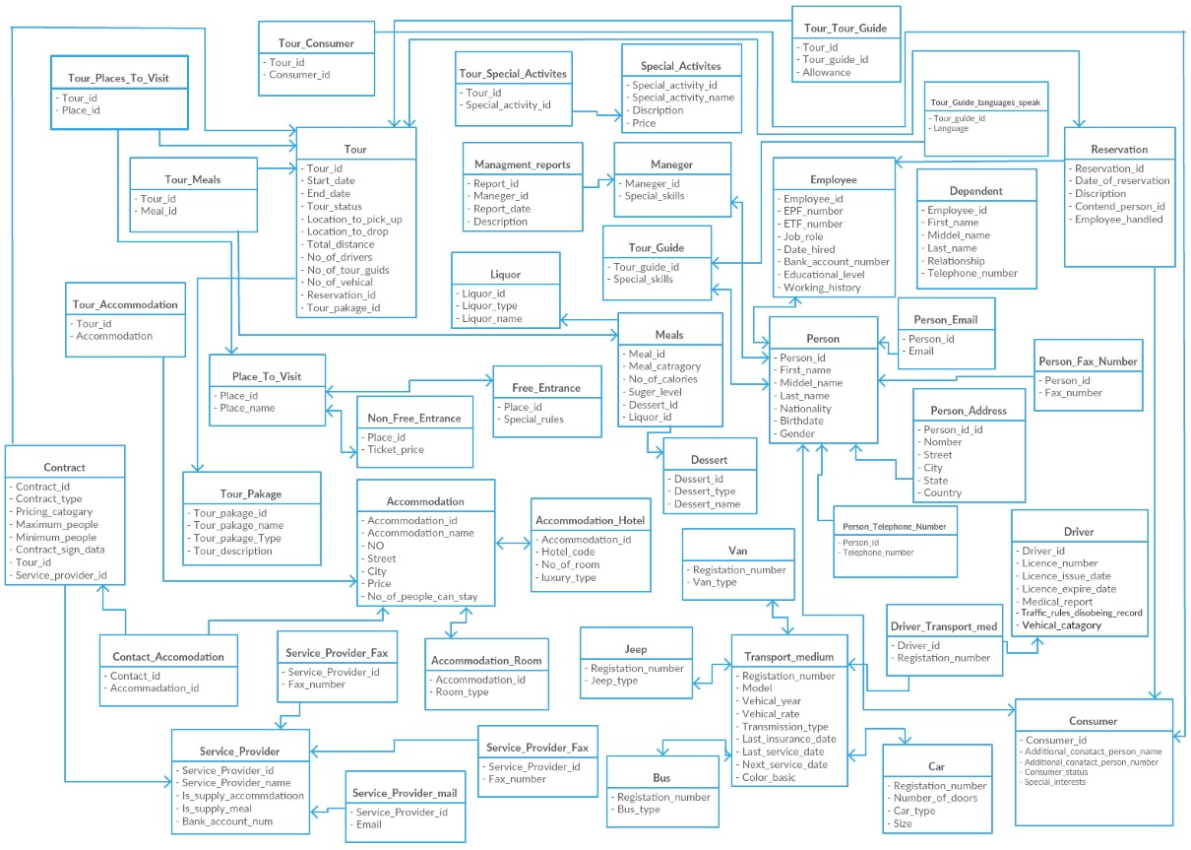

# Triggers

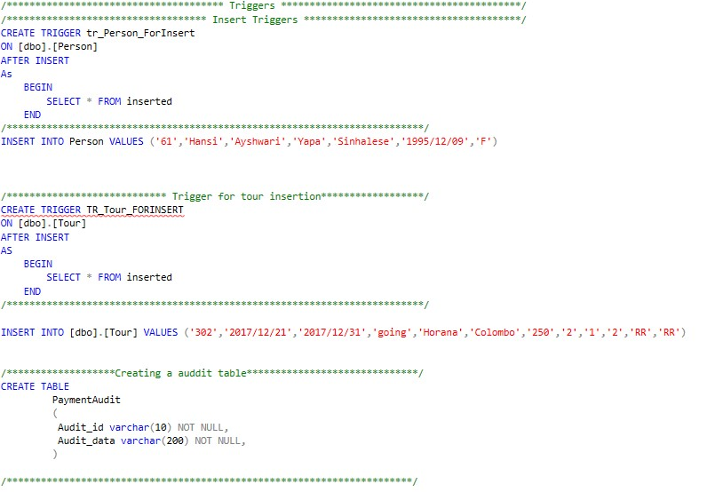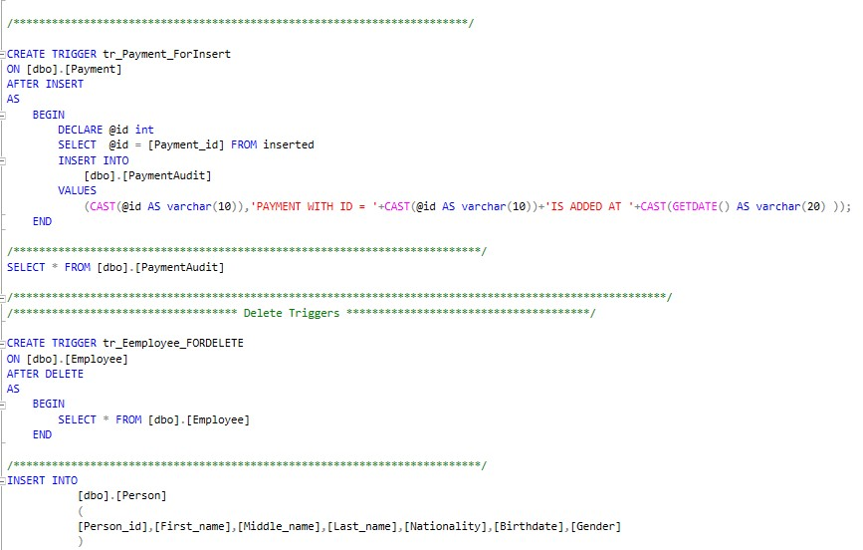

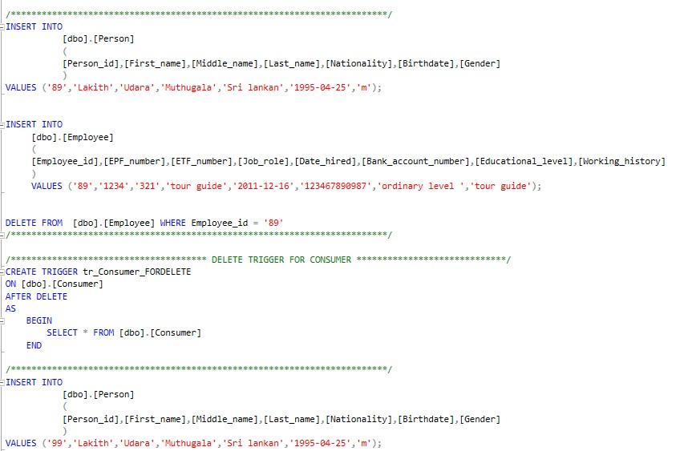

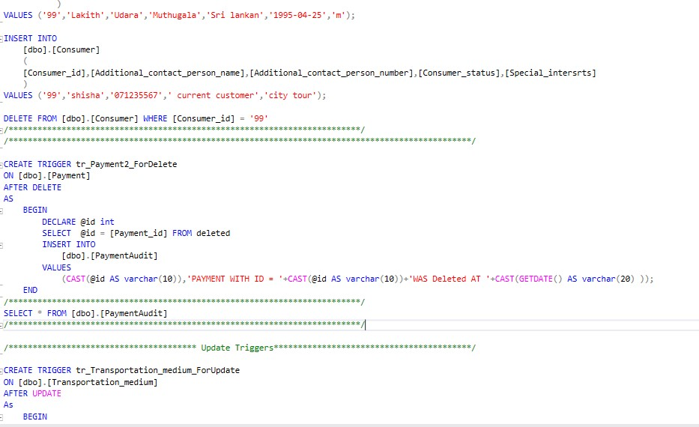

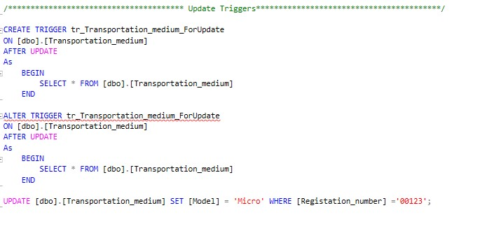

/******************** Triggers **************************/

/************************* Insert Triggers **************************************/

CREATE TRIGGER tr_Person_ForInsert

ON [dbo].[Person]

AFTER INSERT

As

BEGIN

SELECT * FROM inserted

END

/*************************************************************************/

INSERT INTO Person VALUES

('61','Hansi','Ayshwari','Yapa','Sinhalese','1995/12/09','F')

/**************************** Trigger for tour insertion******************/

CREATE TRIGGER TR_Tour_FORINSERT

ON [dbo].[Tour]

AFTER INSERT

AS

BEGIN

SELECT * FROM inserted

END

/*************************************************************************/

INSERT INTO [dbo].[Tour] VALUES

('302','2017/12/21','2017/12/31','going','Horana','Colombo','250','2','1','2','RR','RR

')

/*******************Creating a auddit table******************************/ CREATE TABLE

PaymentAudit

(

Audit_id varchar(10) NOT NULL,

Audit_data varchar(200) NOT NULL,

)

/***********************************************************************/ CREATE TRIGGER tr_Payment_ForInsert

ON [dbo].[Payment]

AFTER INSERT

AS

BEGIN

DECLARE @id int

SELECT @id = [Payment_id] FROM inserted

INSERT INTO

[dbo].[PaymentAudit]

VALUES

(CAST(@id AS varchar(10)),'PAYMENT WITH ID = '+CAST(@id AS

varchar(10))+'IS ADDED AT '+CAST(GETDATE() AS varchar(20) ));

END

/*************************************************************************/

SELECT * FROM [dbo].[PaymentAudit]

/******************************************************************************/

/************************* Delete Triggers **************************************/

CREATE TRIGGER tr_Eemployee_FORDELETE

ON [dbo].[Employee]

AFTER DELETE

AS

BEGIN

SELECT * FROM [dbo].[Employee]

END

/*************************************************************************/

INSERT INTO

[dbo].[Person]

(

[Person_id],[First_name],[Middle_name],[Last_name],[Nationality],[Birthdate],[Gender]

)

VALUES ('89','Lakith','Udara','Muthugala','Sri lankan','1995-04-25','m');

INSERT INTO

[dbo].[Employee]

(

[Employee_id],[EPF_number],[ETF_number],[Job_role],[Date_hired],[Bank_account_number],

[Educational_level],[Working_history]

)

VALUES ('89','1234','321','tour guide','2011-12-16','123467890987','ordinary level ','tour guide');

DELETE FROM [dbo].[Employee] WHERE Employee_id = '89'

/*************************************************************************/

/************************ DELETE TRIGGER FOR CONSUMER *****************************/ CREATE TRIGGER tr_Consumer_FORDELETE

ON [dbo].[Consumer]

AFTER DELETE

AS

BEGIN

SELECT * FROM [dbo].[Consumer]

END

/*************************************************************************/

INSERT INTO

[dbo].[Person]

(

[Person_id],[First_name],[Middle_name],[Last_name],[Nationality],[Birthdate],[Gender]

)

VALUES ('99','Lakith','Udara','Muthugala','Sri lankan','1995-04-25','m');

INSERT INTO

[dbo].[Consumer]

(

[Consumer_id],[Additional_contact_person_name],[Additional_contact_person_numbe r],[Consumer_status],[Special_intersrts]

)

VALUES ('99','shisha','071235567',' current customer','city tour');

DELETE FROM [dbo].[Consumer] WHERE [Consumer_id] = '99'

/*************************************************************************/

/*******************************************************************************/

CREATE TRIGGER tr_Payment2_ForDelete

ON [dbo].[Payment]

AFTER DELETE

AS

BEGIN

DECLARE @id int

SELECT @id = [Payment_id] FROM deleted

INSERT INTO

[dbo].[PaymentAudit]

VALUES

(CAST(@id AS varchar(10)),'PAYMENT WITH ID = '+CAST(@id AS

varchar(10))+'WAS Deleted AT '+CAST(GETDATE() AS varchar(20) ));

END

/*************************************************************************/ SELECT * FROM [dbo].[PaymentAudit]

/*************************************************************************/

/************************** Update Triggers*****************************************/

CREATE TRIGGER tr_Transportation_medium_ForUpdate

ON [dbo].[Transportation_medium]

#### AFTER UPDATE

As

BEGIN

SELECT * FROM [dbo].[Transportation_medium]

END

ALTER TRIGGER tr_Transportation_medium_ForUpdate

ON [dbo].[Transportation_medium]

#### AFTER UPDATE

As

BEGIN

SELECT * FROM [dbo].[Transportation_medium]

END

UPDATE [dbo].[Transportation_medium] SET [Model] = 'Micro' WHERE [Registation_number] ='00123';

# Functions

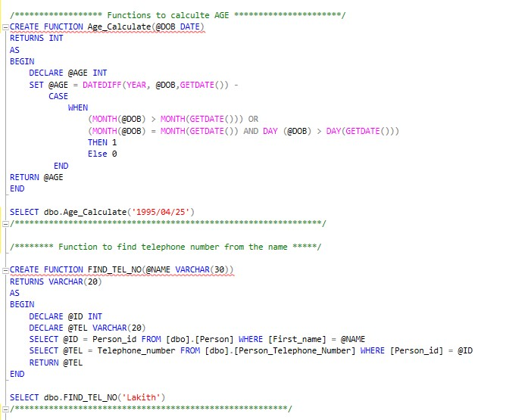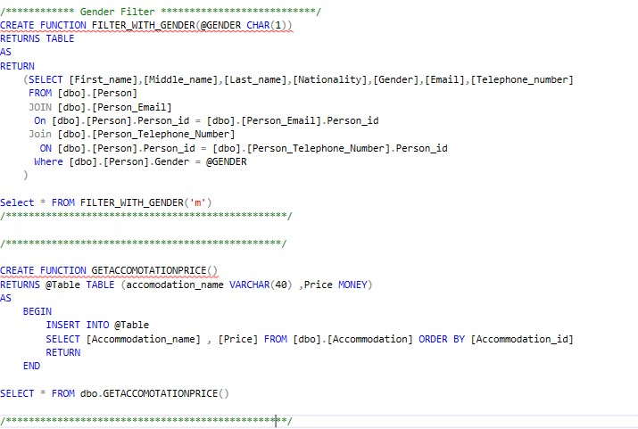

/****************** Functions to calculte AGE **********************/

CREATE FUNCTION Age_Calculate(@DOB DATE)

RETURNS INT

AS

BEGIN

DECLARE @AGE INT

#### SET @AGE = DATEDIFF(YEAR, @DOB,GETDATE()) -

CASE

WHEN

|  |  |  |
| --- | --- | --- |
|  |  | (MONTH(@DOB) > MONTH(GETDATE())) OR |
| DAY(GETDATE())) |  | (MONTH(@DOB) = MONTH(GETDATE()) AND DAY (@DOB) > |
|  |  | THEN 1 |
|  |  | Else 0 |

END

RETURN @AGE

END

SELECT dbo.Age_Calculate('1995/04/25')

/***************************************************************/

/******** Function to find telephone number from the name *****/

CREATE FUNCTION FIND_TEL_NO(@NAME VARCHAR(30))

RETURNS VARCHAR(20)

AS

BEGIN

DECLARE @ID INT

DECLARE @TEL VARCHAR(20)

SELECT @ID = Person_id FROM [dbo].[Person] WHERE [First_name] = @NAME

SELECT @TEL = Telephone_number FROM [dbo].[Person_Telephone_Number] WHERE [Person_id] = @ID

RETURN @TEL

END

SELECT dbo.FIND_TEL_NO('Lakith')

/********************************************************/

/************ Gender Filter ***************************/

CREATE FUNCTION FILTER_WITH_GENDER(@GENDER CHAR(1))

RETURNS TABLE

AS

RETURN

(SELECT

[First_name],[Middle_name],[Last_name],[Nationality],[Gender],[Email],[Telephone_numbe r]

FROM [dbo].[Person]

JOIN [dbo].[Person_Email]

On [dbo].[Person].Person_id = [dbo].[Person_Email].Person_id

Join [dbo].[Person_Telephone_Number]

ON [dbo].[Person].Person_id = [dbo].[Person_Telephone_Number].Person_id

Where [dbo].[Person].Gender = @GENDER

)

Select * FROM FILTER_WITH_GENDER('m')

/*************************************************/

/************************************************/

CREATE FUNCTION GETACCOMOTATIONPRICE()

RETURNS @Table TABLE (accomodation_name VARCHAR(40) ,Price MONEY)

AS

BEGIN

INSERT INTO @Table

SELECT [Accommodation_name] , [Price] FROM [dbo].[Accommodation] ORDER BY [Accommodation_id]

RETURN

END

SELECT * FROM dbo.GETACCOMOTATIONPRICE()

/*************************************************/

# Create View

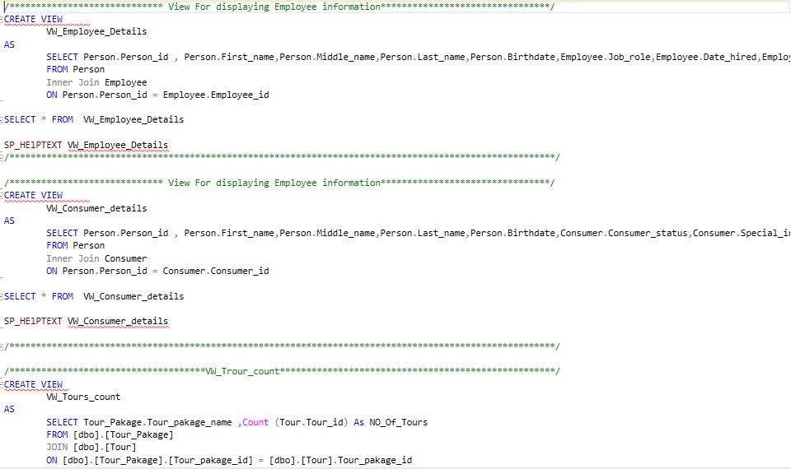

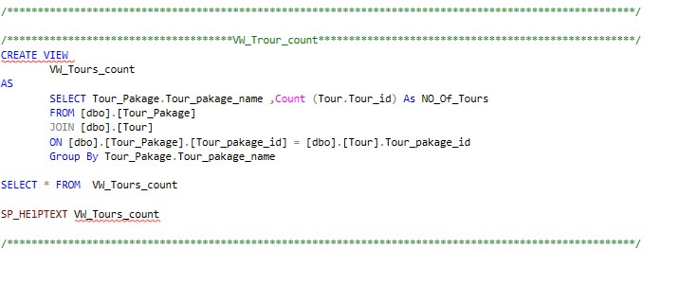

/******************** View For displaying Employee information********************/

CREATE VIEW

VW_Employee_Details

AS

SELECT Person.Person_id ,

Person.First_name,Person.Middle_name,Person.Last_name,Person.Birthdate,Employee.Job_ro le,Employee.Date_hired,Employee.Working_history,Employee.EPF_number,Employee.ETF_numbe r

FROM Person

Inner Join Employee

ON Person.Person_id = Employee.Employee_id

SELECT * FROM VW_Employee_Details

SP_HElPTEXT VW_Employee_Details /********************************************************************************/

/******************** View For displaying Employee information***********************/

CREATE VIEW

VW_Consumer_details

AS

SELECT Person.Person_id ,

Person.First_name,Person.Middle_name,Person.Last_name,Person.Birthdate,Consumer.Consum er_status,Consumer.Special_intersrts,Consumer.Additional_contact_person_name,Consumer.

Additional_contact_person_number

FROM Person

Inner Join Consumer

ON Person.Person_id = Consumer.Consumer_id

SELECT * FROM VW_Consumer_details

SP_HElPTEXT VW_Consumer_details

/***************************************************************************/

/**********************VW_Trour_count********************************************/

CREATE VIEW

VW_Tours_count

AS

SELECT Tour_Pakage.Tour_pakage_name ,Count (Tour.Tour_id) As NO_Of_Tours

FROM [dbo].[Tour_Pakage]

JOIN [dbo].[Tour]

ON [dbo].[Tour_Pakage].[Tour_pakage_id] = [dbo].[Tour].Tour_pakage_id

Group By Tour_Pakage.Tour_pakage_name

SELECT * FROM VW_Tours_count

SP_HElPTEXT VW_Tours_count

/**************************************************************************/

# Procedure

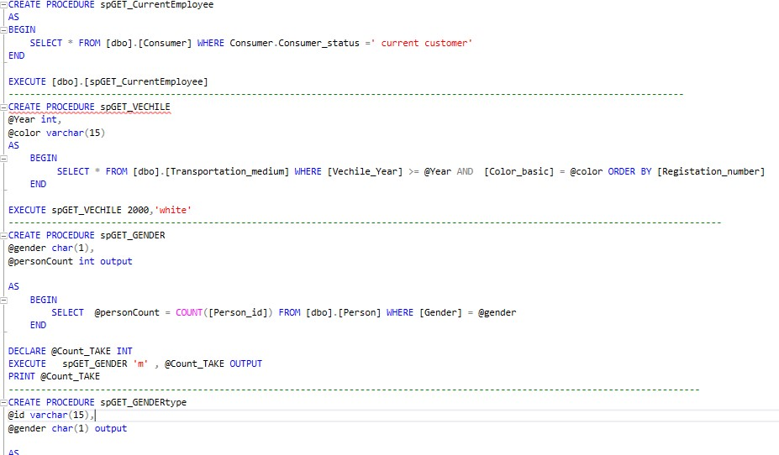

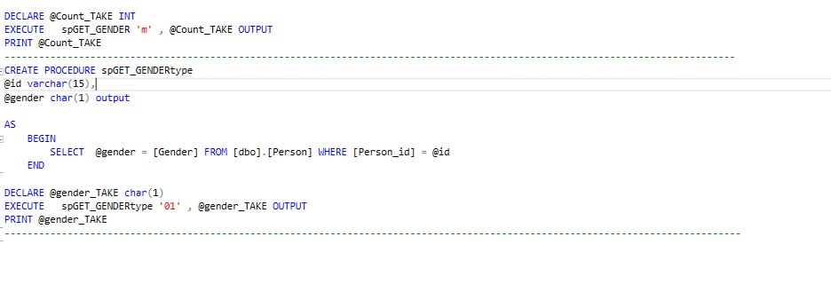

CREATE PROCEDURE spGET_CurrentEmployee

AS

BEGIN

SELECT * FROM [dbo].[Consumer] WHERE Consumer.Consumer_status =' current customer' END

EXECUTE [dbo].[spGET_CurrentEmployee]

--------------------------------------------------------------------------------------

CREATE PROCEDURE spGET_VECHILE

@Year int,

@color varchar(15)

AS

BEGIN

SELECT * FROM [dbo].[Transportation_medium] WHERE [Vechile_Year] >= @Year AND [Color_basic] = @color ORDER BY [Registation_number]

END

EXECUTE spGET_VECHILE 2000,'white'

-------------------------------------------------------------------------------- CREATE PROCEDURE spGET_GENDER

@gender char(1),

@personCount int output

AS

BEGIN

SELECT @personCount = COUNT([Person_id]) FROM [dbo].[Person] WHERE [Gender] = @gender

END

DECLARE @Count_TAKE INT

EXECUTE spGET_GENDER 'm' , @Count_TAKE OUTPUT

PRINT @Count_TAKE

----------------------------------------------------------------------------------

CREATE PROCEDURE spGET_GENDERtype

@id varchar(15),

@gender char(1) output

AS

BEGIN

SELECT @gender = [Gender] FROM [dbo].[Person] WHERE [Person_id] = @id

END

DECLARE @gender_TAKE char(1)

EXECUTE spGET_GENDERtype '01' , @gender_TAKE OUTPUT

PRINT @gender_TAKE

-------------------------------------------------------------------------------